**Group5_W2020_MAD3115_FP**

MAD3115

Documentation of Final Project

Vehicle Renting System

C0766552 – Nikita Sandhu

C0777682 – Kamalpreet Kaur

C0775696 – Jyothi Thomas

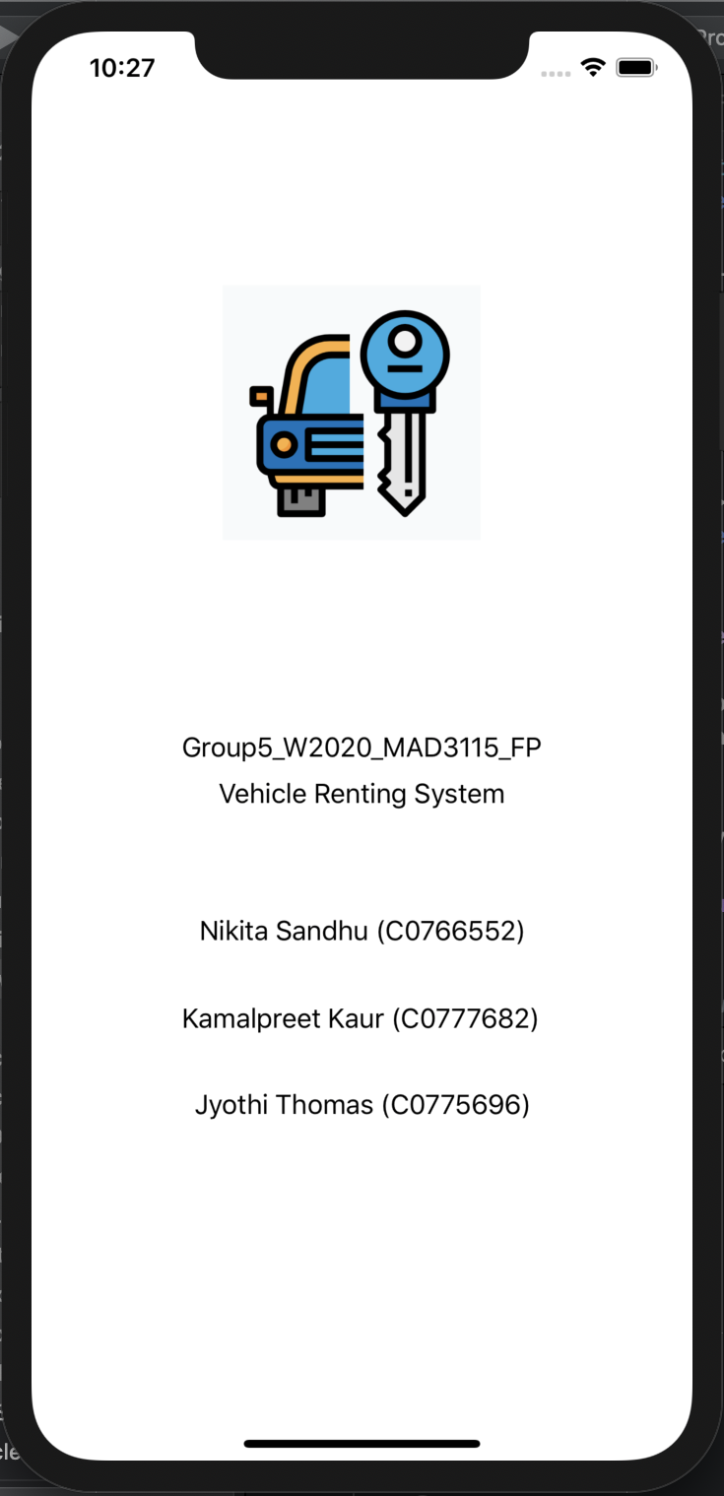

Fig 1. Launch VIEW CONTROLLER

* This is the first screen that will appear when the application is started, this is the launch screen.
* This will appear for a significant amount of time and then the next VIEW CONTROLLER will appear.

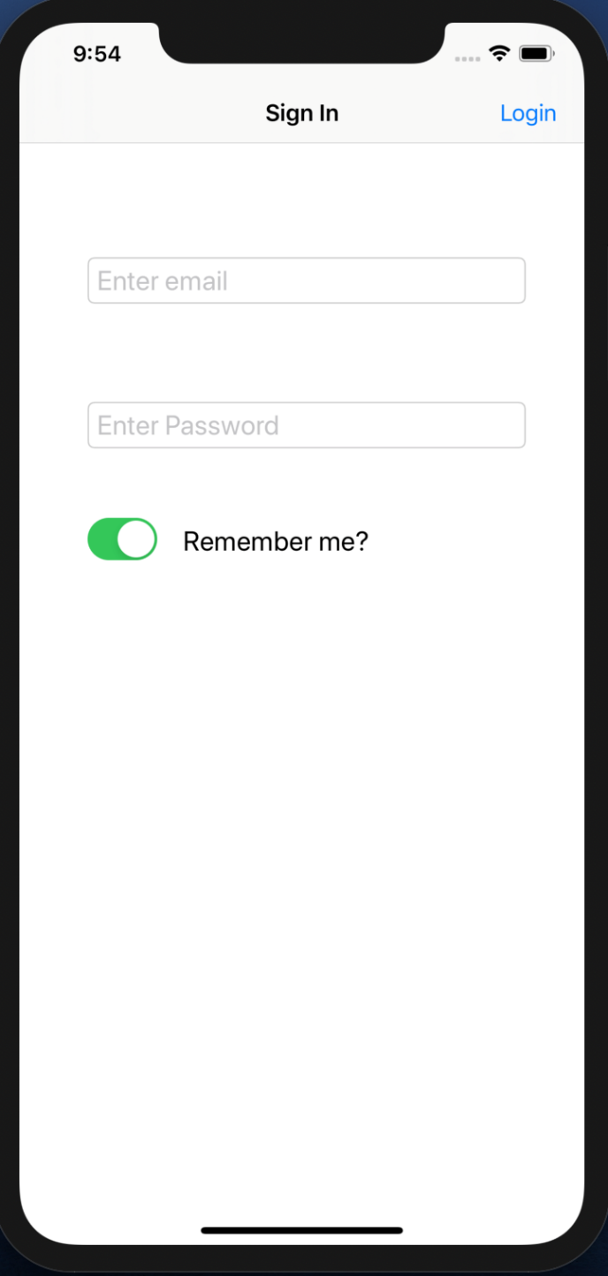

Fig 2. Login VIEW CONTROLLER

* Login Screen requires an email and the consecutive password to login into the application and these are the TEXTFIELDs.
* There is a remember me SWITCH.
* Login BAR BUTTON is there.

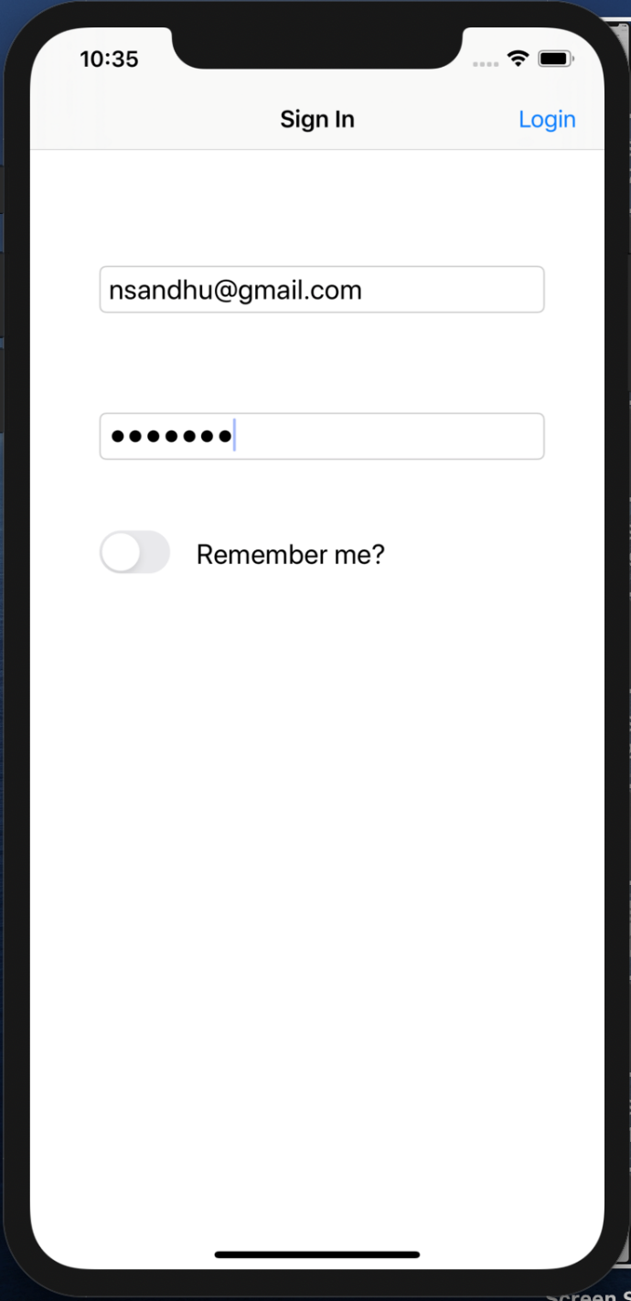

Fig 3. Logging in with Remember me OFF

* The remember me SWITCH can be turned ON or OFF according to preference.
* The user details are entered.
* Login BAR BUTTON is pressed to log into the application.

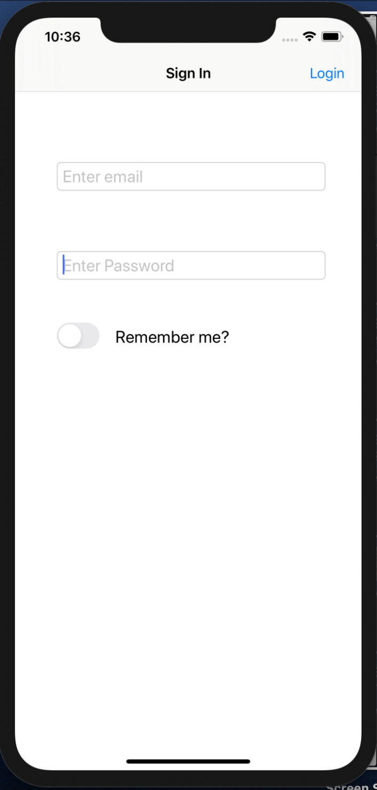

Fig 4. Logging Out when Remember me OFF

* When the user Logs out of the application and the Remember me SWITCH was turned OFF when the user logged into the application in the first place then user details will not be saved and user has to enter the login details again in order to login.

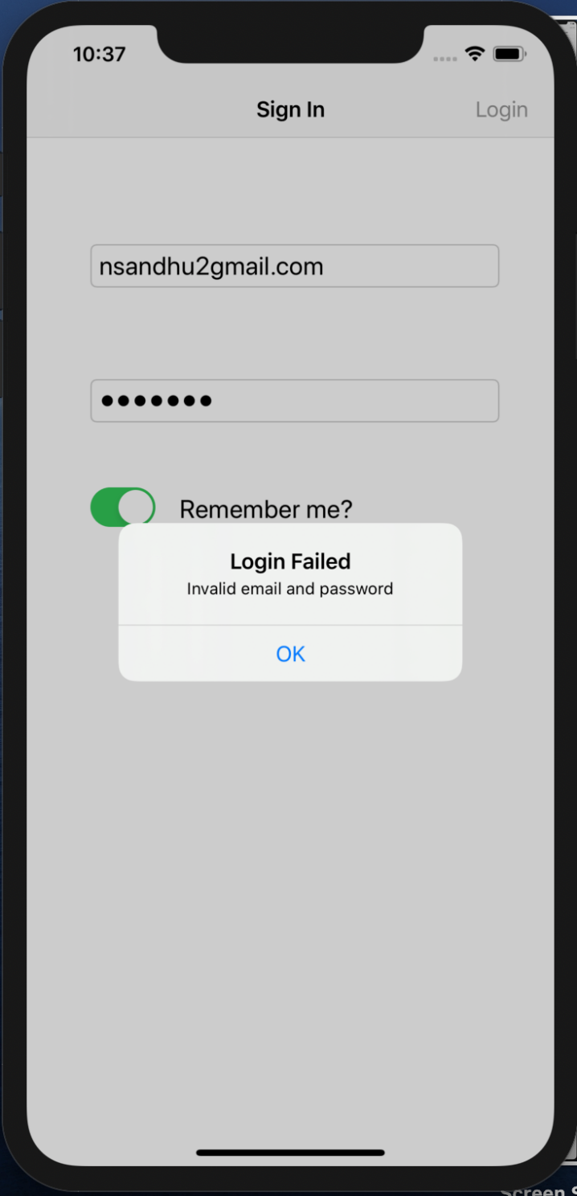

Fig 5. Login with Login Validation

* Login process requires a valid email and password.
* Three email and password combinations are there to access the application.
* In this application one user email and password detail is fixed and the same needs to be entered in order to login.

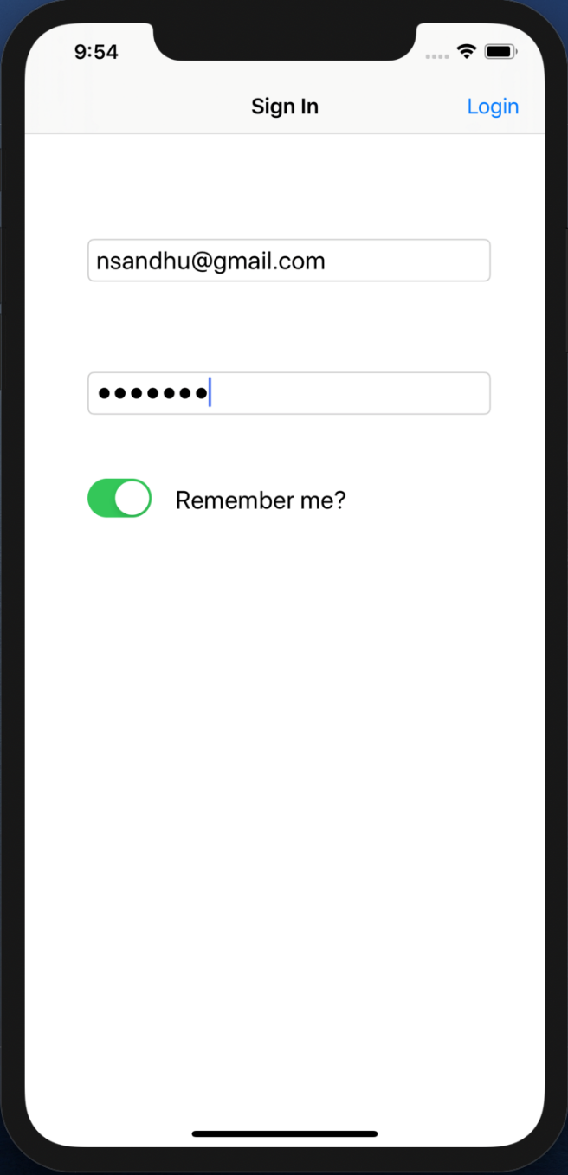

Fig 6. Login with Remember me ON

* When the user Logs out of the application and the Remember me SWITCH was turned ON when the user logged into the application in the first place then user details will be saved and user doesn’t have to enter the login details again in order to login.

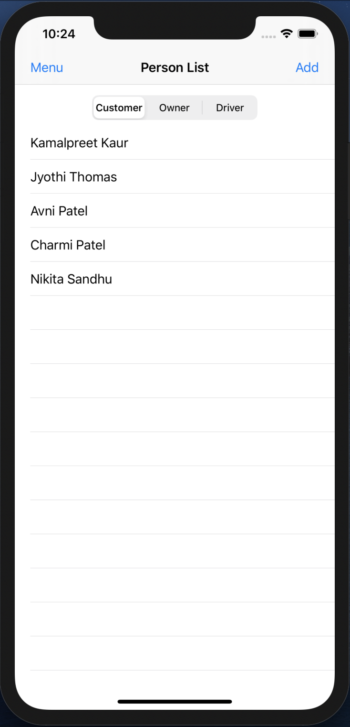

Fig 7. Customer TABLEVIEW

* After logging in, the Person list appears, it is a VIEW CONTROLLER with TABLE VIEW and SEGMENT.
* Each segment index holds the details of individual Person Class objects.
* Segment index one holds the Customer objects.

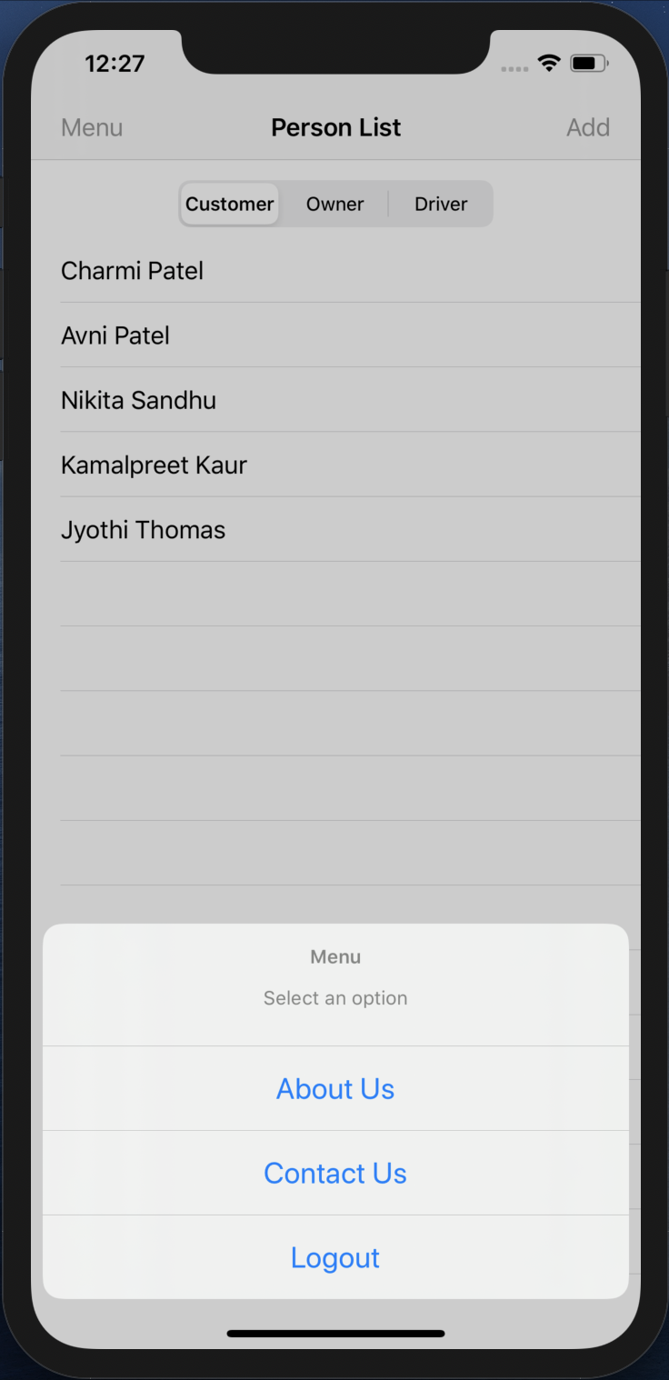

Fig 8. Menu

* When the Menu BAR BUTTON is pressed, ALERT ACTION pops up on screen.
* When Logout is press, the user logs out of the application.

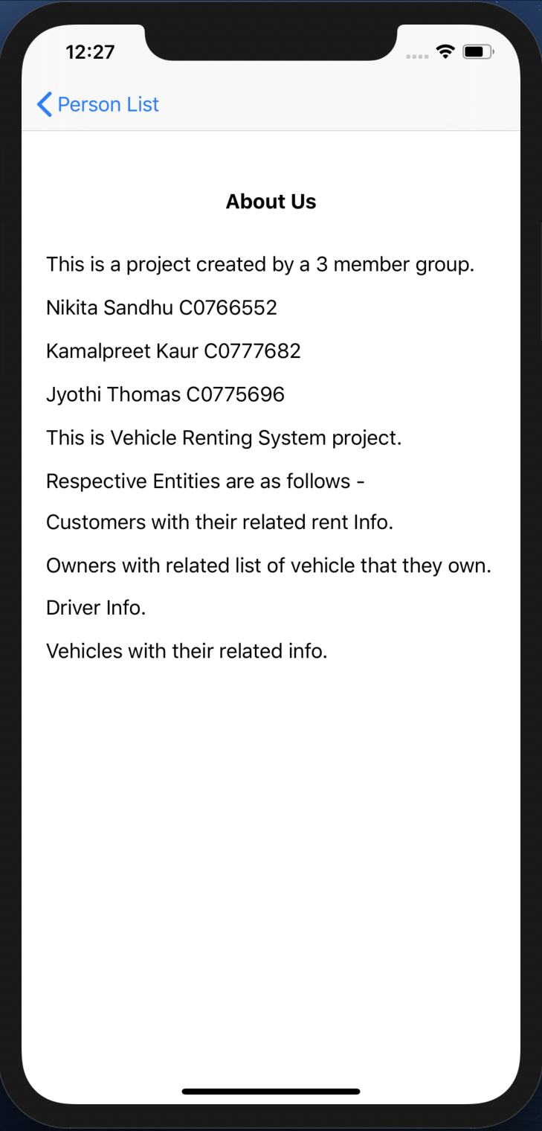

Fig 9. About Us

* When About Us is pressed, a VIEW CONTROLLER appears with details about the app.

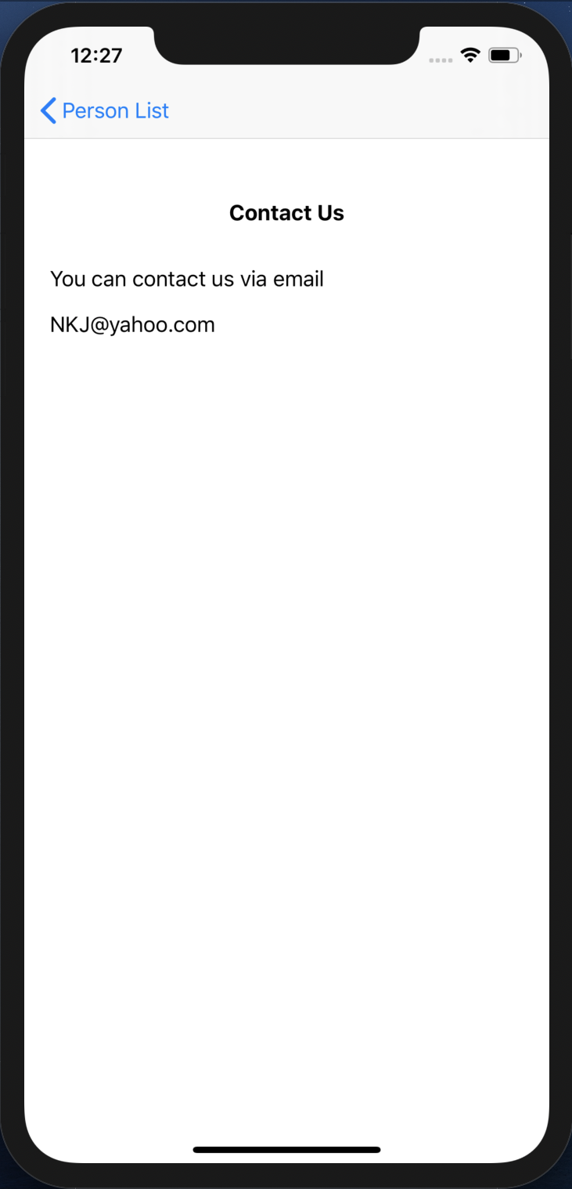

Fig 10. Contact Us

* When Contact Us is pressed, the same VIEW CONTROLLER appears with contact details.

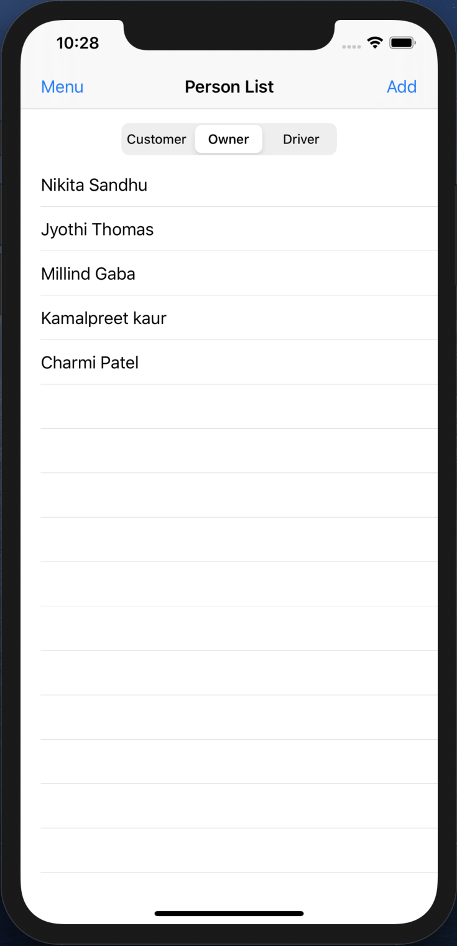

Fig 11. Owner TABLEVIEW

* Segment index two holds the Owner objects.

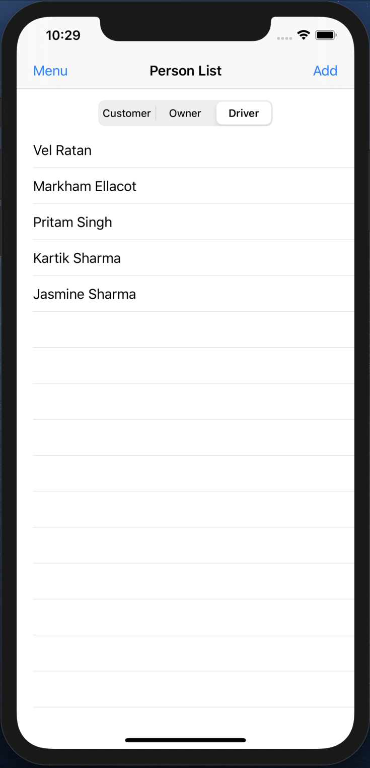

Fig 12. Driver TABLEVIEW

* Segment index three holds the Driver objects.

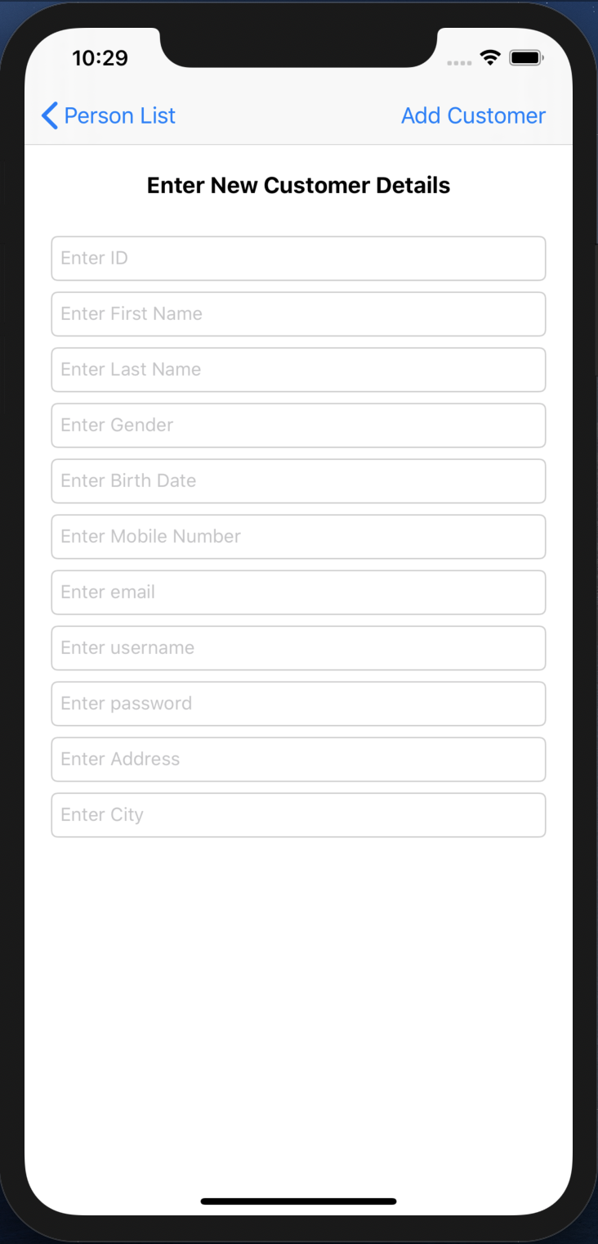

Fig 13. New Customer creation

* When segment one is selected and the Add BAR BUTTON is pressed a new VIEW CONTROLLER appears.
* This VIEW CONTROLLER contains TEXTFIELDs that shows the requirements that needs to be entered in order to create a new customer.
* When no new customer is needed to be created then the user can simple press the Person List back BAR BUTTON on the top left and go back to the previous screen.

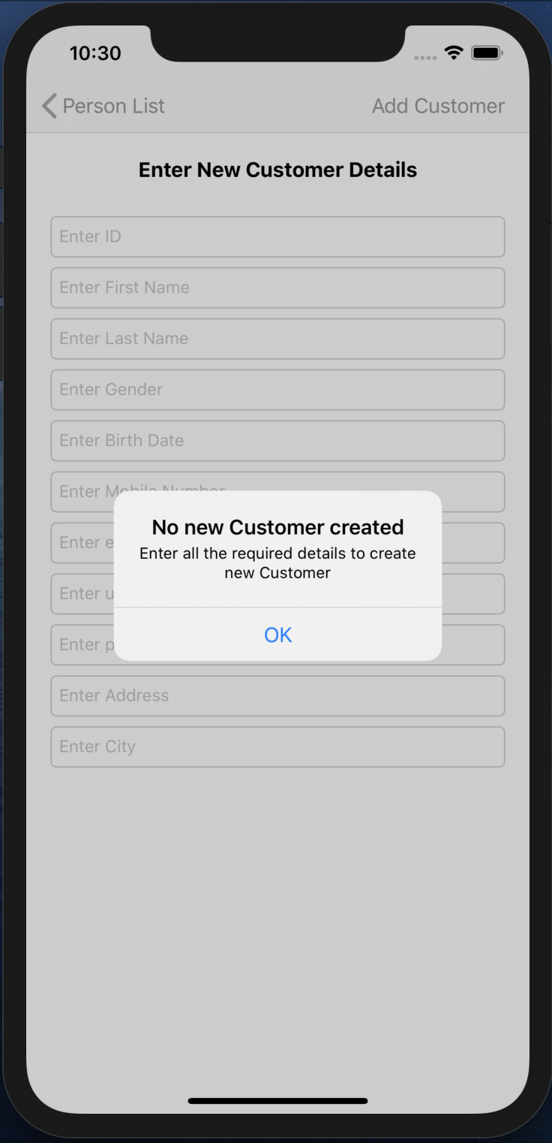

Fig 14. Alert

* When the Add Customer BAR BUTTON is pressed without entering any of the details, an ALERT pops up.
* This alert shows a message asking to fill the details that are required to create a new customer.

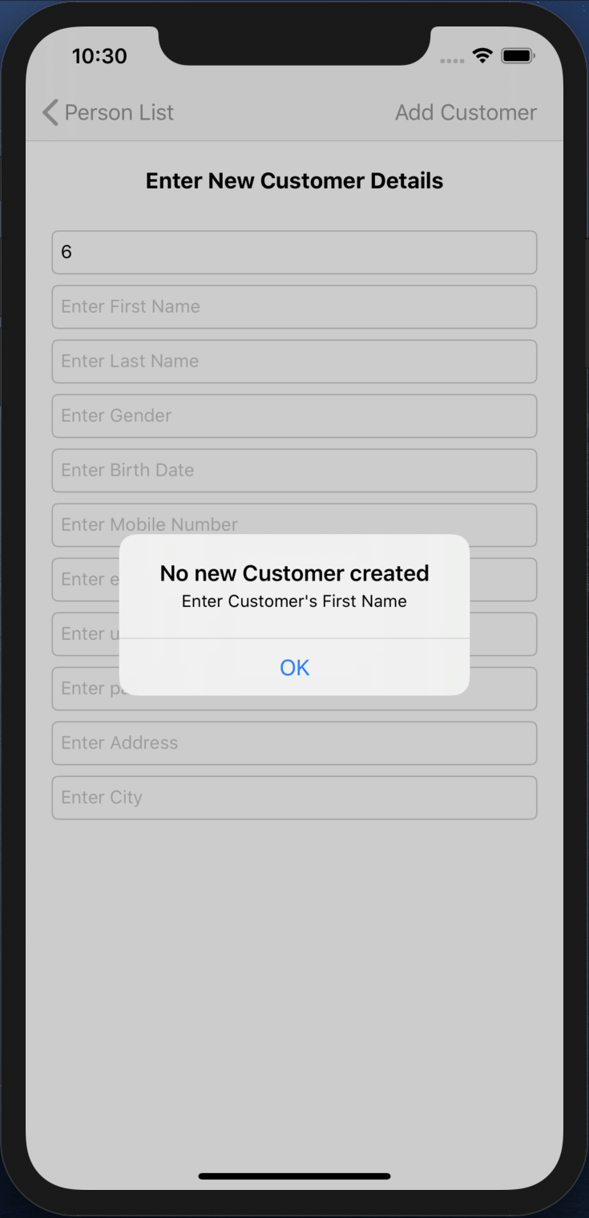

Fig 15. Alert

* An alert will pop up, when the Customer’s First Name is not filled.

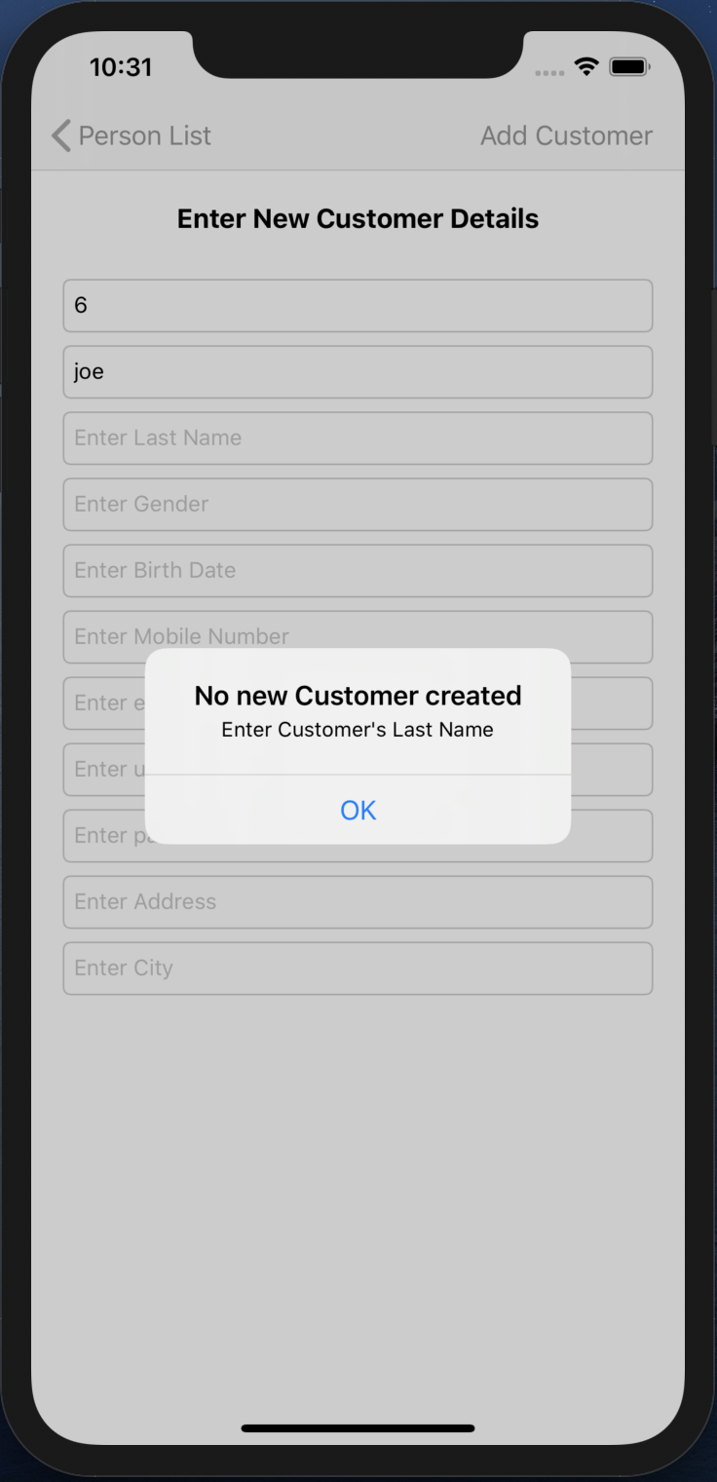

Fig 16. Alert

* An alert will pop up, when the Customer’s Last Name is not filled.

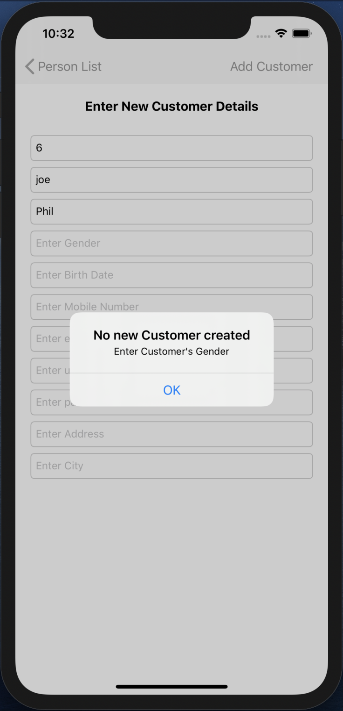

Fig 17. Alert

* An alert will pop up, when the Customer’s Gender is not filled.

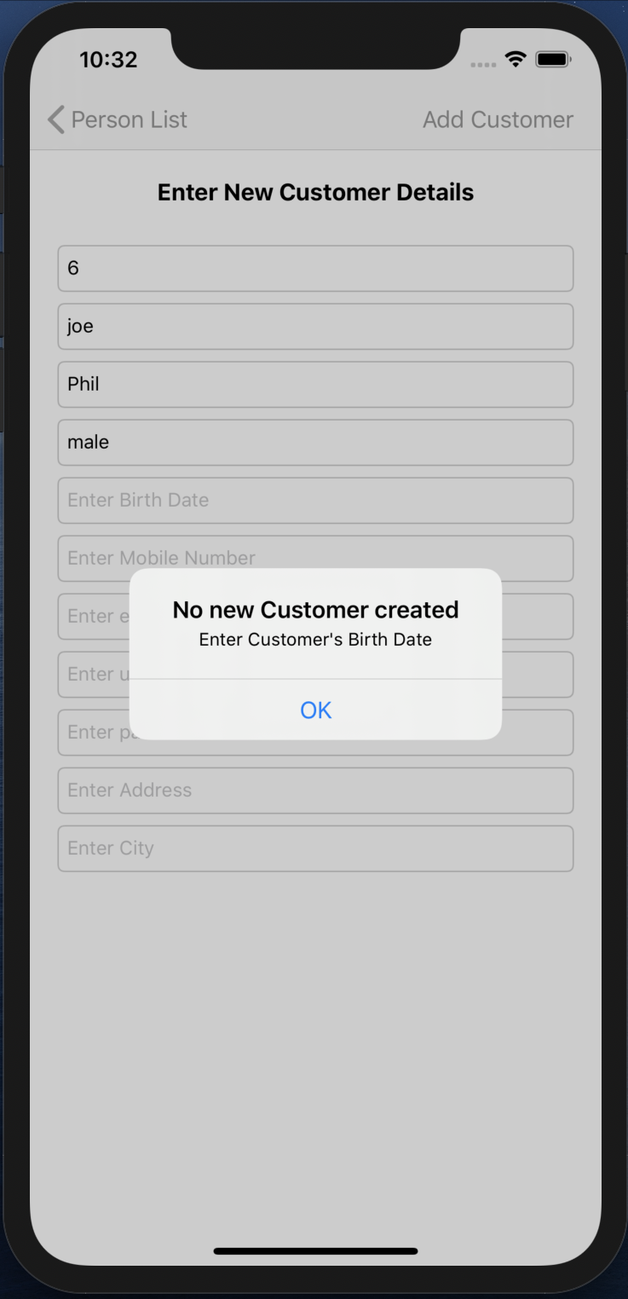

Fig 18. Alert

* An alert will pop up, when the Customer’s Birth Date is not filled.

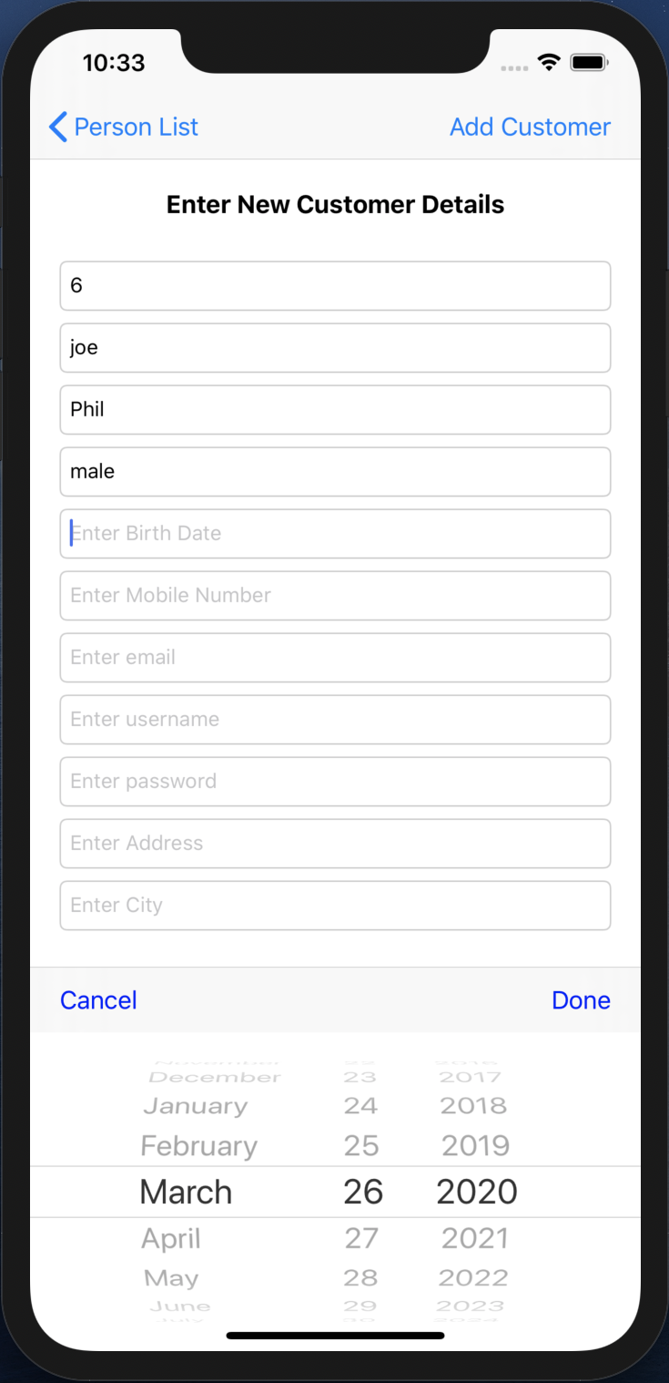

Fig 19. Date Picker

* When we click on the Birth Date TEXTFIELD, the DATE PICKER pops up to fill it.
* Date is selected and Done TOOLBAR BUTTON is pressed of the DATE PICKER, that date is filled in the Birth Date TEXTFIELD.

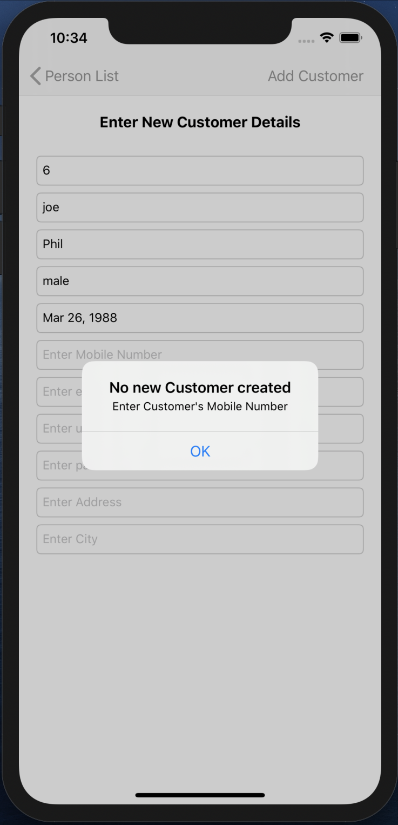

Fig 20. Alert

* An alert will pop up, when the Customer’s Mobile Number is not filled.

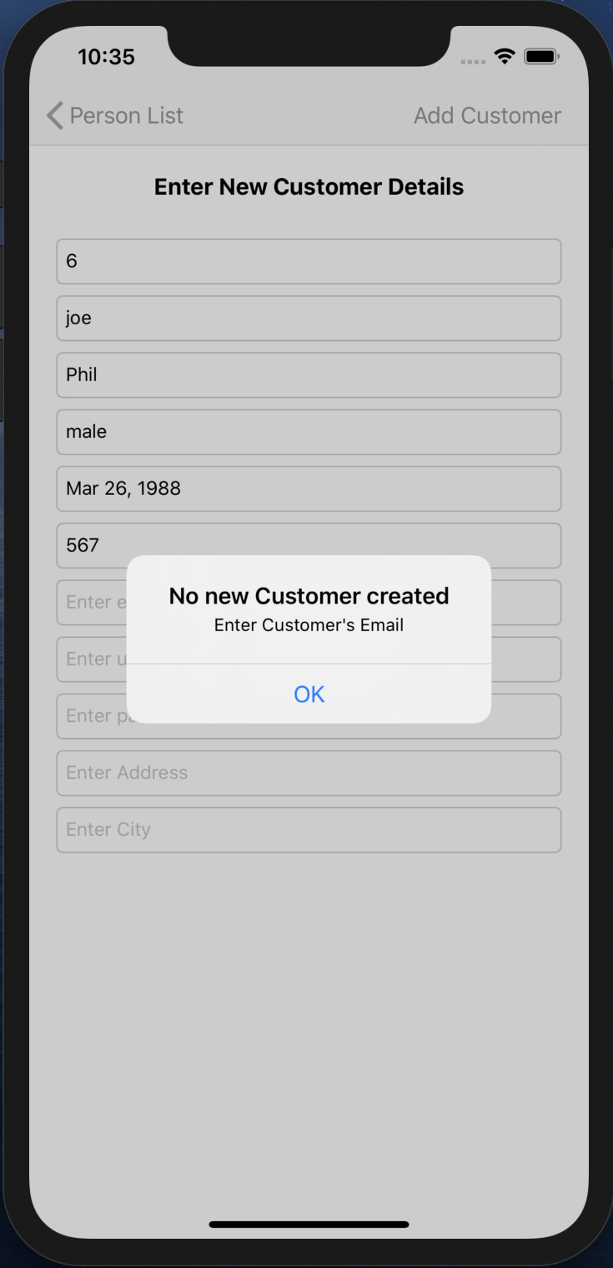

Fig 21. Alert

* An alert will pop up, when the Customer’s Email is not filled.

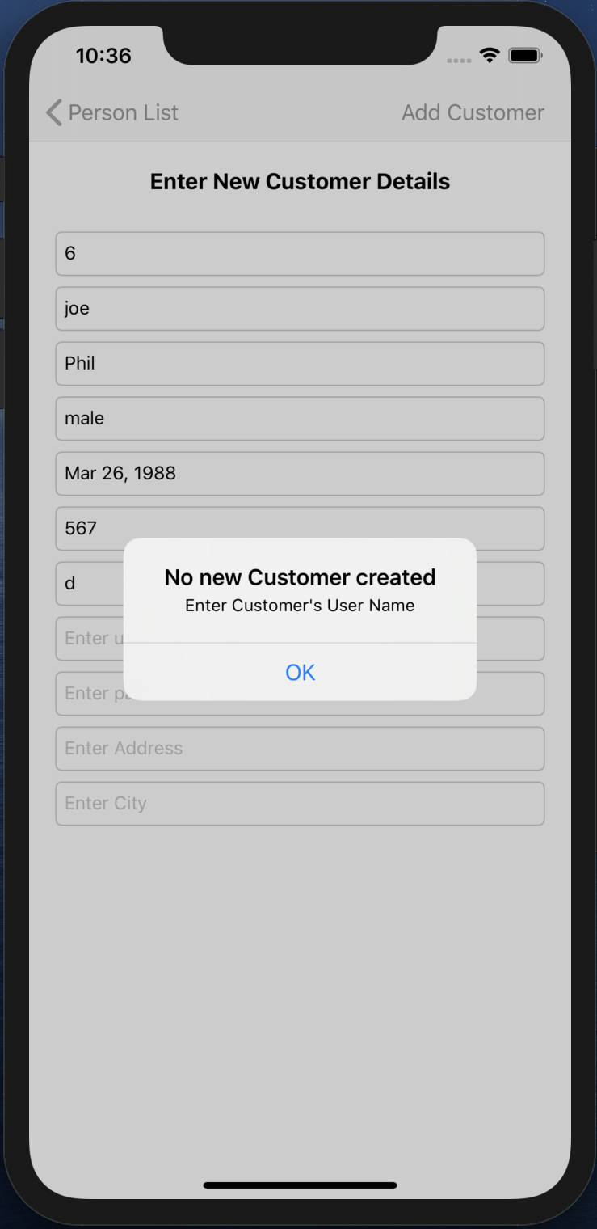

Fig 22. Alert

* An alert will pop up, when the Customer’s User Name is not filled.

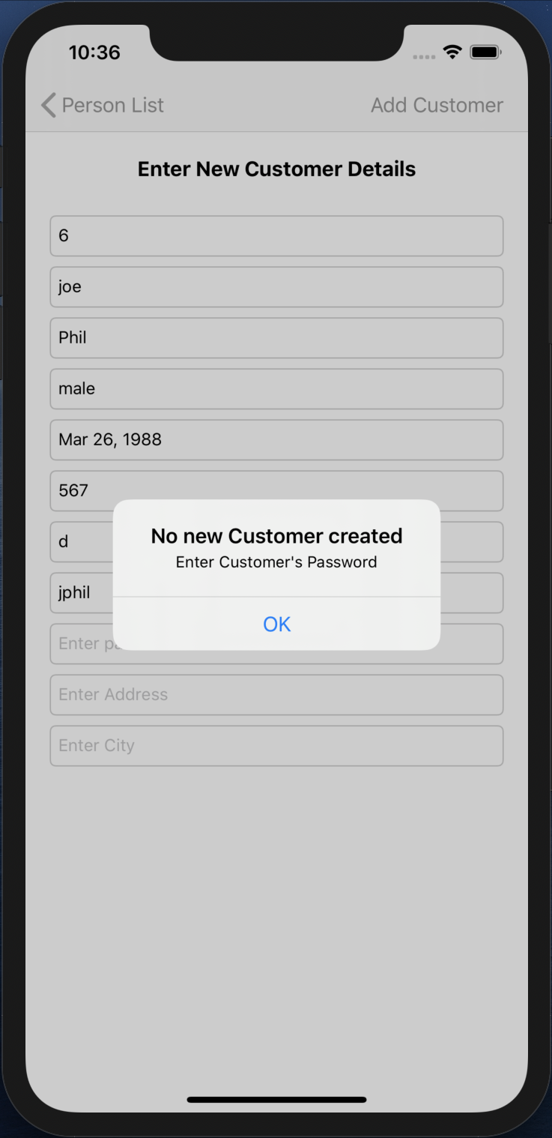

Fig 23. Alert

* An alert will pop up, when the Customer’s Password is not filled.

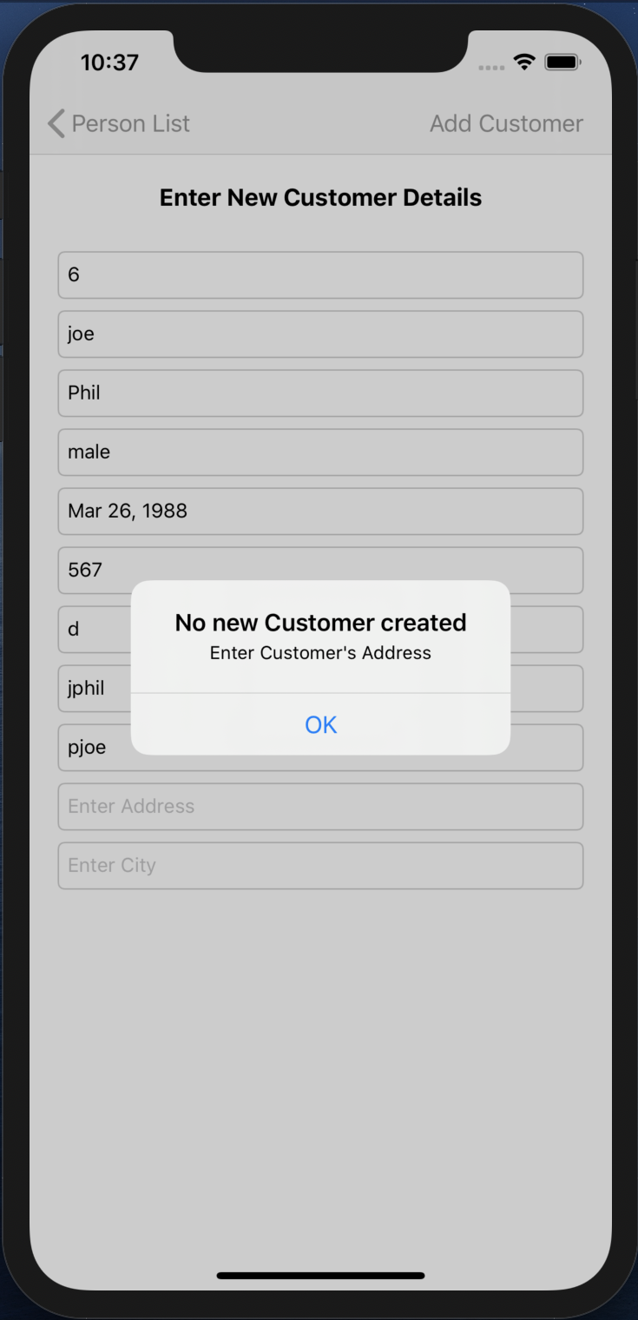

Fig 24. Alert

* An alert will pop up, when the Customer’s Address is not filled.

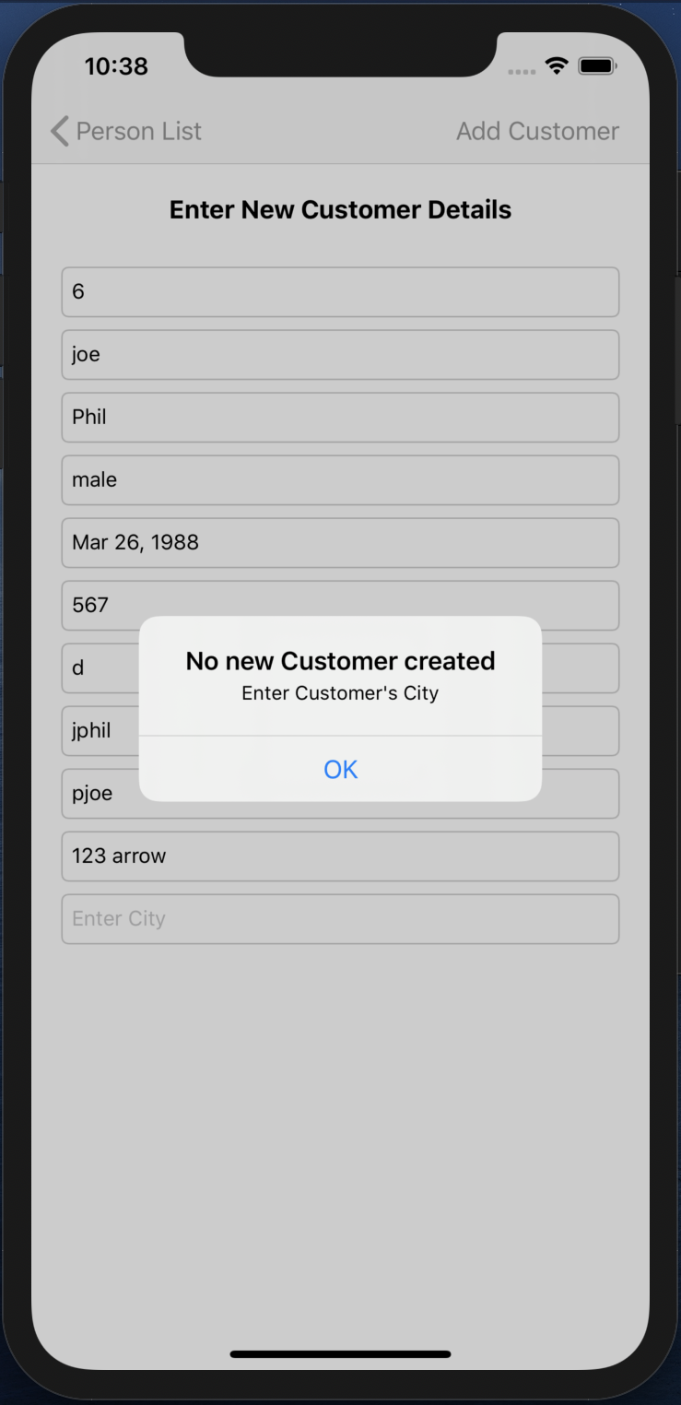

Fig 25. Alert

* An alert will pop up, when the Customer’s City is not filled.

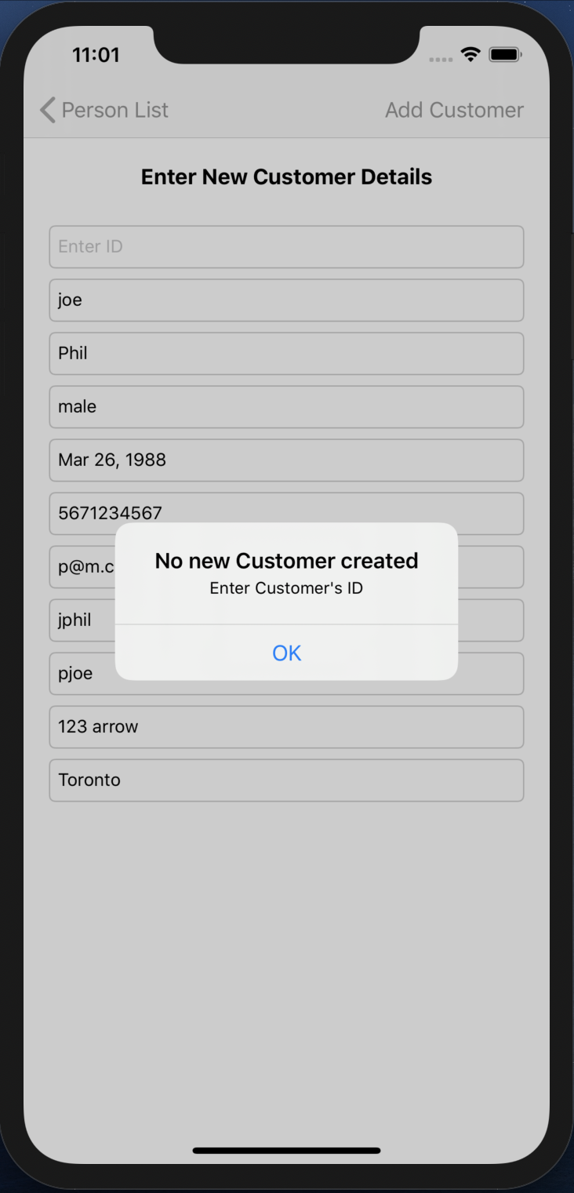

Fig 26. Alert

* An alert will pop up, when the Customer’s ID is not filled.

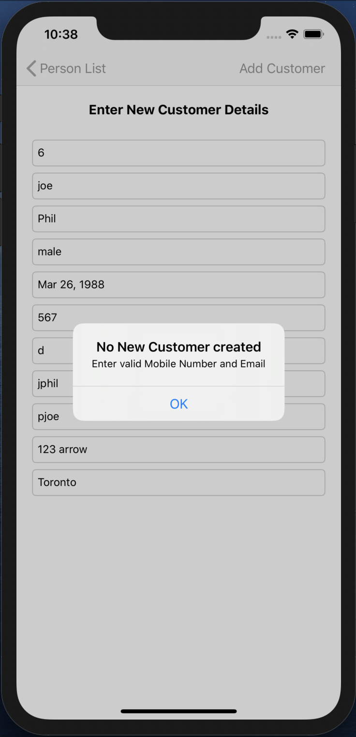

Fig 27. Alert

* An alert will pop up, when the Customer’s Valid email and mobile number are not filled.

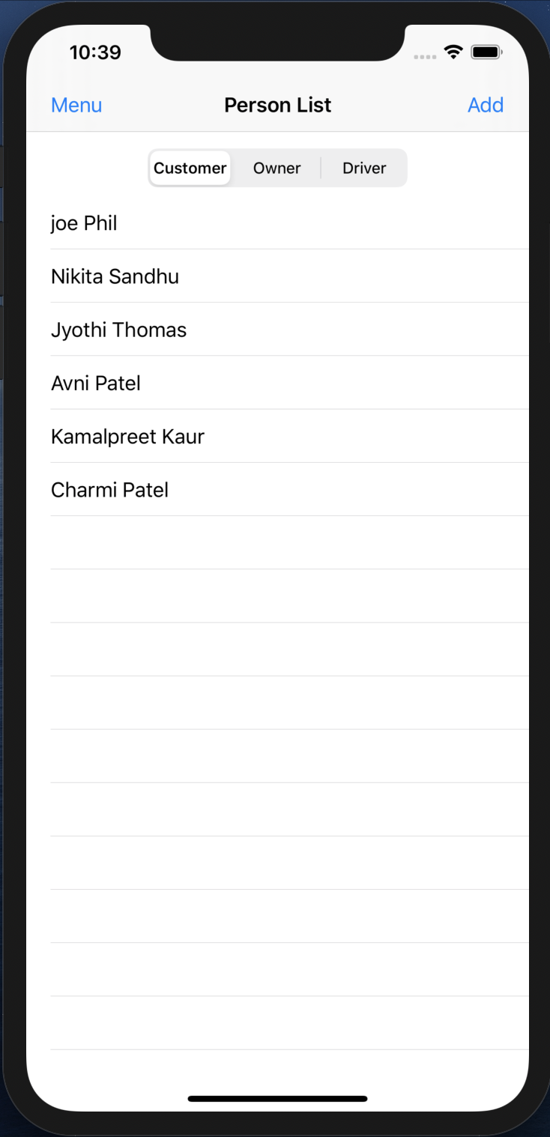

Fig 28. Updated Customer TABLE VIEW

* When all fields are filled and Add Customer BAR BUTTON is pressed, the VIEW CONTROLLER pops.
* The Customer TABLE VIEW gets updated.

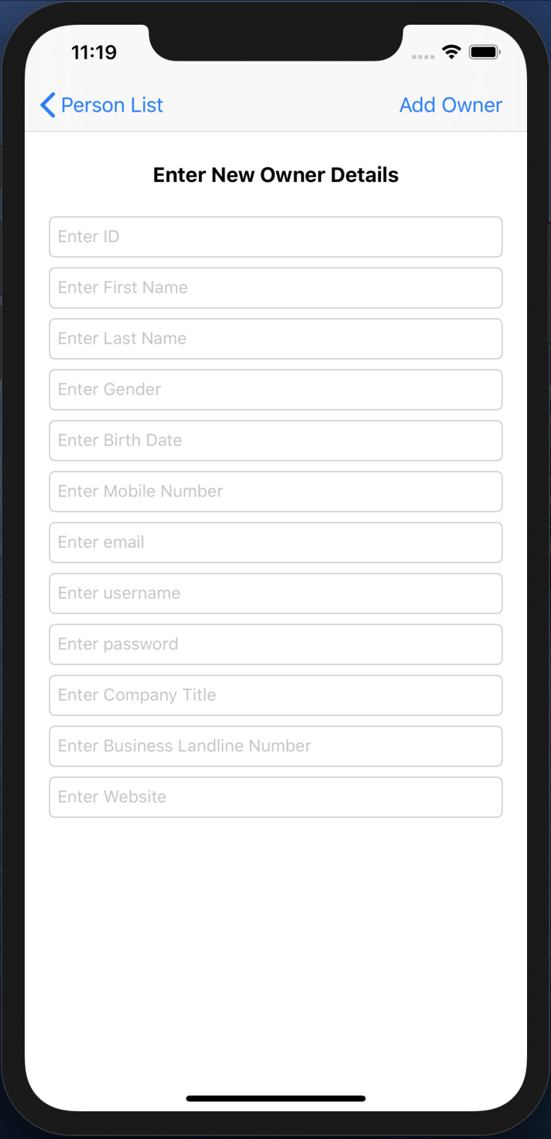

Fig 29. New Owner creation

* When segment two is selected and the Add BAR BUTTON is pressed a new VIEW CONTROLLER appears.
* This VIEW CONTROLLER contains TEXTFIELDs that shows the requirements that needs to be entered in order to create a new owner.
* When no new owner is needed to be created then the user can simple press the Person List back BAR BUTTON on the top left and go back to the previous screen.

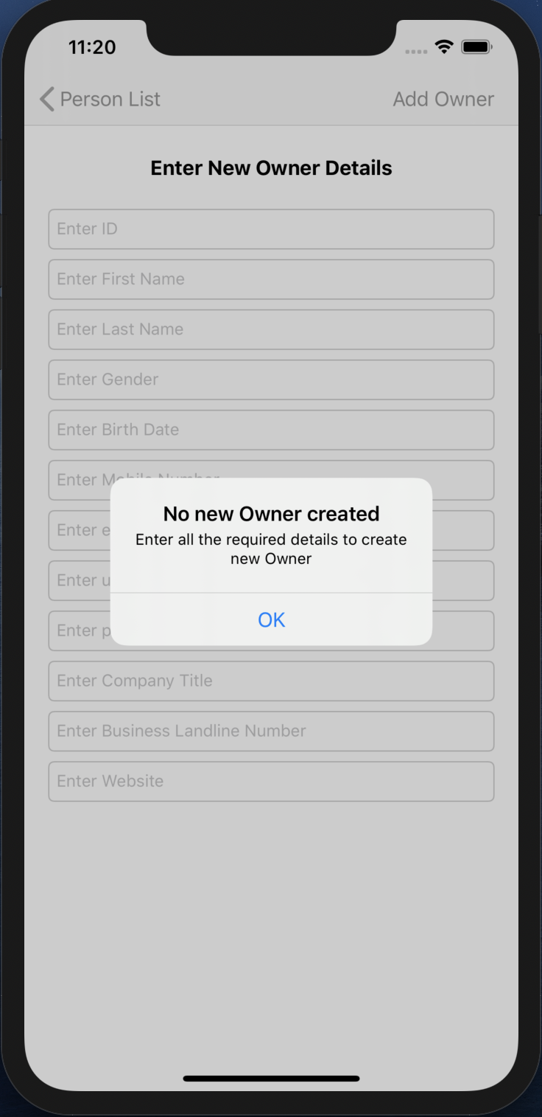

Fig 30. Alert

* When the Add Owner BAR BUTTON is pressed without entering any of the details, an ALERT pops up.
* This alert shows a message asking to fill the details that are required to create a new owner.

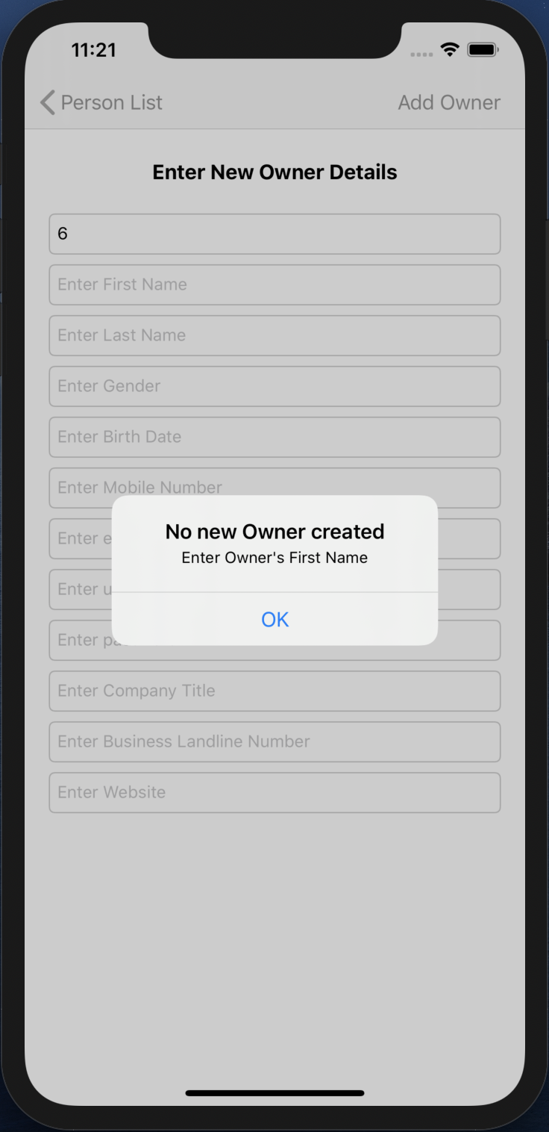

Fig 31. Alert

* An alert will pop up, when the Owner’s First Name is not filled.

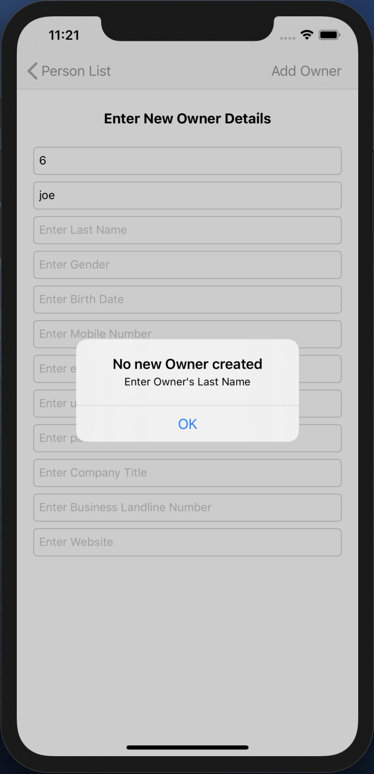

Fig 32. Alert

* An alert will pop up, when the Owner’s Last Name is not filled.

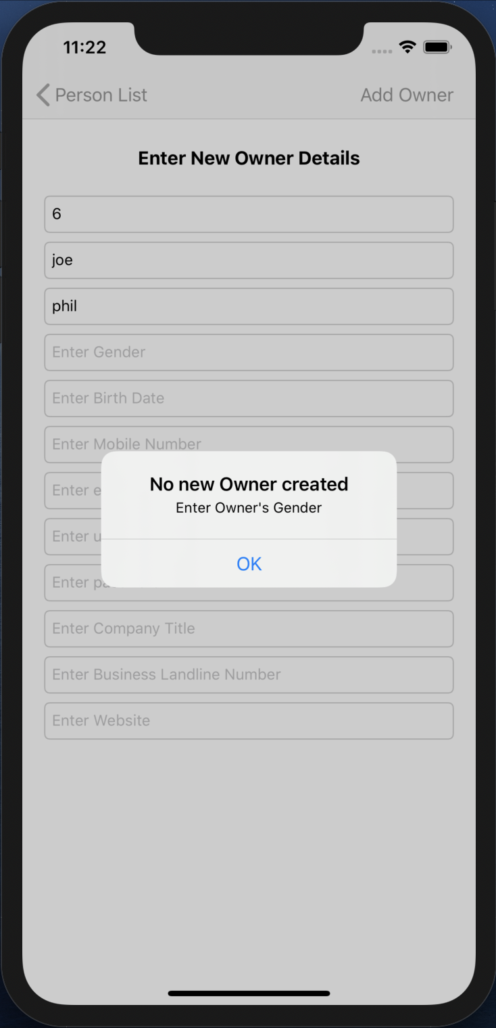

Fig 33. Alert

* An alert will pop up, when the Owner’s Gender is not filled.

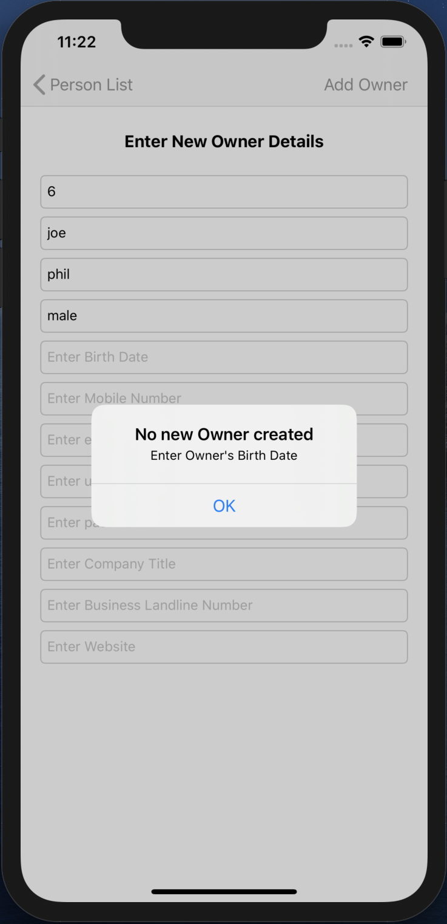

Fig 34. Alert

* An alert will pop up, when the Owner’s Birth Date is not filled.

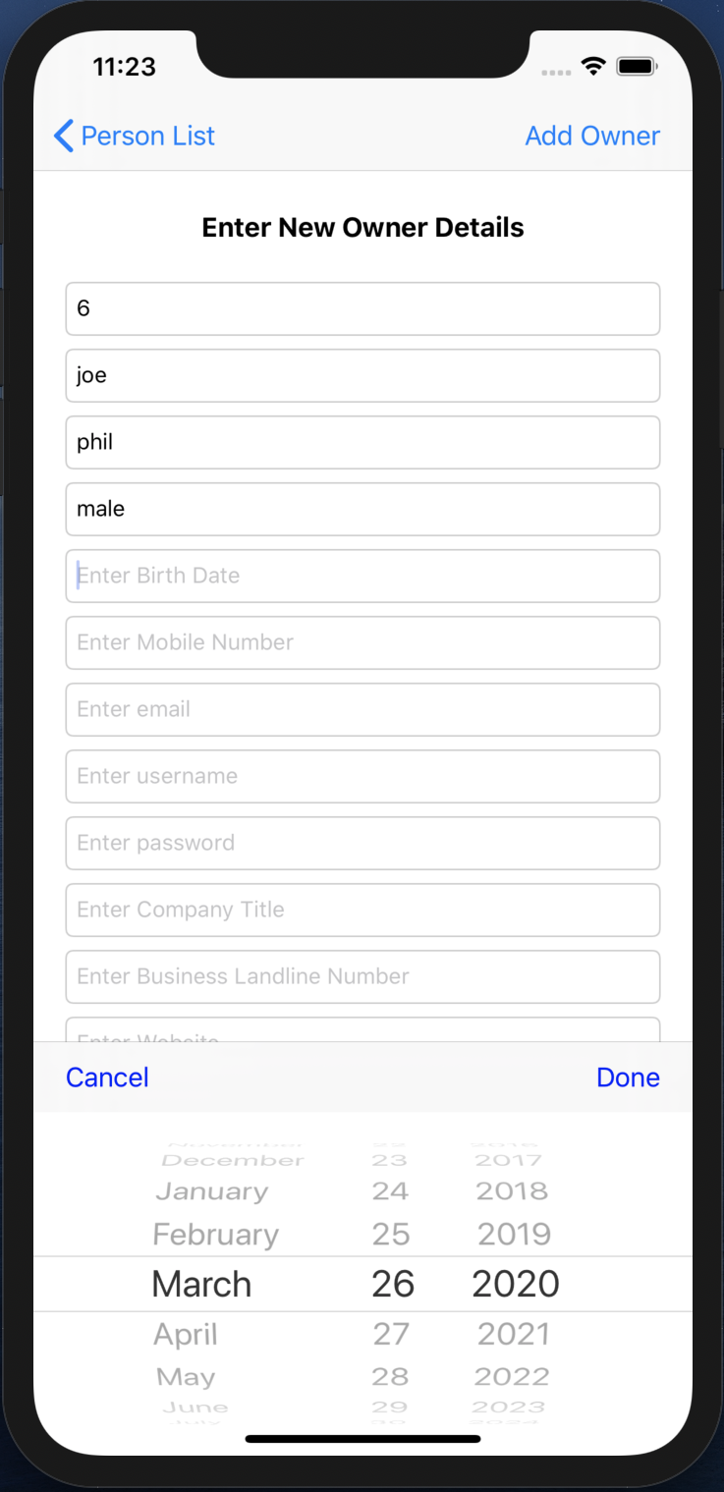

Fig 35. Date Picker

* When we click on the Birth Date TEXTFIELD, the DATE PICKER pops up to fill it.
* Date is selected and Done TOOLBAR BUTTON is pressed of the DATE PICKER, that date is filled in the Birth Date TEXTFIELD.

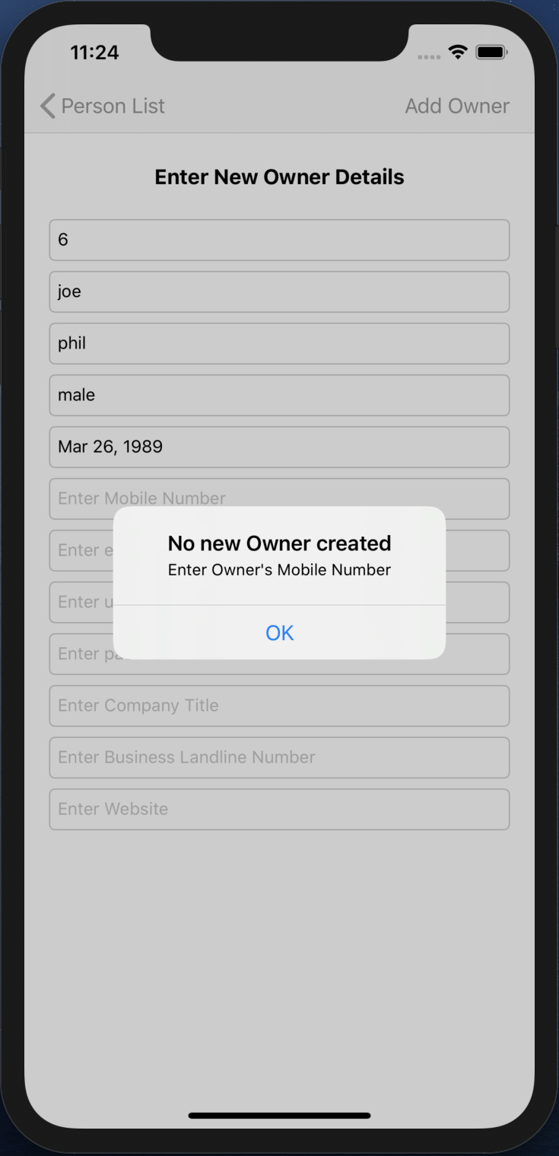

Fig 36. Alert

* An alert will pop up, when the Owner’s Mobile Number is not filled.

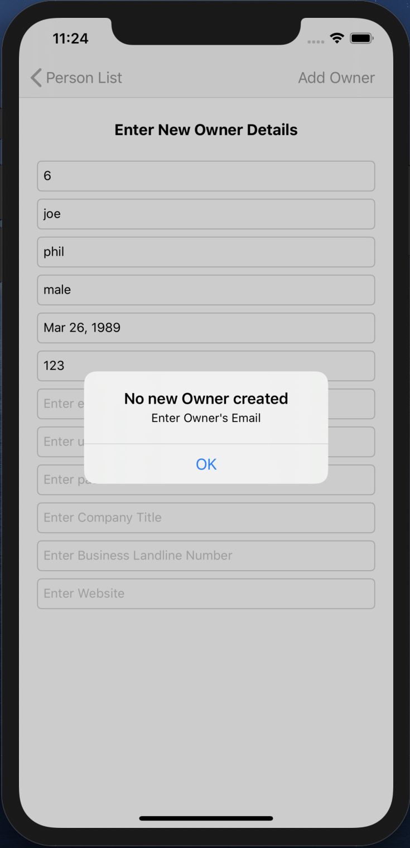

Fig 37. Alert

* An alert will pop up, when the Owner’s Email is not filled.

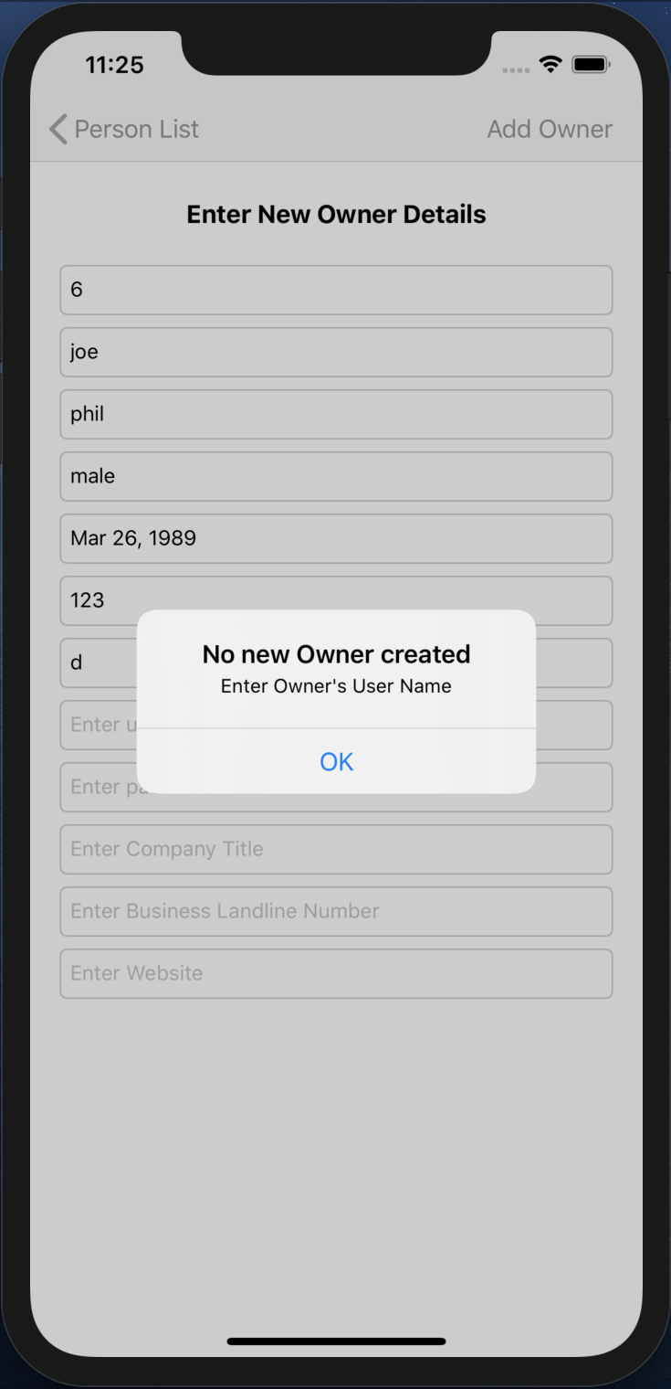

Fig 38. Alert

* An alert will pop up, when the Owner’s User Name is not filled.

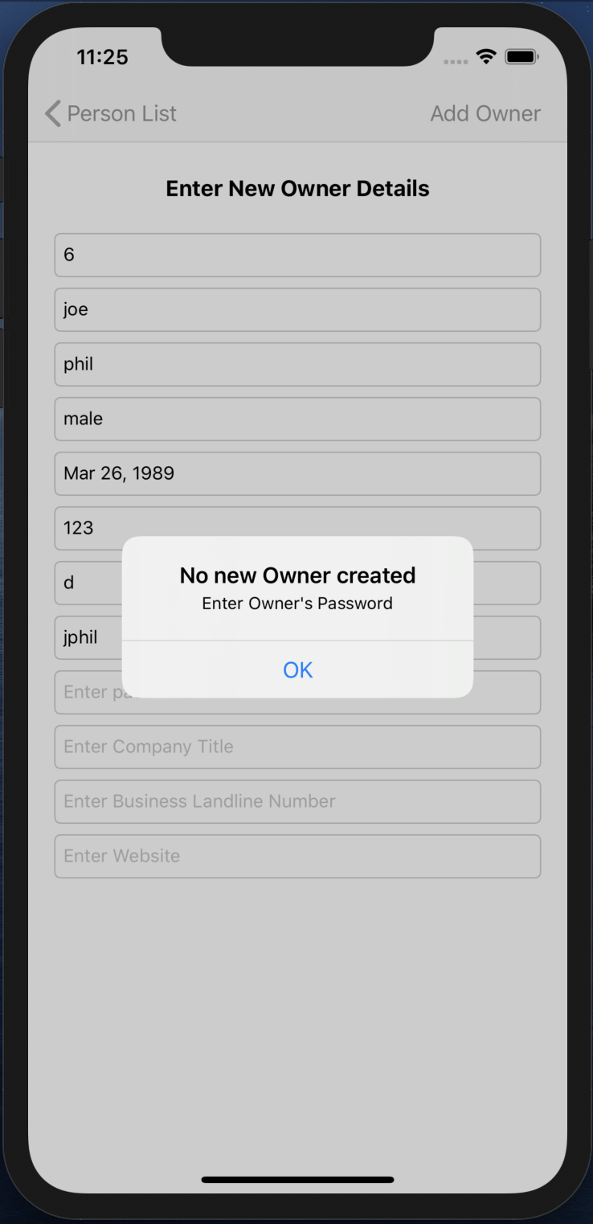

Fig 39. Alert

* An alert will pop up, when the Owner’s Password is not filled.

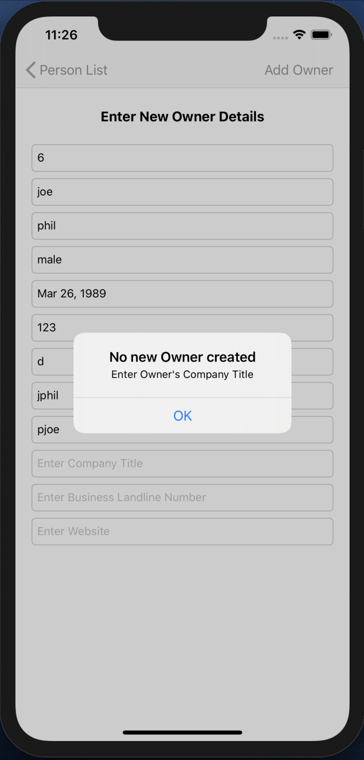

Fig 40. Alert

* An alert will pop up, when the Owner’s Company Title is not filled.

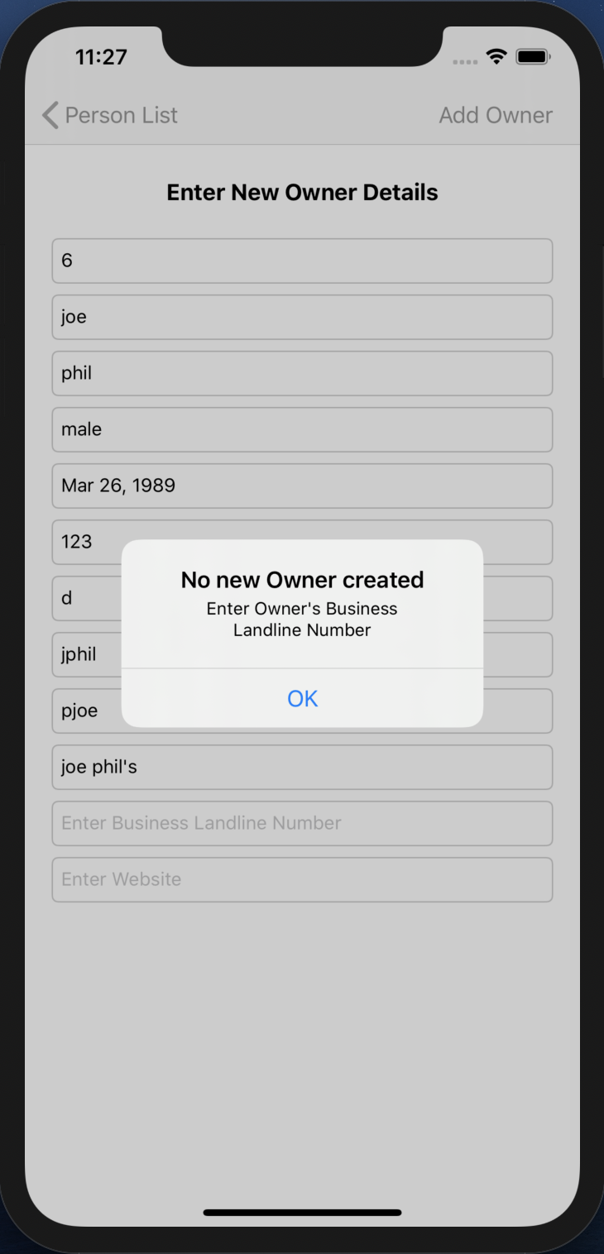

Fig 41. Alert

* An alert will pop up, when the Owner’s Business Landline Number is not filled.

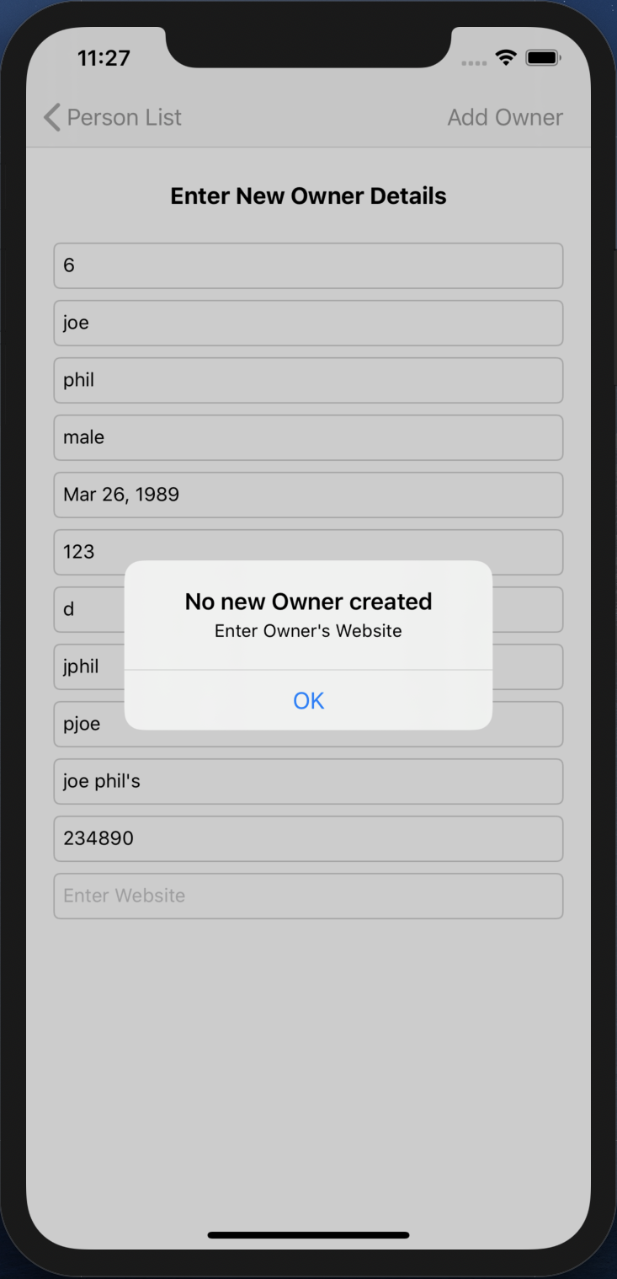

Fig 42. Alert

* An alert will pop up, when the Owner’s Website is not filled.

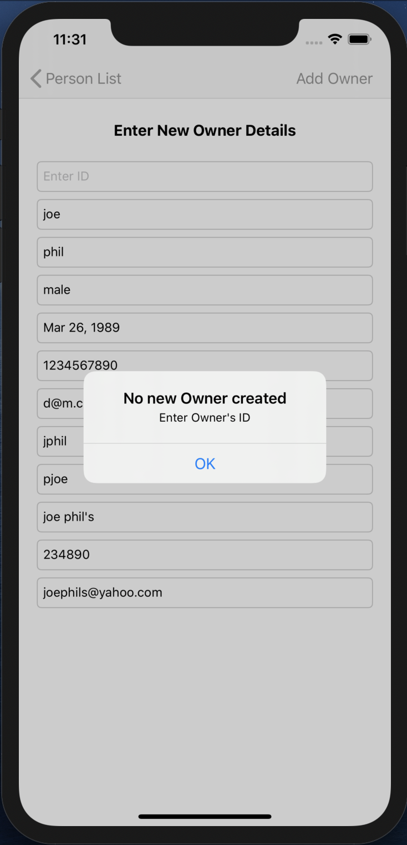

Fig 43. Alert

* An alert will pop up, when the Owner’s ID is not filled.

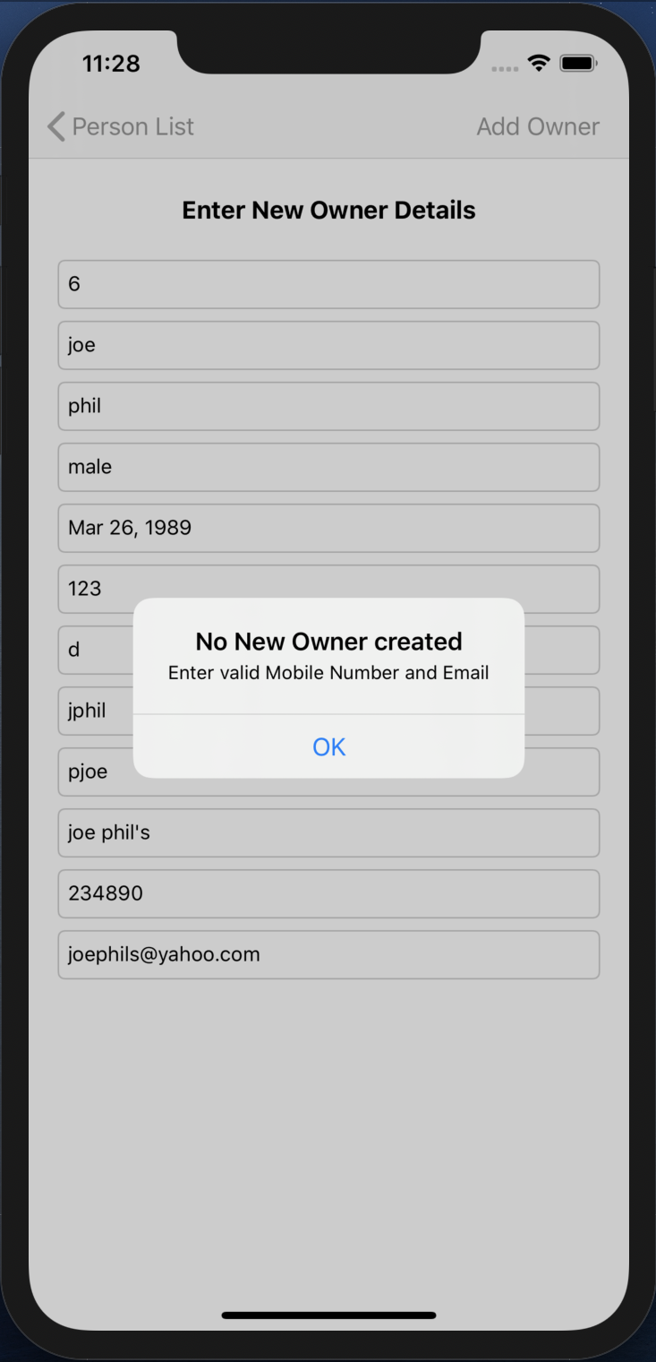

Fig 44. Alert

* An alert will pop up, when the Owner’s Valid email and mobile number are not filled.

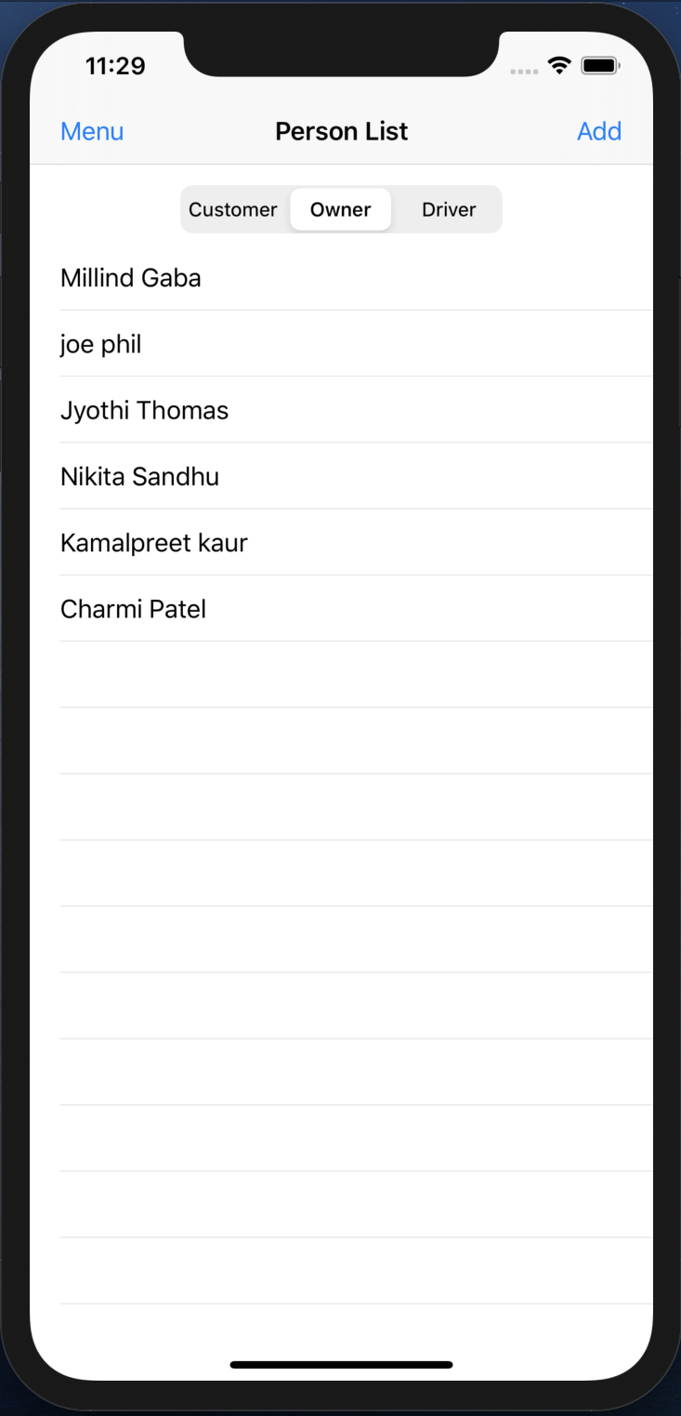

Fig 45. Updated Customer TABLE VIEW

* When all fields are filled and Add Owner BAR BUTTON field is pressed, the VIEW CONTROLLER pops.
* The Owner TABLE VIEW gets updated.

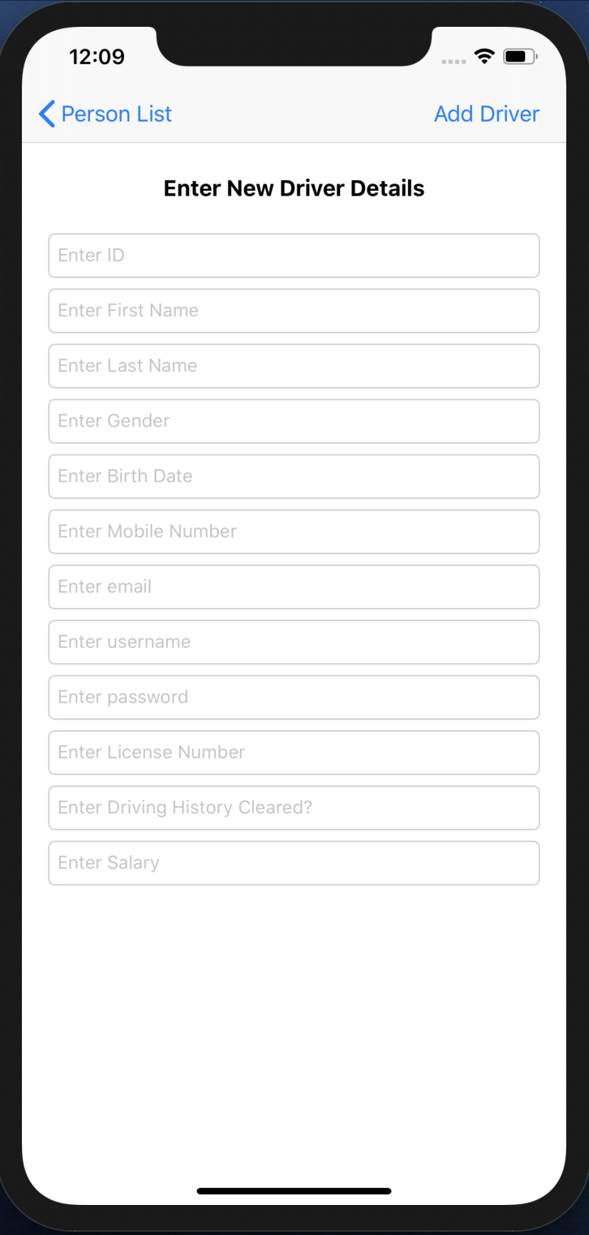

Fig 46. New Driver creation

* When segment three is selected and the Add BAR BUTTON is pressed a new VIEW CONTROLLER appears.
* This VIEW CONTROLLER contains TEXTFIELDs that shows the requirements that needs to be entered in order to create a new driver.
* When no new driver is needed to be created then the user can simple press the Person List back BAR BUTTON on the top left and go back to the previous screen.

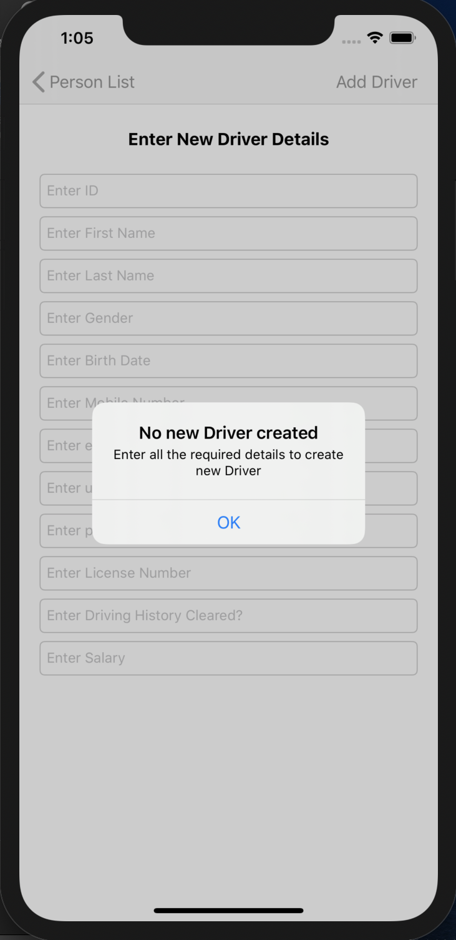

Fig 47. Alert

* When the Add Driver BAR BUTTON is pressed without entering any of the details, an ALERT pops up.
* This alert shows a message asking to fill the details that are required to create a new driver.

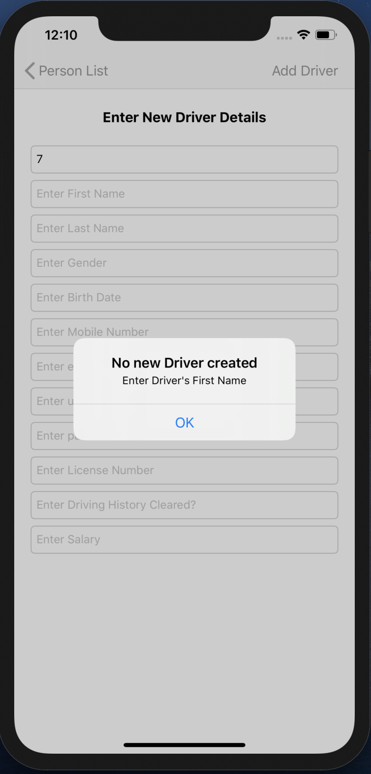

Fig 48. Alert

* An alert will pop up, when the Driver’s First Name is not filled.

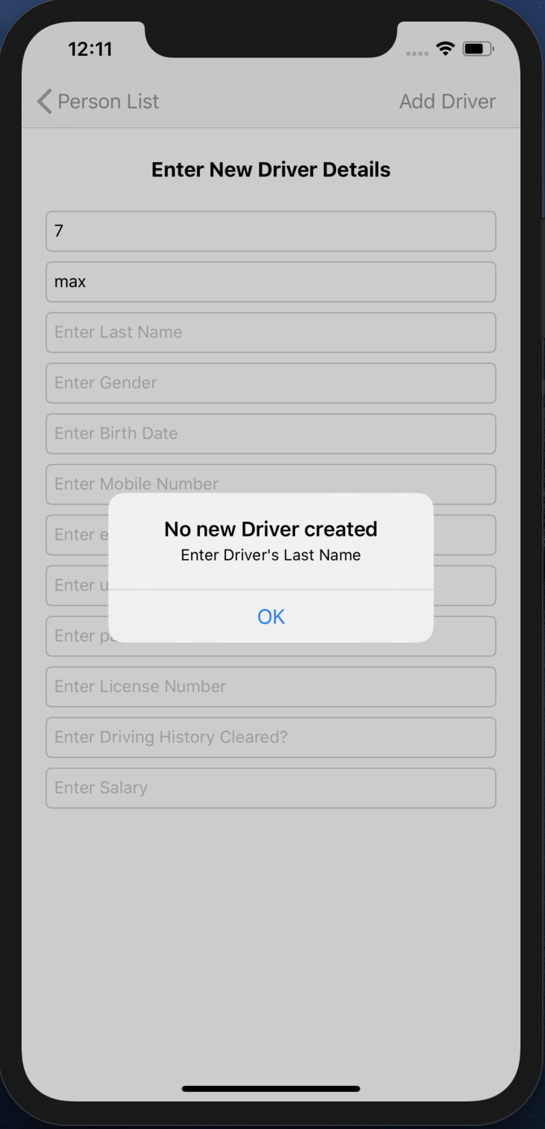

Fig 49. Alert

* An alert will pop up, when the Driver’s Last Name is not filled.

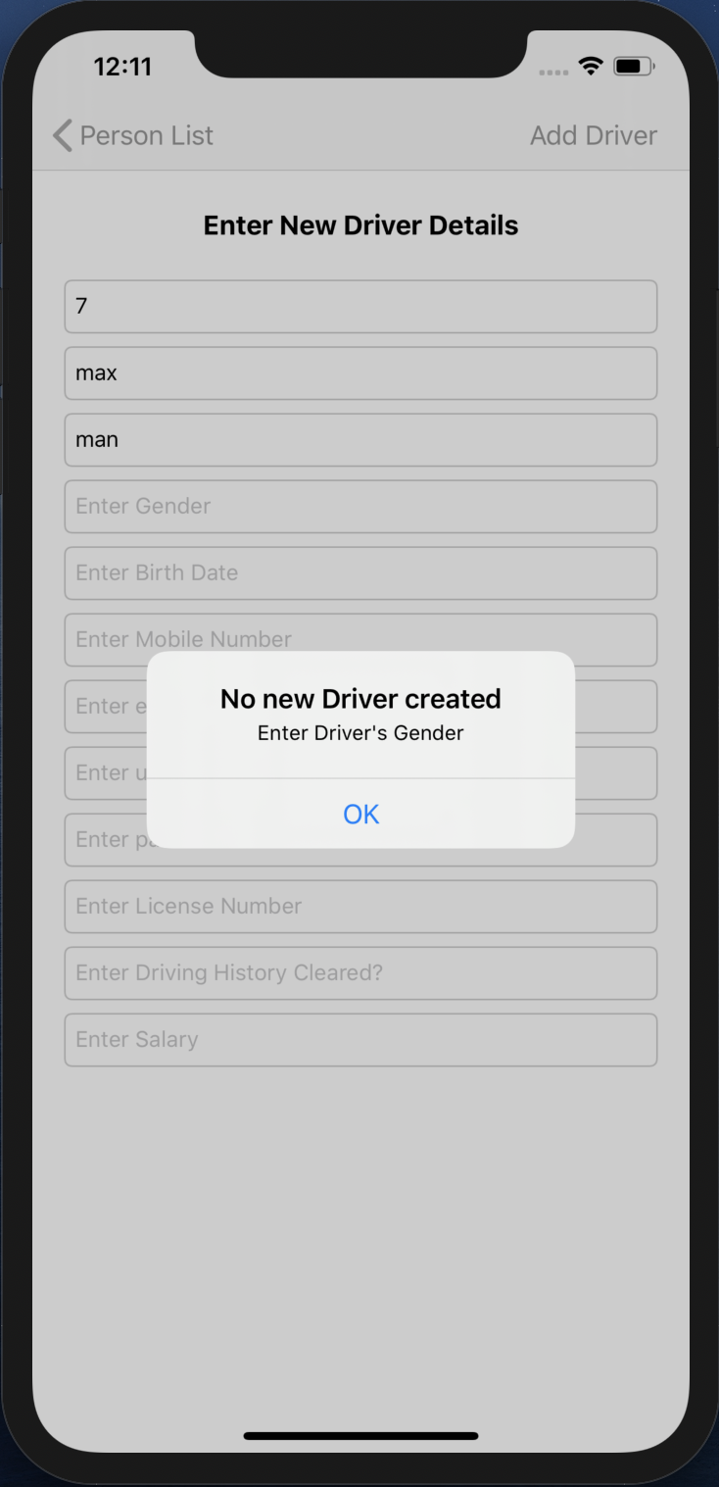

Fig 50. Alert

* An alert will pop up, when the Driver’s Gender is not filled.

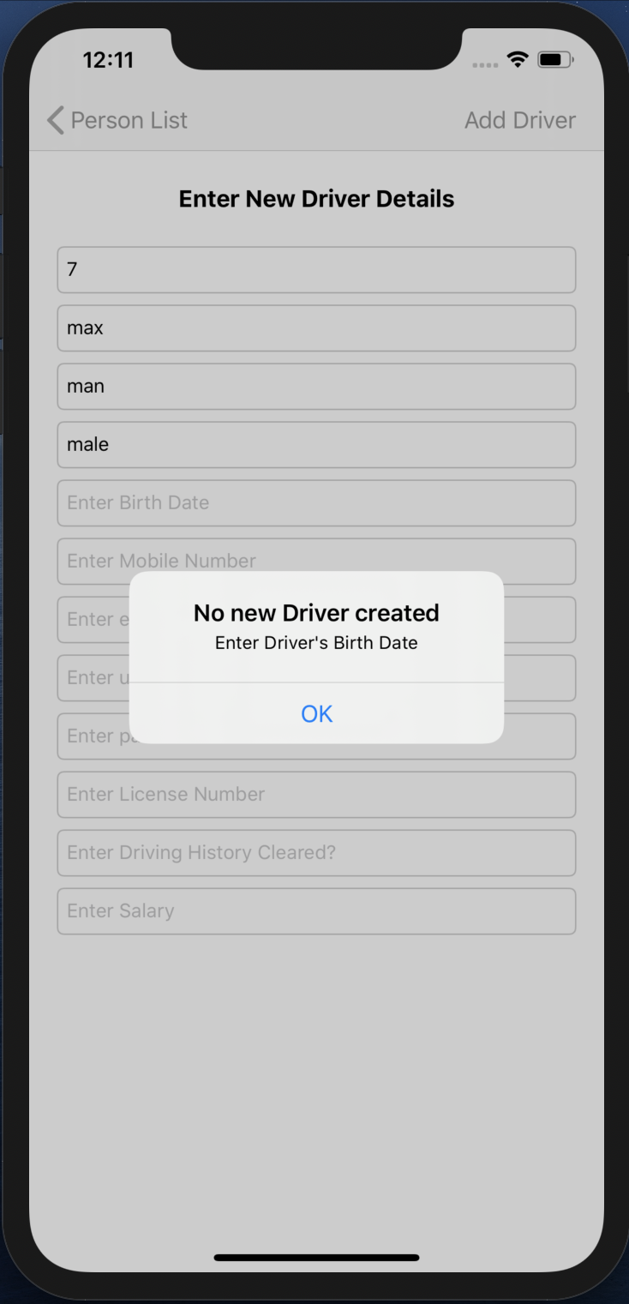

Fig 51. Alert

* An alert will pop up, when the Driver’s Birth Date is not filled.

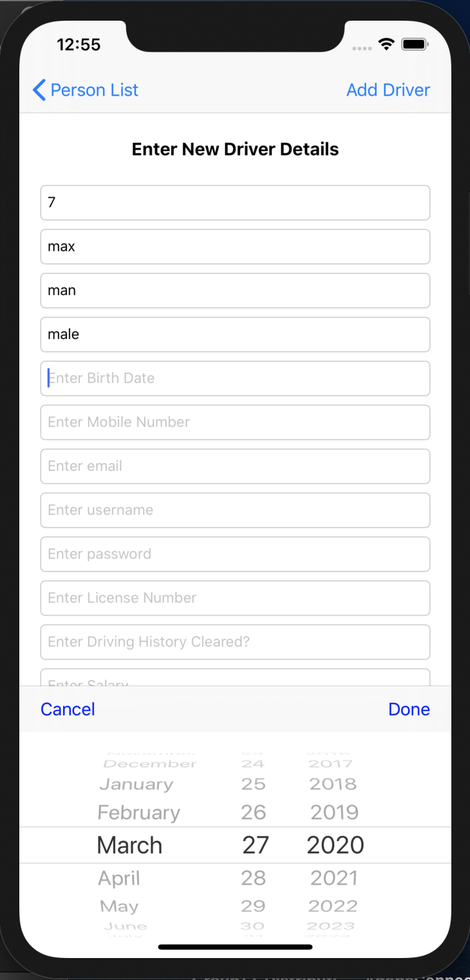

Fig 52. Date Picker

* When we click on the Birth Date TEXTFIELD, the DATE PICKER pops up to fill it.
* Date is selected and Done TOOLBAR BUTTON is pressed of the DATE PICKER, that date is filled in the Birth Date TEXTFIELD.

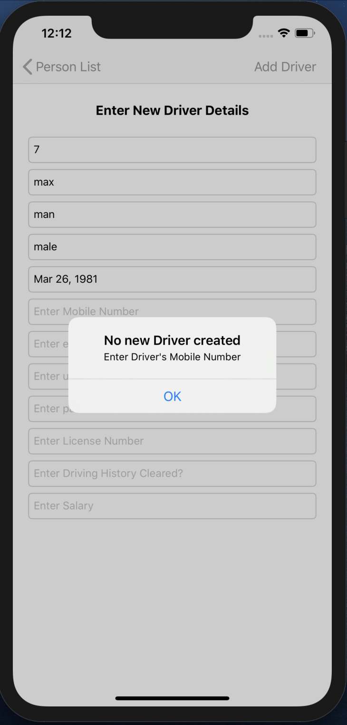

Fig 53. Alert

* An alert will pop up, when the Driver’s Mobile Number is not filled.

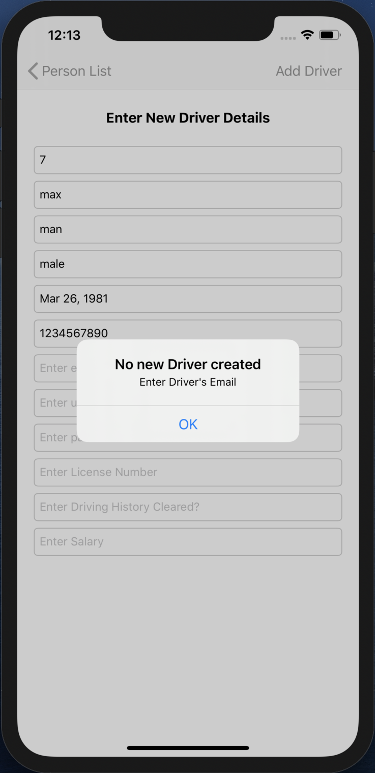

Fig 54. Alert

* An alert will pop up, when the Driver’s Email is not filled.

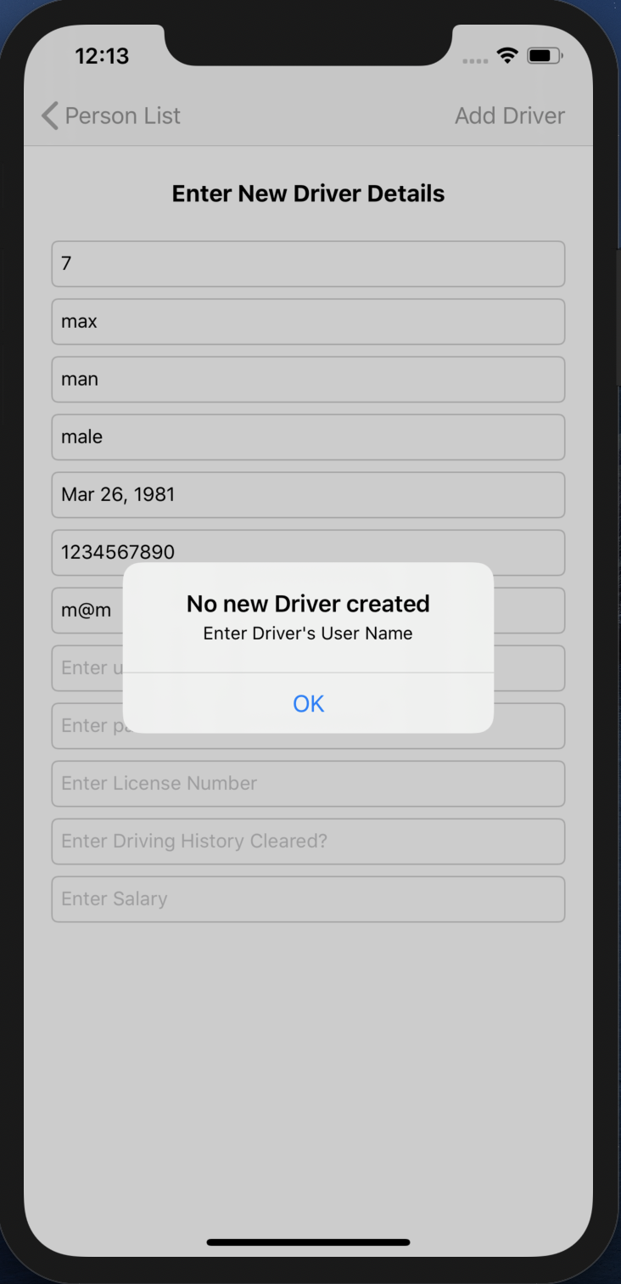

Fig 55. Alert

* An alert will pop up, when the Driver’s User Name is not filled.

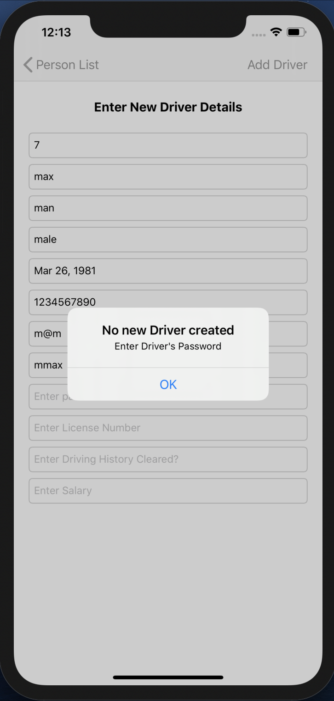

Fig 56. Alert

* An alert will pop up, when the Driver’s Password is not filled.

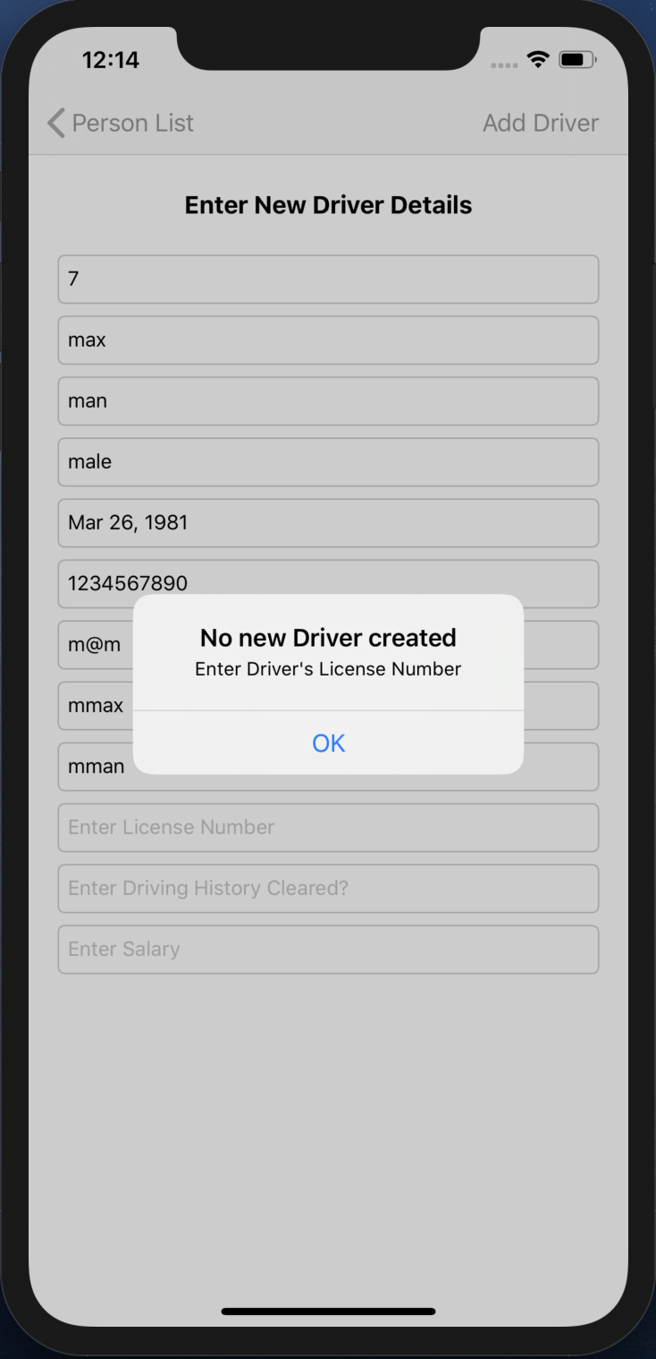

Fig 57. Alert

* An alert will pop up, when the Driver’s License Number is not filled.

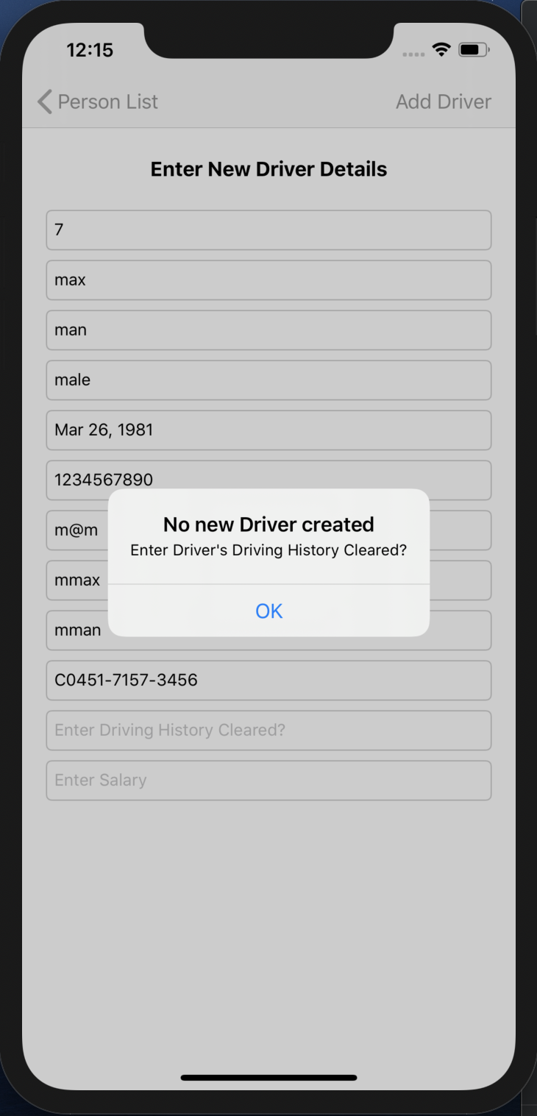

Fig 58. Alert

* An alert will pop up, when the Driver’s Driving History Cleared? is not filled.

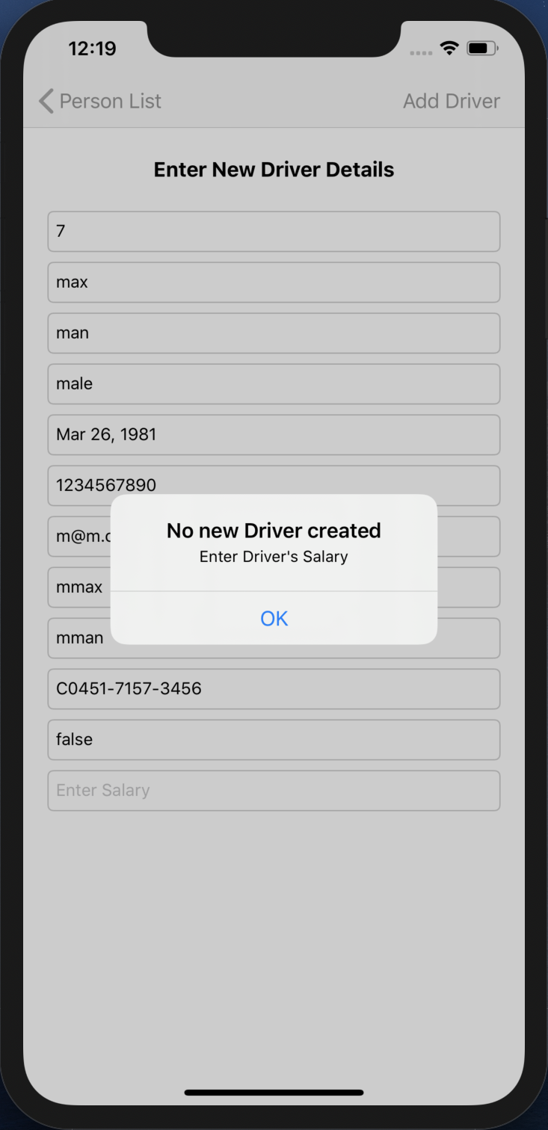

Fig 59. Alert

* An alert will pop up, when the Driver’s Salary is not filled.

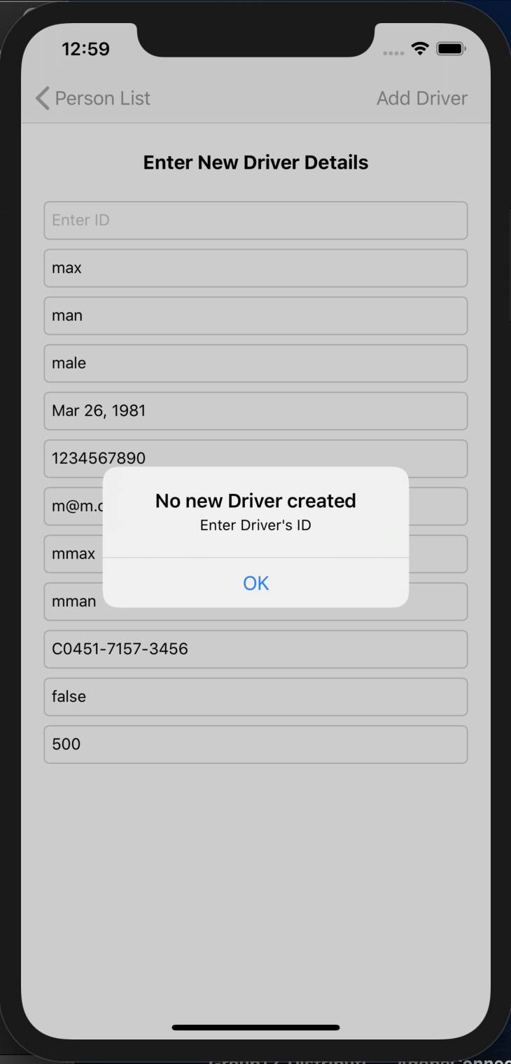

Fig 60. Alert

* An alert will pop up, when the Driver’s ID is not filled.

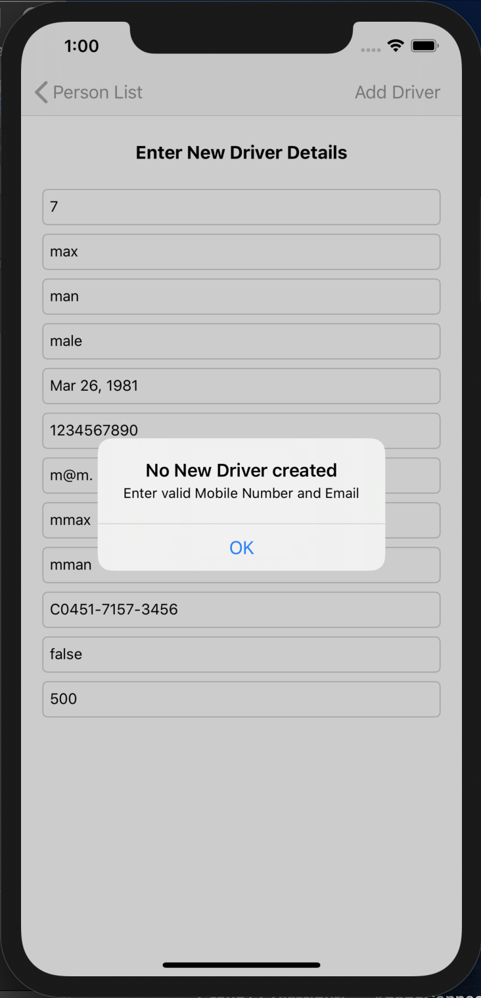

Fig 61. Alert

* An alert will pop up, when the Driver’s Valid email and mobile number are not filled.

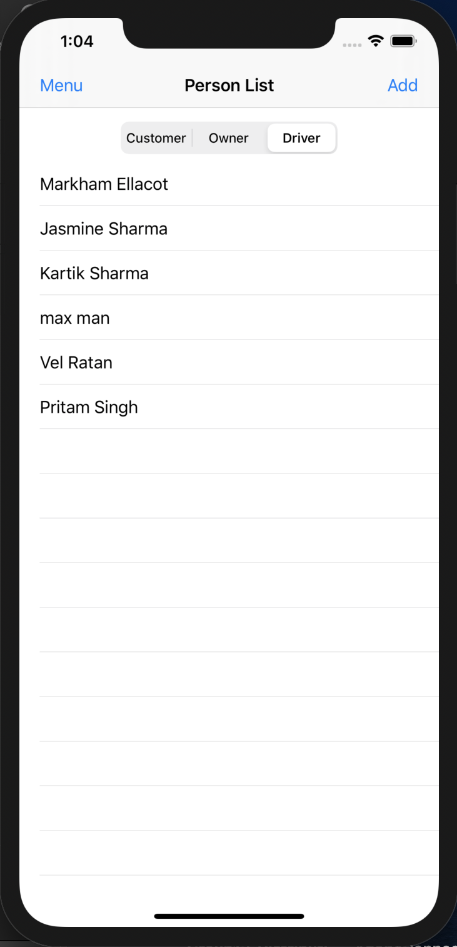

Fig 62. Updated Driver TABLE VIEW

* When all fields are filled and Add Driver BAR BUTTON field is pressed, the VIEW CONTROLLER pops.
* The Driver TABLE VIEW gets updated.

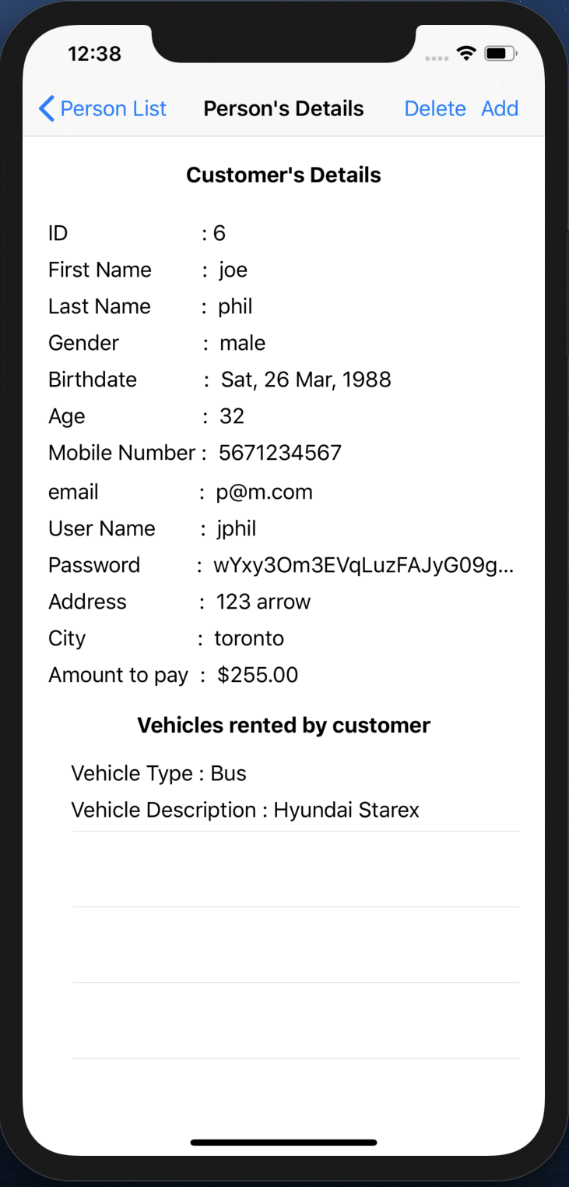

Fig 63. Customer’s Details

* When you click on a customer its details will be available.
* Vehicle rented by customer can be seen in the Vehicles rented by customer TABLE VIEW.
* When you click on Delete BAR BUTTON, this customer will get deleted and the customer TABLE VIEW of the previous screen will get updated.

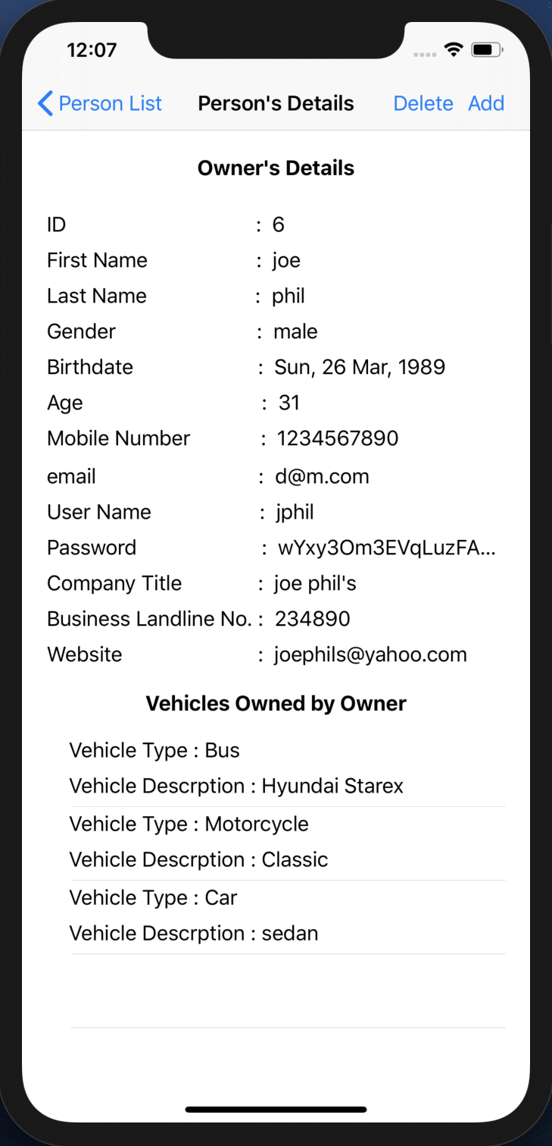

Fig 64. Owner’s Details

* When you click on an owner its details will be available.
* Vehicle owned by owner can be seen in the Vehicles Owned by customer TABLE VIEW.
* When you click on Delete BAR BUTTON, this owner will get deleted and the owner TABLE VIEW of the previous screen will get updated.

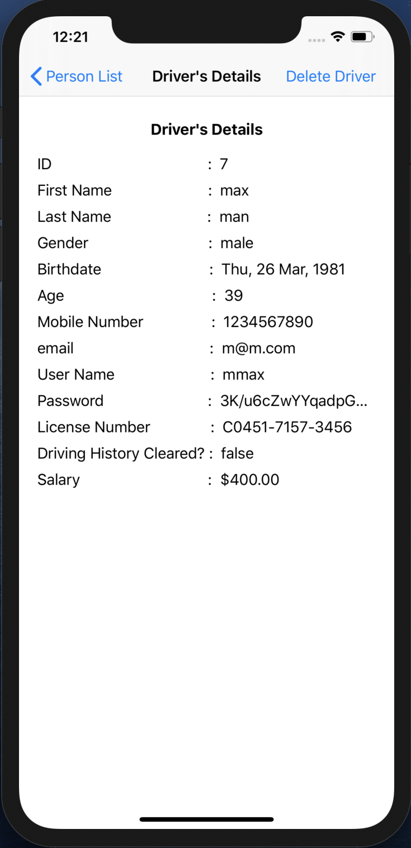

Fig 65. Driver’s Details

* When you click on a driver its details will be available.
* When you click on Delete Driver BAR BUTTON, this driver will get deleted and the driver TABLE VIEW of the previous screen will get updated.

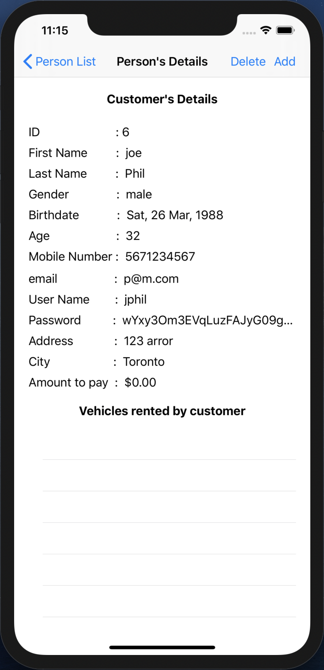

Fig 66. Customer with no vehicle rent

* This customer has not rented any vehicle, so his vehicles rented by customer TABLE VIEW is empty and the Amount to pay says $0.00
* When you click on Add BAR BUTTON, a new VIEW CONTROLLER WILL appear and ask you to enter new vehicle rent details.

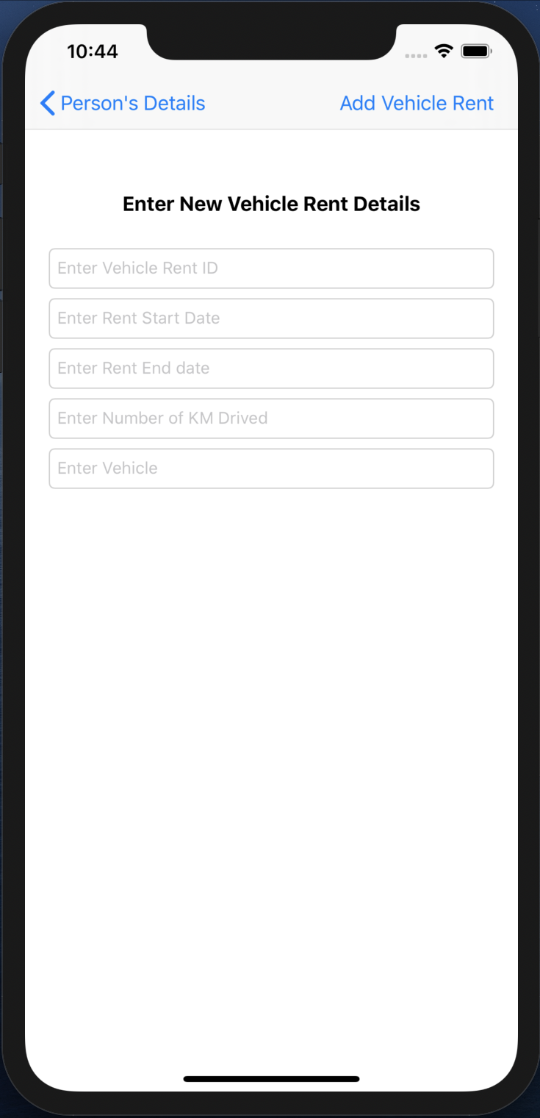

Fig 67. New Vehicle Rent creation

* This VIEW CONTROLLER contains TEXTFIELDs that shows the requirements that needs to be entered in order to create a new vehicle rent.
* When no new vehicle rent is needed to be created then the user can simple press the Person’s Details back BAR BUTTON on the top left and go back to the previous screen.

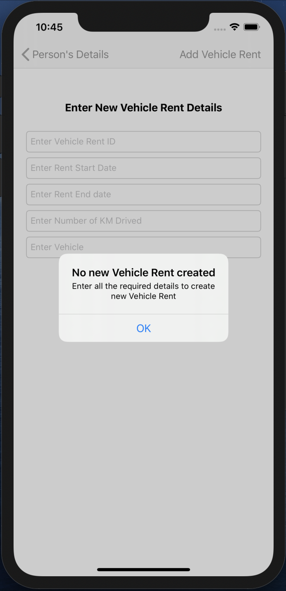

Fig 68. Alert

* When the Add Vehicle Rent BAR BUTTON is pressed without entering any of the details, an ALERT pops up.
* This alert shows a message asking to fill the details that are required to create a new vehicle rent.

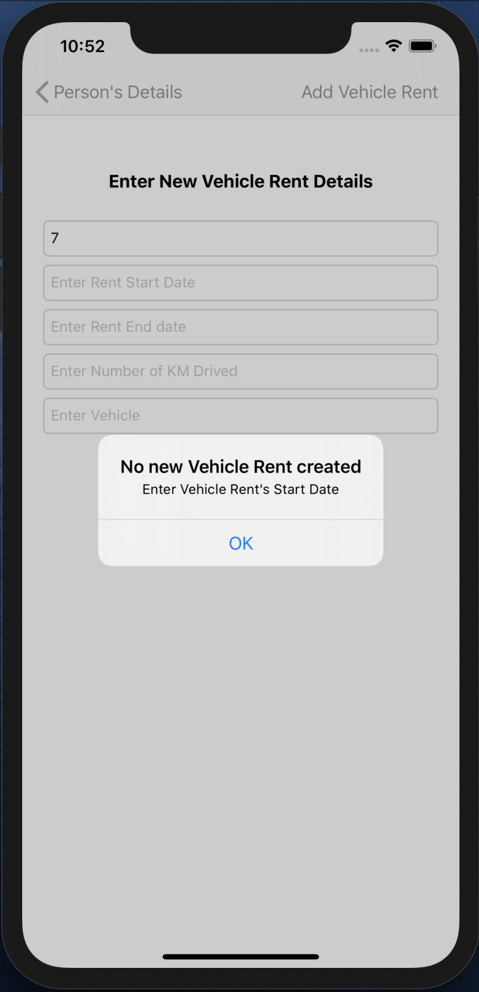

Fig 69. Alert

* An alert will pop up, when the Vehicle Rent’s Start Date is not filled.

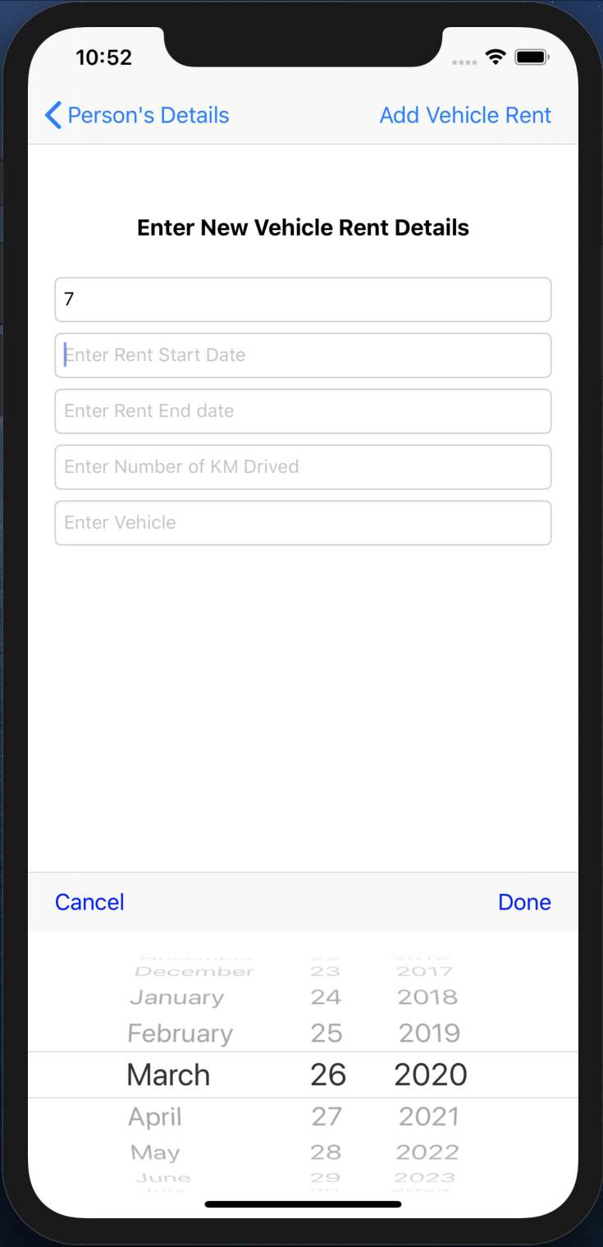

Fig 70. Date Picker

* When we click on the Rent Start Date TEXTFIELD, the DATE PICKER pops up to fill it.
* Date is selected and Done TOOLBAR BUTTON is pressed of the DATE PICKER, that date is filled in the Rent Start Date TEXTFIELD.

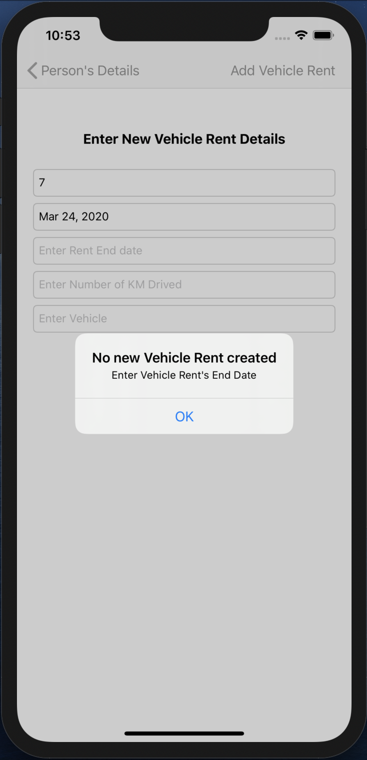

Fig 71. Alert

* An alert will pop up, when the Vehicle Rent’s End Date is not filled.

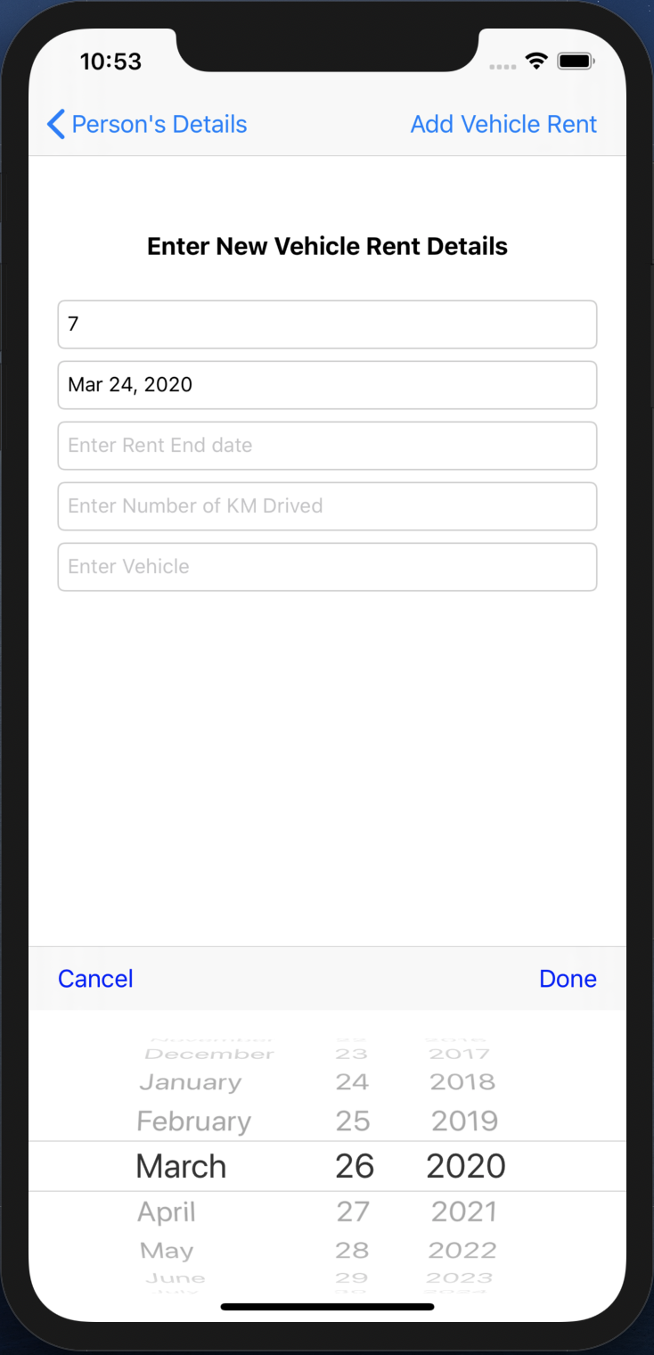

Fig 72. Date Picker

* When we click on the Rent End Date TEXTFIELD, the DATE PICKER pops up to fill it.
* Date is selected and Done TOOLBAR BUTTON is pressed of the DATE PICKER, that date is filled in the Rent End Date TEXTFIELD.

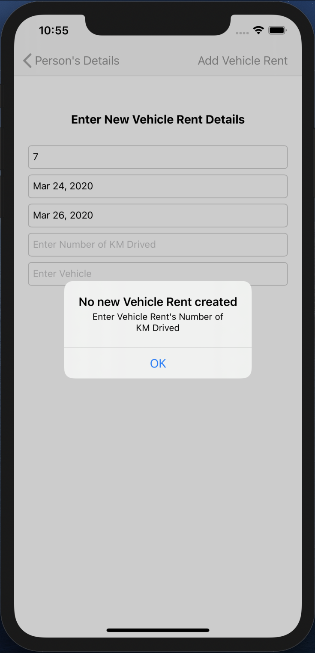

Fig 73. Alert

* An alert will pop up, when the Vehicle Rent’s Number of KM Drived is not filled.

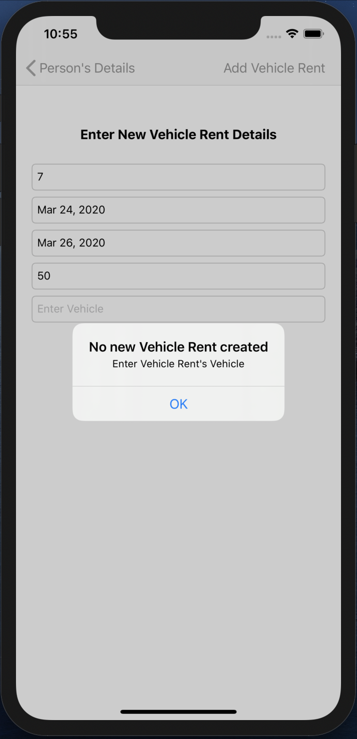

Fig 74. Alert

* An alert will pop up, when the Vehicle Rent’s Vehicle is not filled.

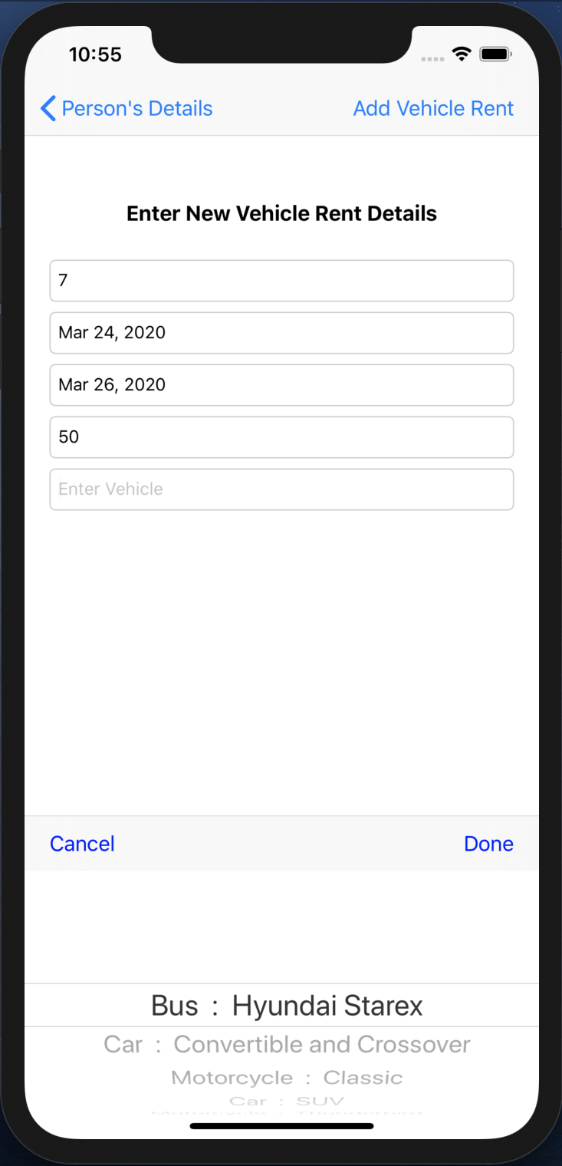

Fig 75. Picker View

* When we click on the Vehicle TEXTFIELD, the PICKER VIEW pops up to fill it. It contains Vehicle objects.
* Vehicle object is selected and Done TOOLBAR BUTTON is pressed of the PICKER VIEW, that vehicle is filled in the Vehicle TEXTFIELD.

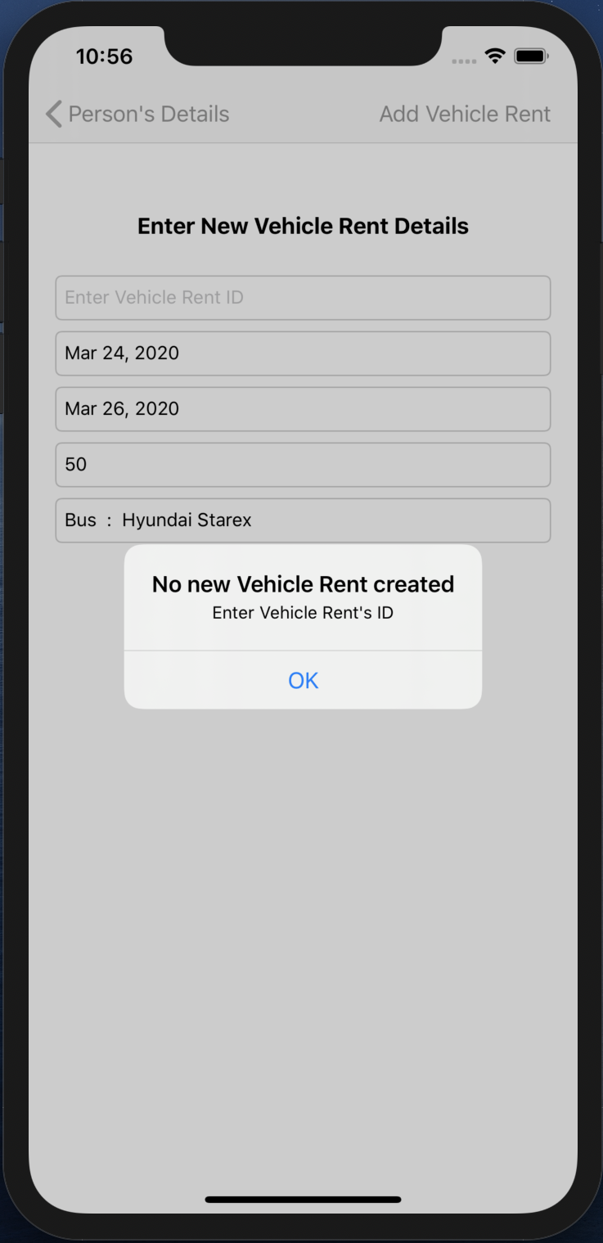

Fig 76. Alert

* An alert will pop up, when the Vehicle Rent’s ID is not filled.



Fig 77. Updated Customer’s Vehicles rent list

* When all fields are filled and Add Vehicle BAR BUTTON field is pressed, the VIEW CONTROLLER pops.
* The Customer’s Vehicles rented by customer TABLE VIEW gets updated as well as the Amount to pay is also updated.

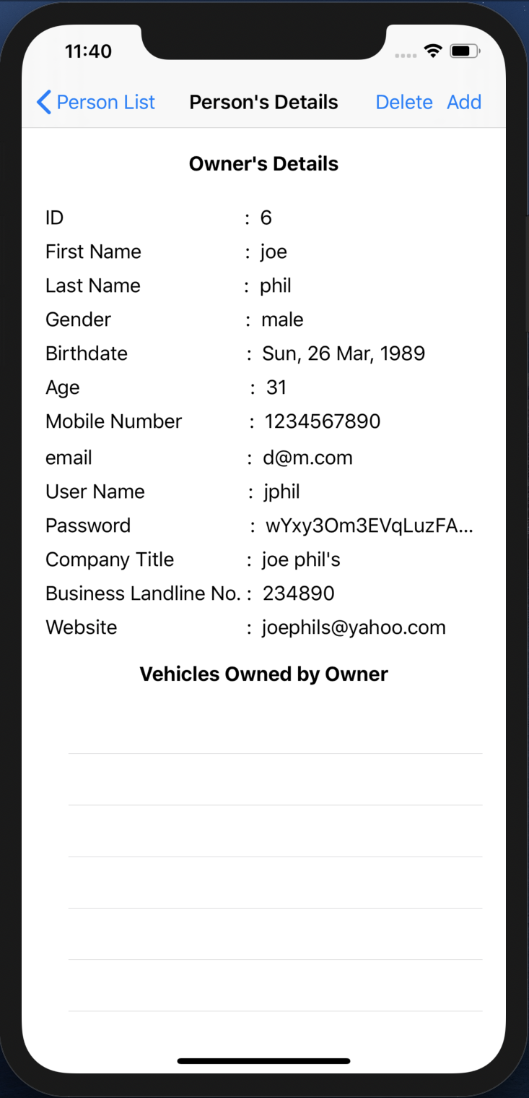

Fig 78. Customer with no vehicle owned

* This owner doesn’t own any vehicle, so his vehicles owned by owner TABLE VIEW is empty.

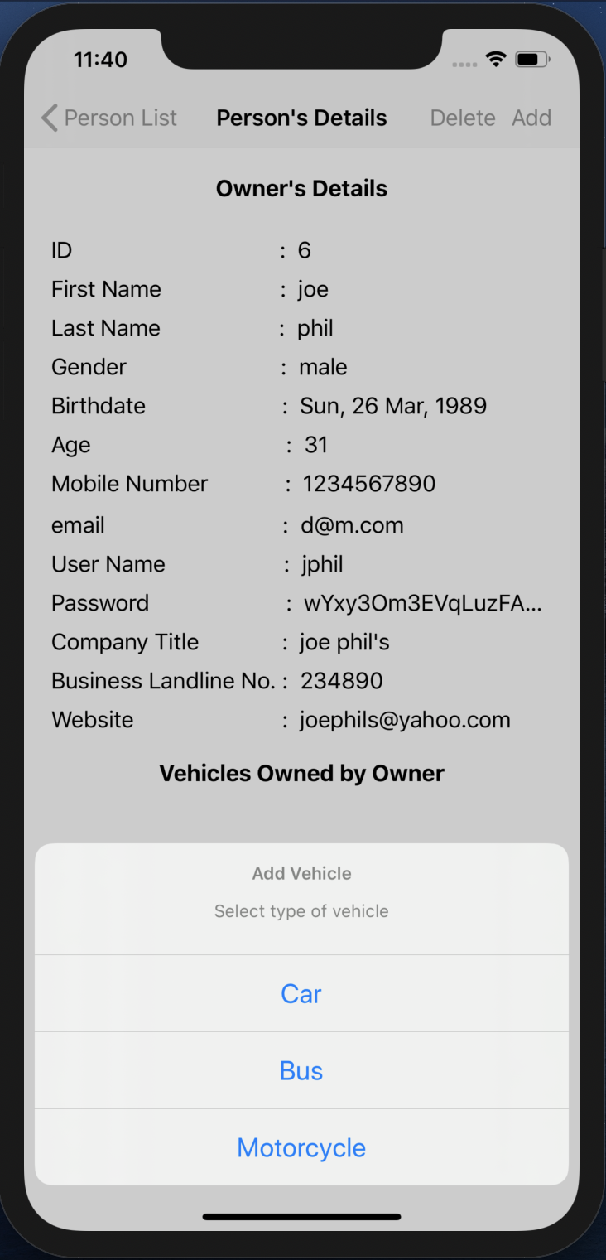

Fig 79. ALERT ACTION

* When the Add BAR BUTTON is pressed, ALERT ACTION pops up on screen with multiple options.

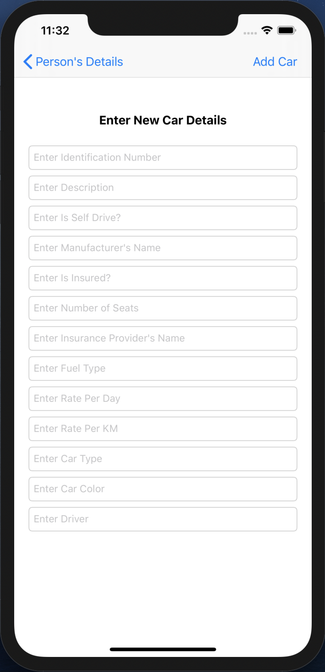

Fig 80. New Car creation

* This VIEW CONTROLLER contains TEXTFIELDs that shows the requirements that needs to be entered in order to create a new car.
* When no new car is needed to be created then the user can simple press the Person’s Details back BAR BUTTON on the top left and go back to the previous screen.

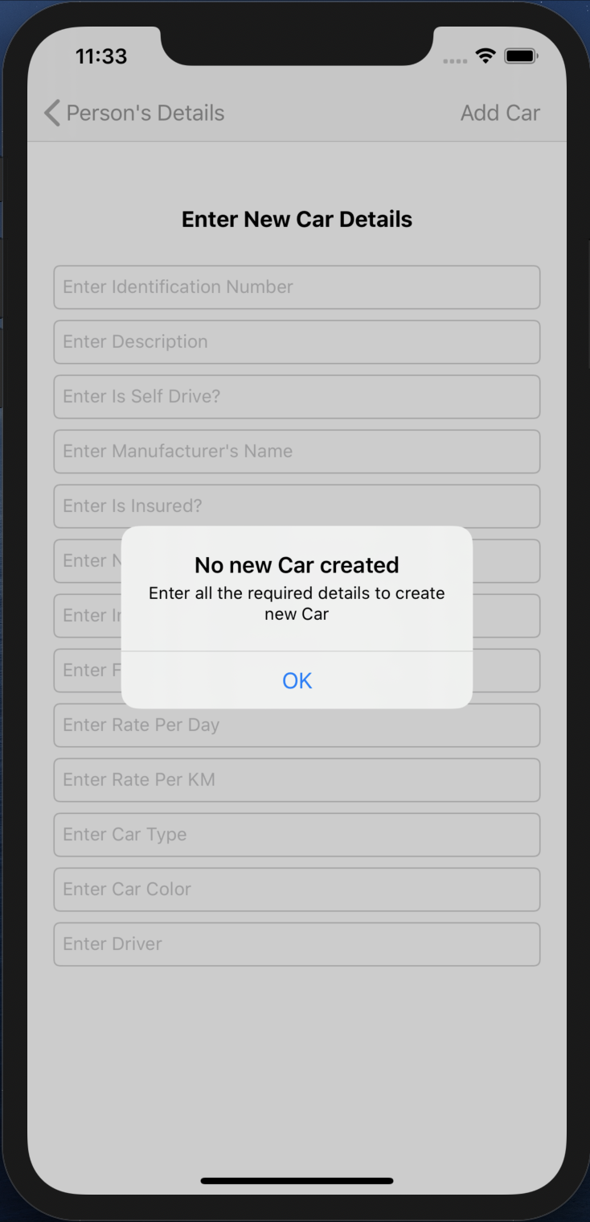

Fig 81. Alert

* When the Add Car BAR BUTTON is pressed without entering any of the details, an ALERT pops up.
* This alert shows a message asking to fill the details that are required to create a new car.

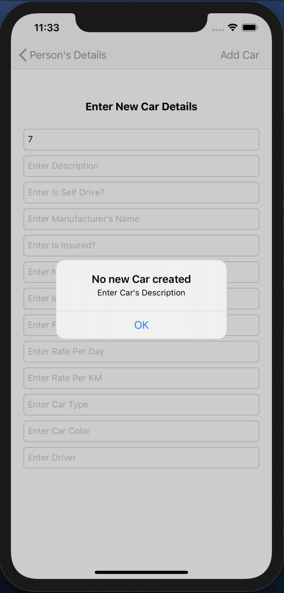

Fig 82. Alert

* An alert will pop up, when the Car’s Description is not filled.

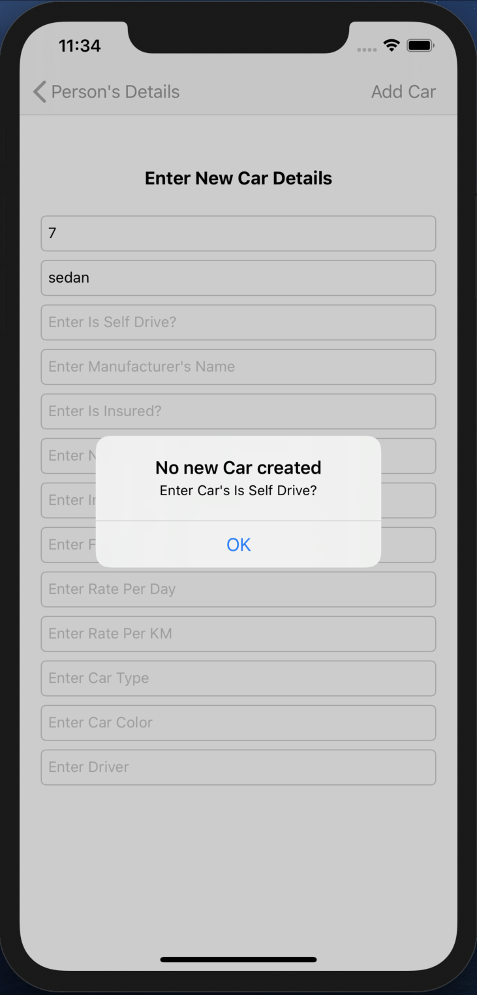

Fig 83. Alert

* An alert will pop up, when the Car’s Is Self Drive? is not filled.

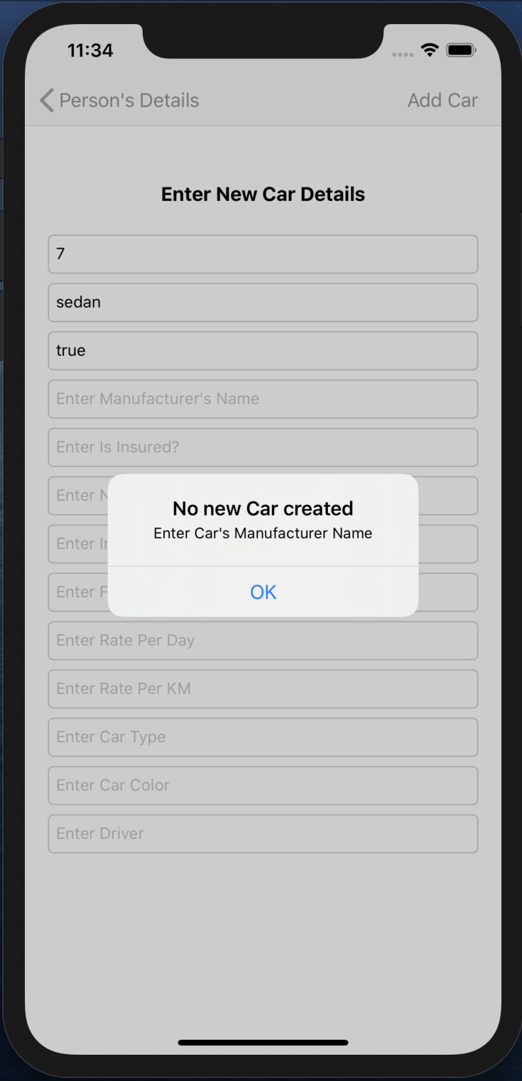

Fig 84. Alert

* An alert will pop up, when the Car’s Manufacturer Name is not filled.

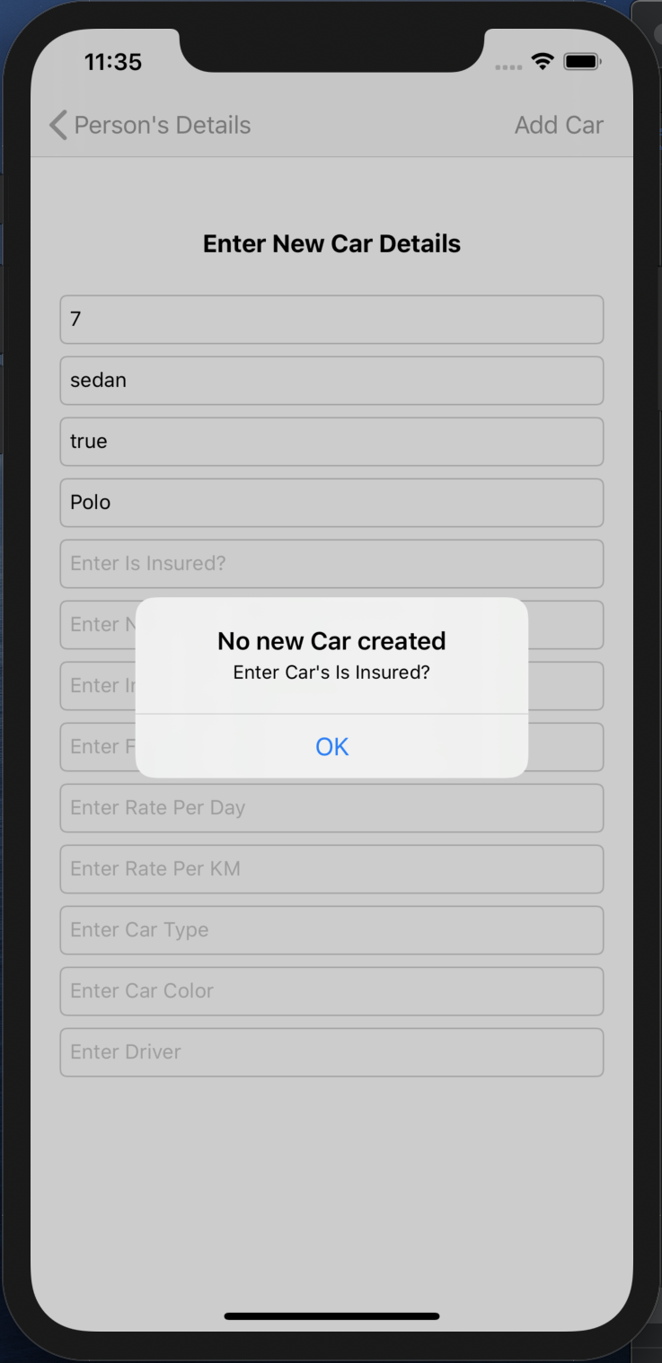

Fig 85. Alert

* An alert will pop up, when the Car’s Is Insured? is not filled.

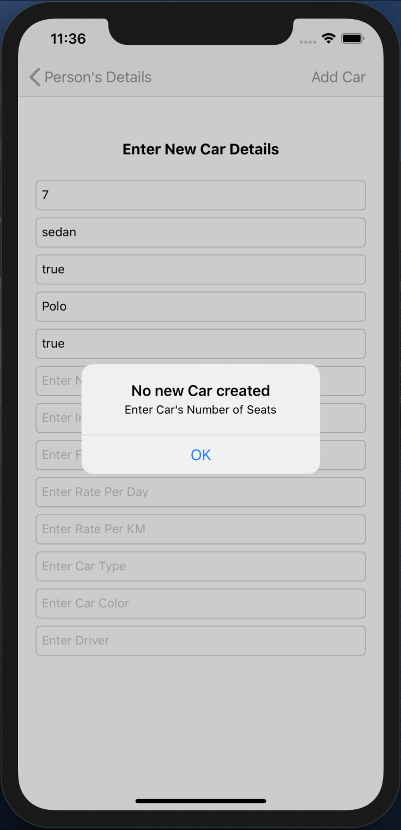

Fig 86. Alert

* An alert will pop up, when the Car’s Number of seats is not filled.

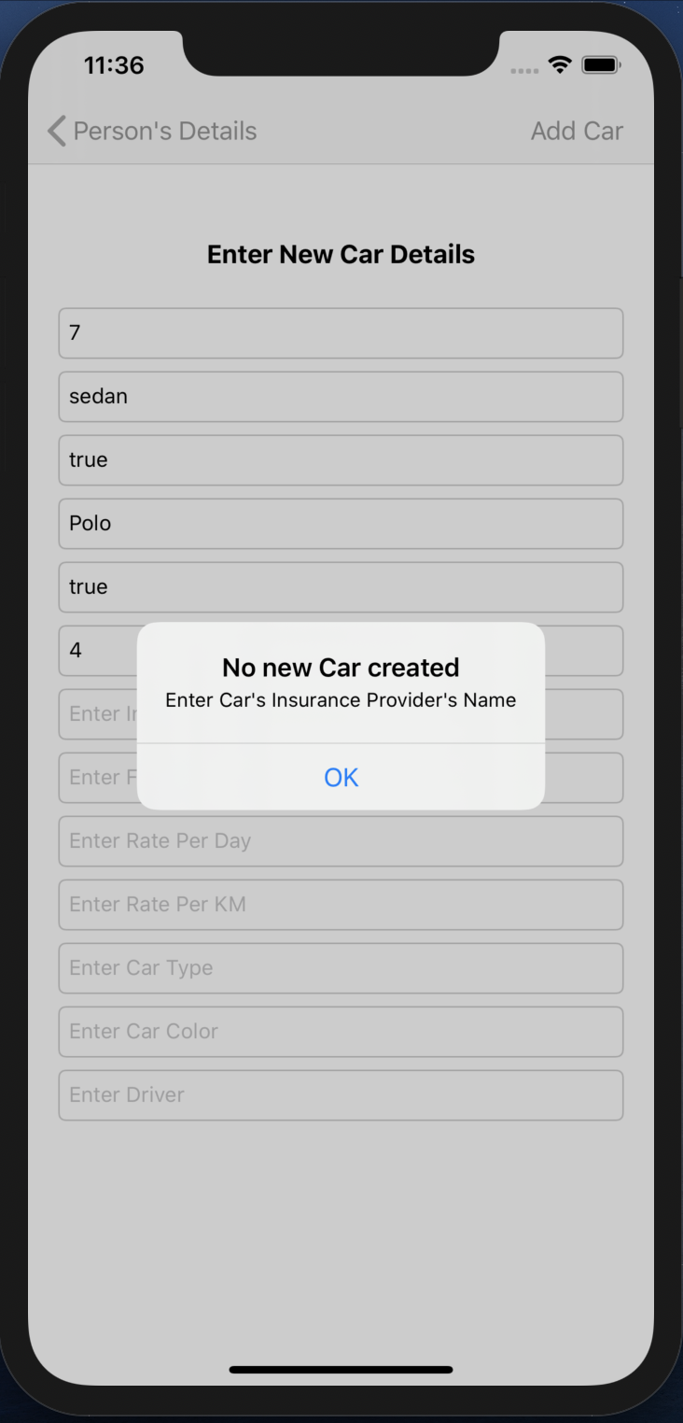

Fig 87. Alert

* An alert will pop up, when the Car’s Insurance Provider’s Name is not filled.

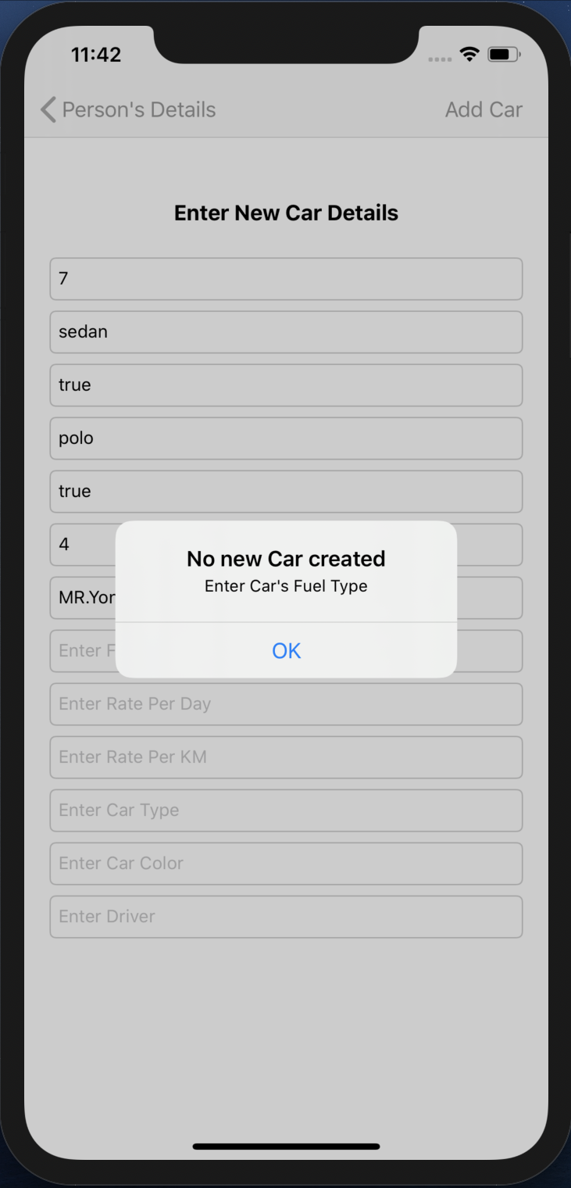

Fig 88. Alert

* An alert will pop up, when the Car’s Fuel Type is not filled.

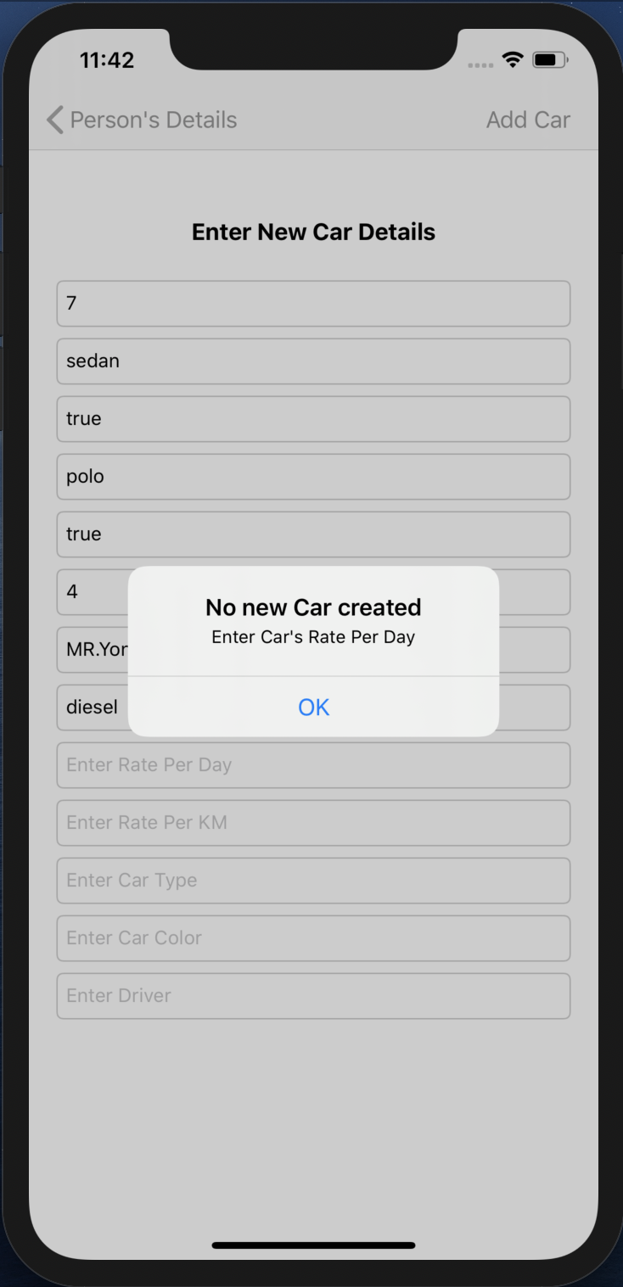

Fig 89. Alert

* An alert will pop up, when the Car’s Rate Per Day is not filled.

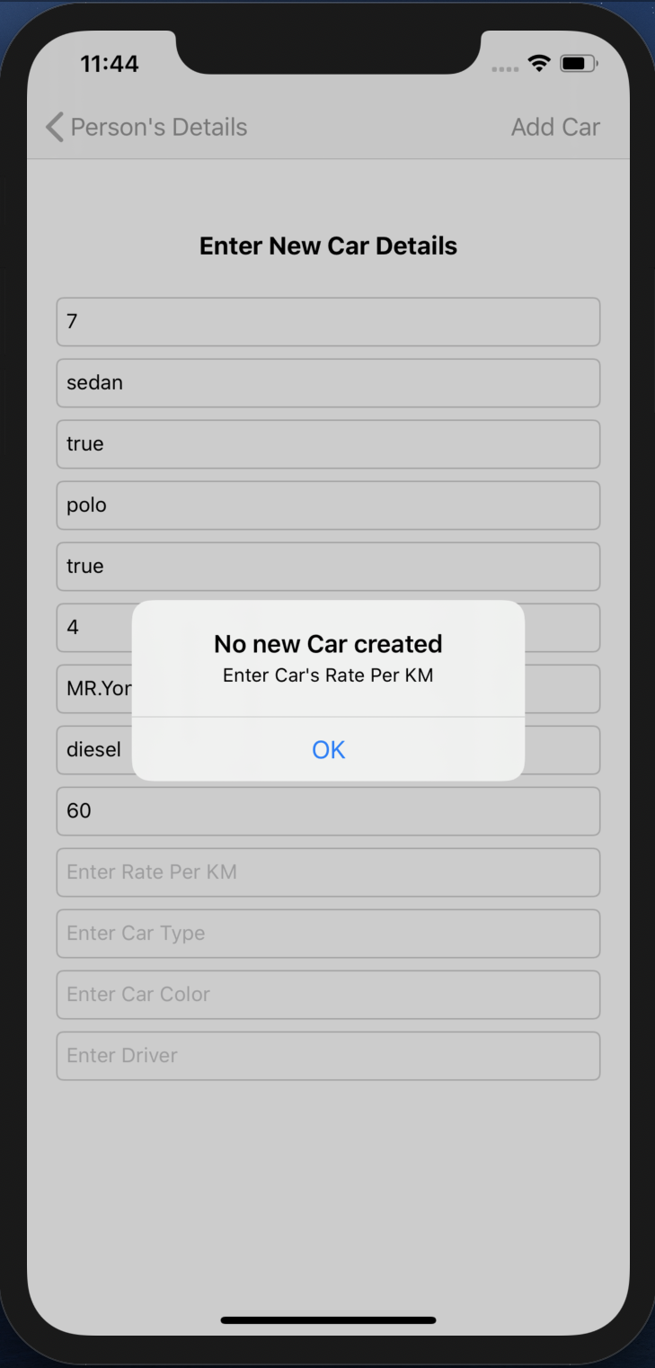

Fig 90. Alert

* An alert will pop up, when the Car’s Rate Per KM is not filled.

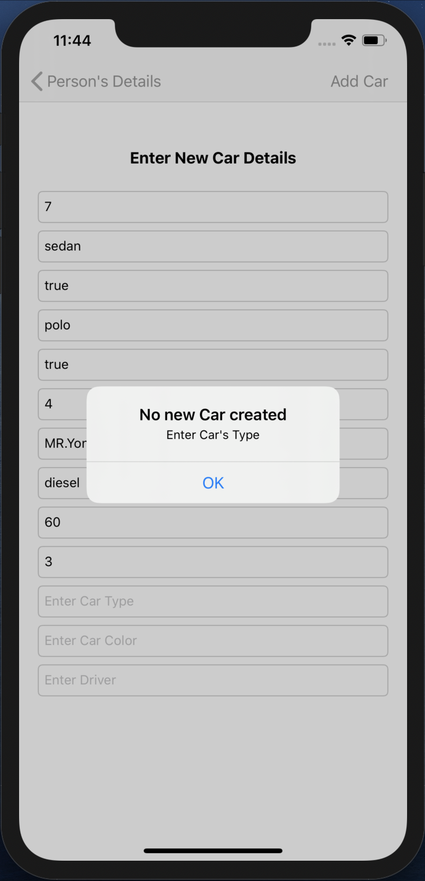

Fig 91. Alert

* An alert will pop up, when the Car’s Type is not filled.

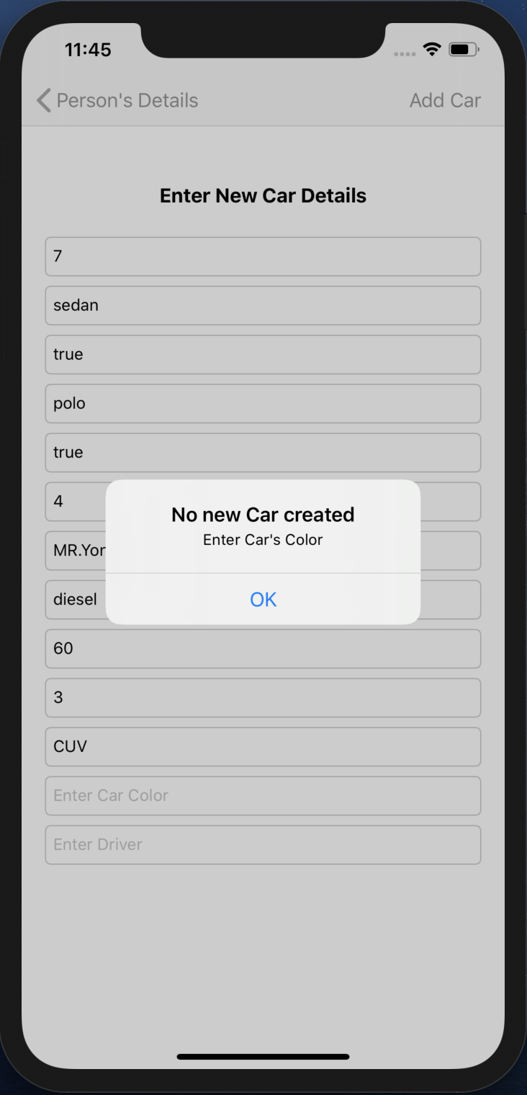

Fig 92. Alert

* An alert will pop up, when the Car’s Color is not filled.

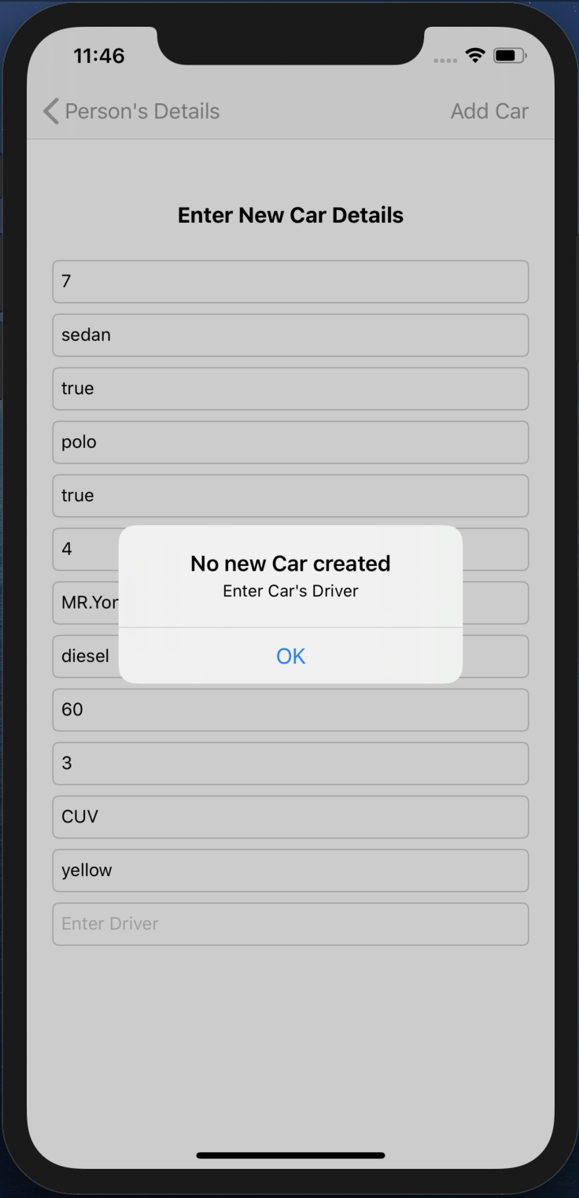

Fig 93. Alert

* An alert will pop up, when the Car’s Driver is not filled.

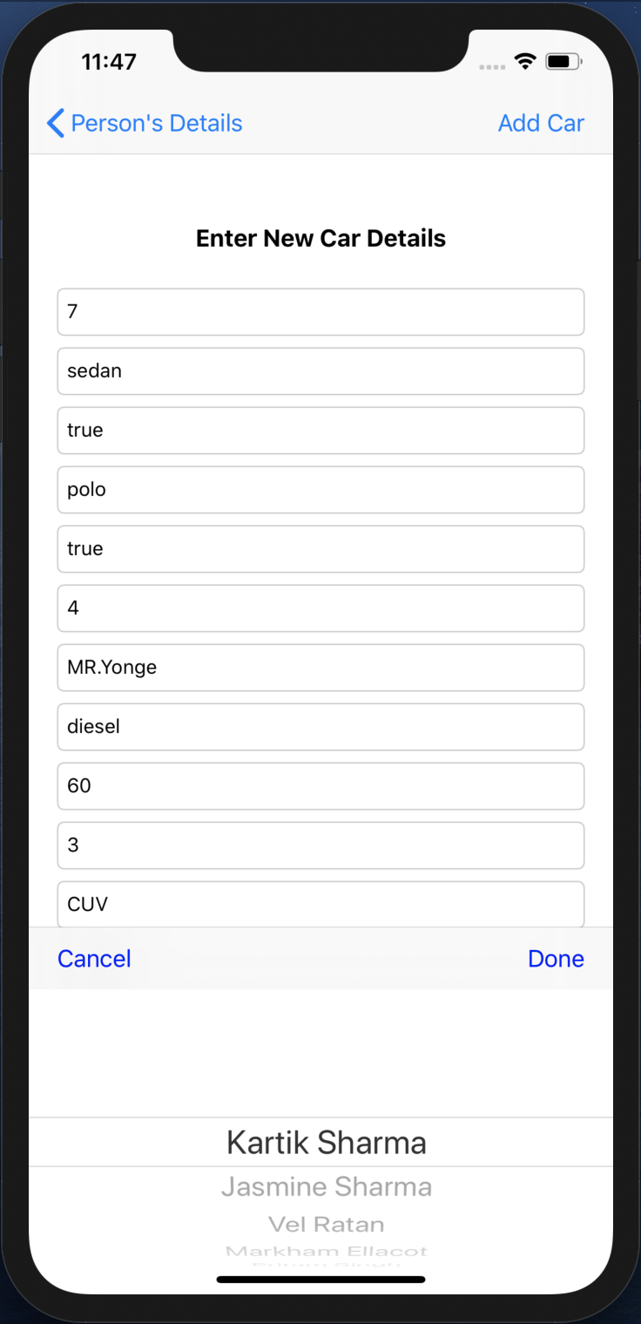

Fig 94. Picker View

* When we click on the Driver TEXTFIELD, the PICKER VIEW pops up to fill it. It contains Driver objects.
* Driver object is selected and Done TOOLBAR BUTTON is pressed of the PICKER VIEW, that driver is filled in the Driver TEXTFIELD.

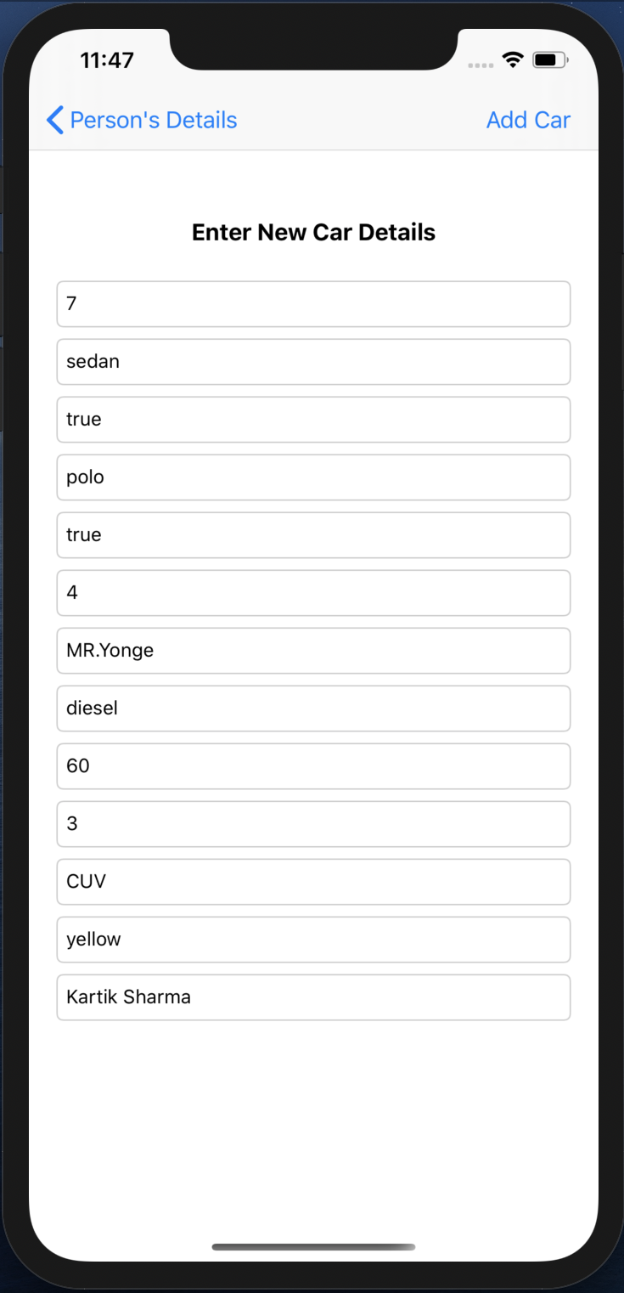

Fig 95. New Car details

* All the details are entered and Add Car BAR BUTTON is pressed and the VIEW CONTROLLER pops.

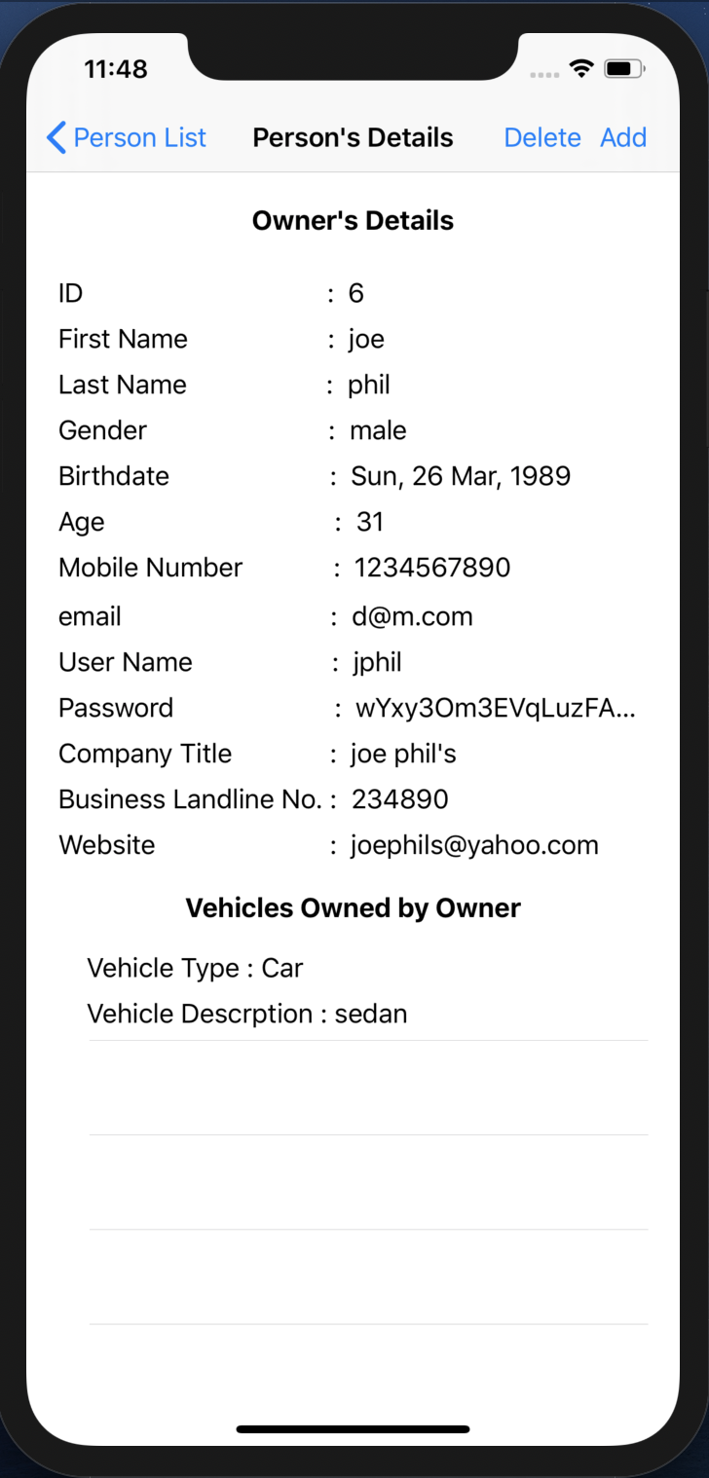

Fig 96. Updated Owner’s Vehicles owned list

* The Owner’s Vehicles owned by owner TABLE VIEW gets updated.

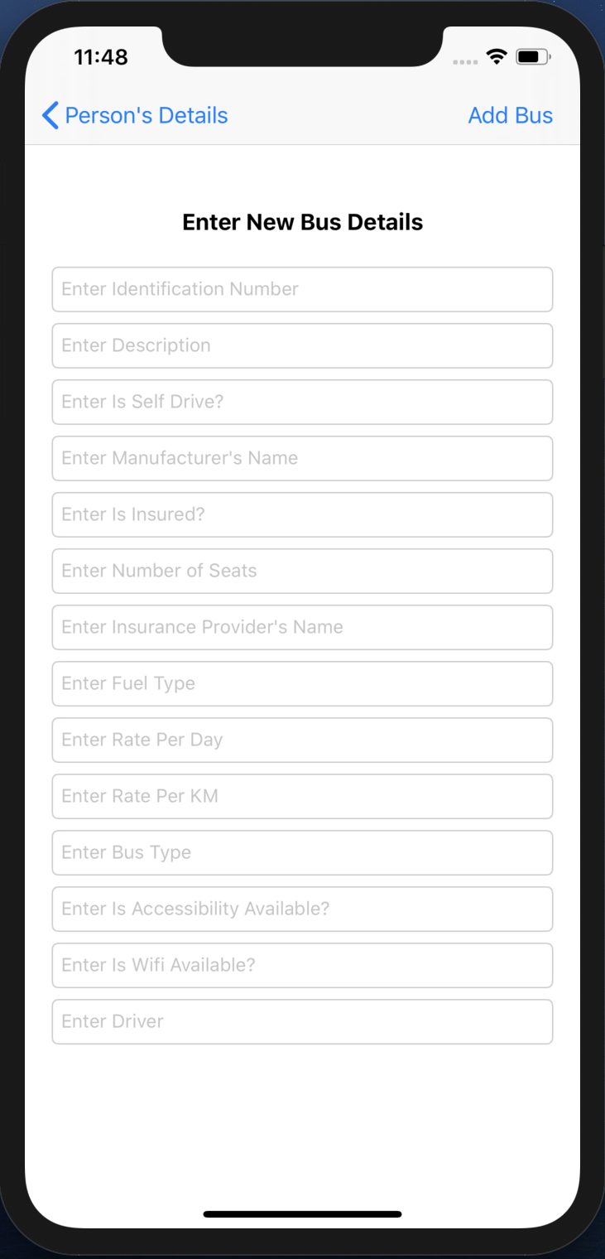

Fig 97. New Bus creation

* This VIEW CONTROLLER contains TEXTFIELDs that shows the requirements that needs to be entered in order to create a new bus.
* When no new bus is needed to be created then the user can simple press the Person’s Details back BAR BUTTON on the top left and go back to the previous screen.

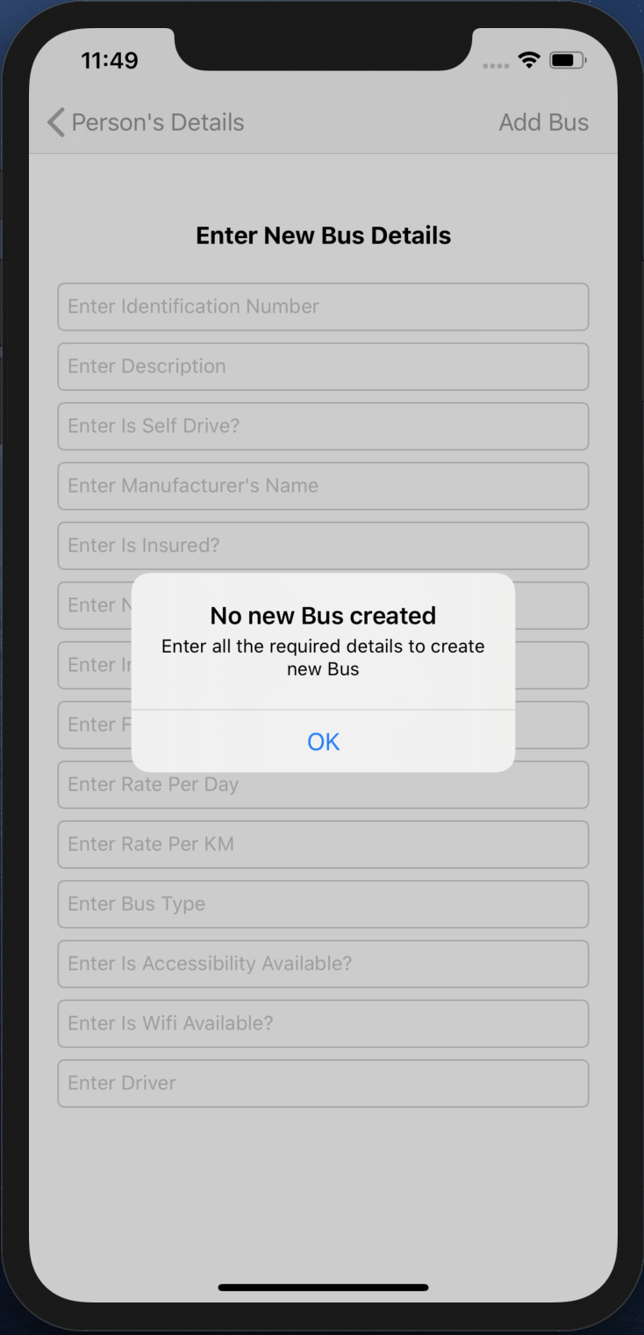

Fig 98. Alert

* When the Add Bus BAR BUTTON is pressed without entering any of the details, an ALERT pops up.
* This alert shows a message asking to fill the details that are required to create a new bus.

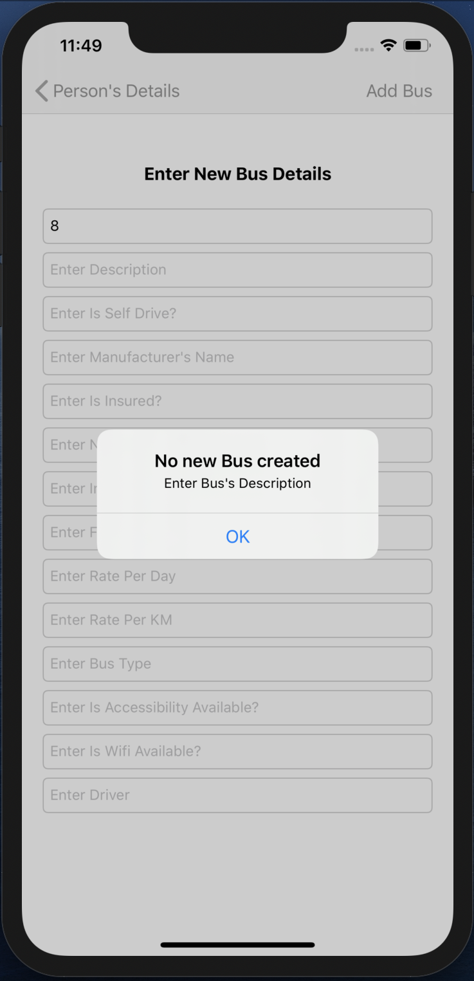

Fig 99. Alert

* An alert will pop up, when the Bus’s Description is not filled.

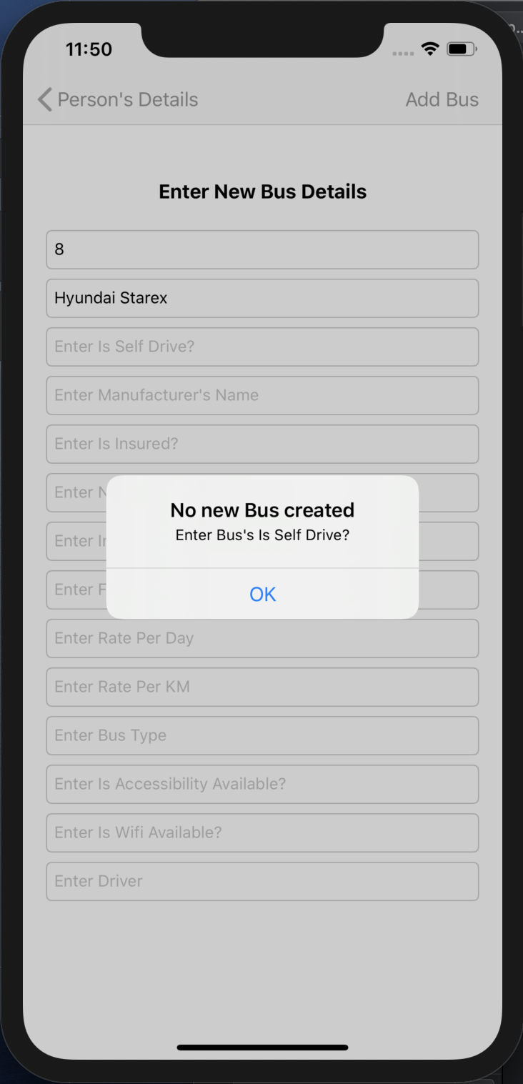

Fig 100. Alert

* An alert will pop up, when the Bus’s Is Self Drive? is not filled.

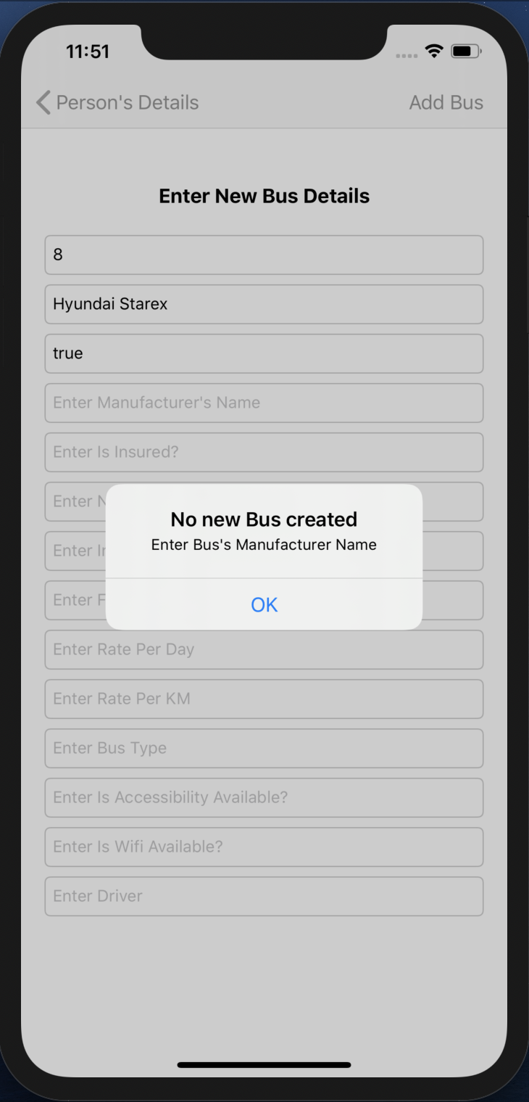

Fig 101. Alert

* An alert will pop up, when the Bus’s Manufacturer Name is not filled.

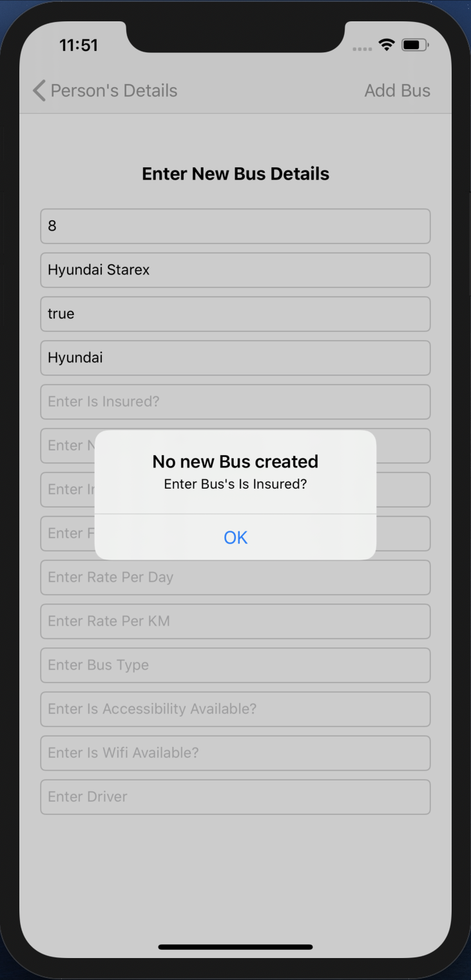

Fig 102. Alert

* An alert will pop up, when the Bus’s Is Insured? is not filled.

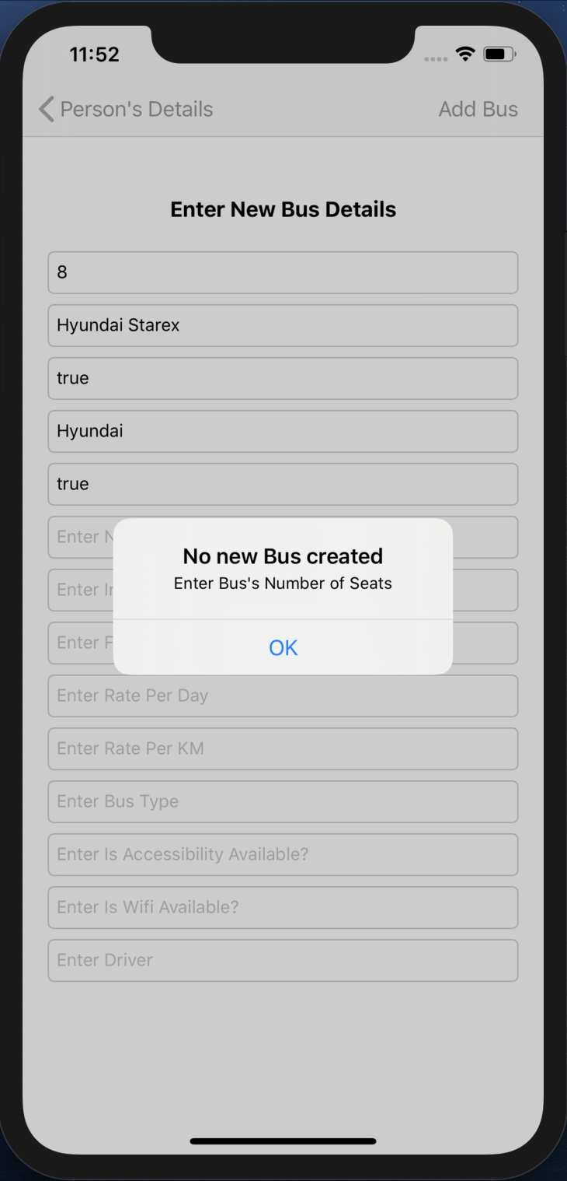

Fig 103. Alert

* An alert will pop up, when the Bus’s Number of seats is not filled.

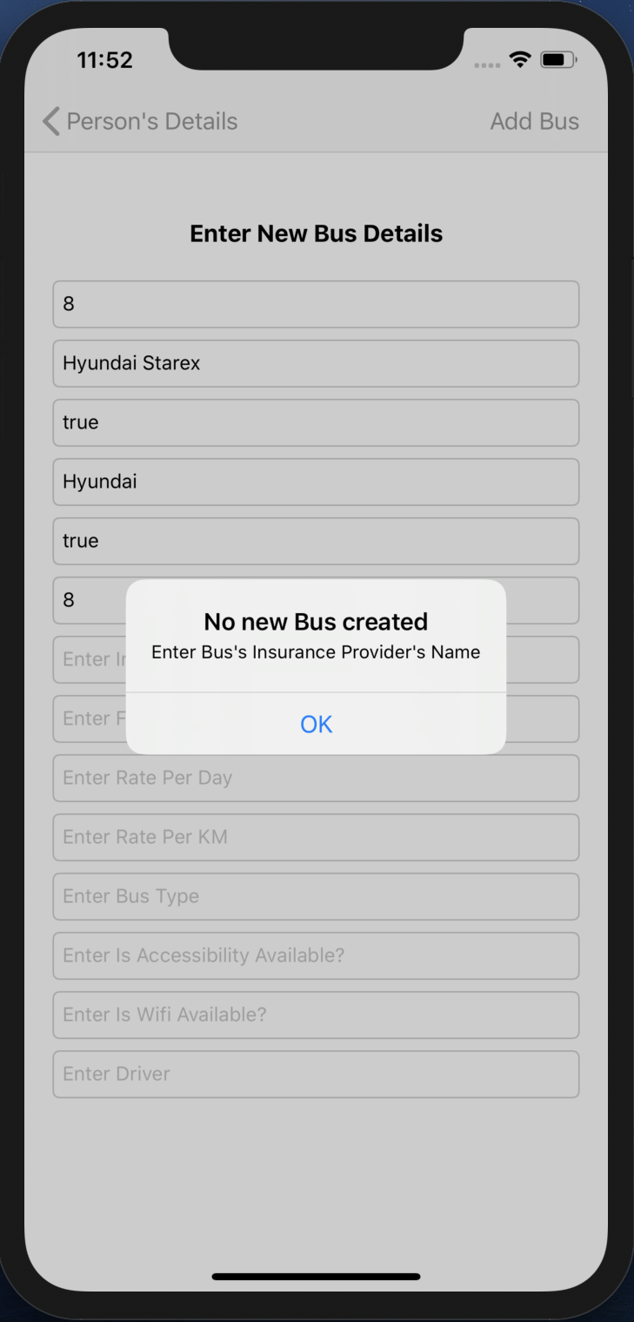

Fig 104. Alert

* An alert will pop up, when the Bus’s Insurance Provider’s Name is not filled.

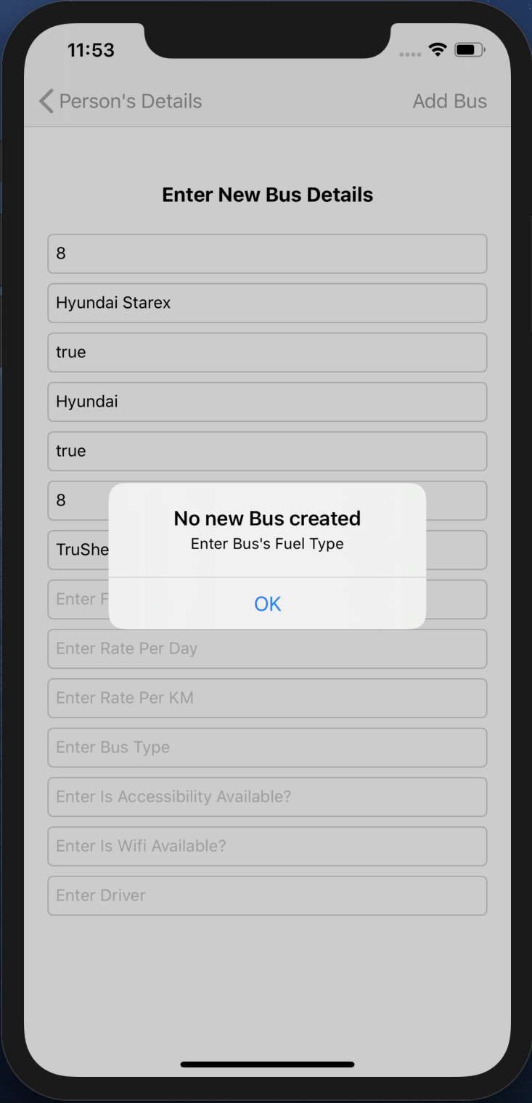

Fig 105. Alert

* An alert will pop up, when the Bus’s Fuel Type is not filled.

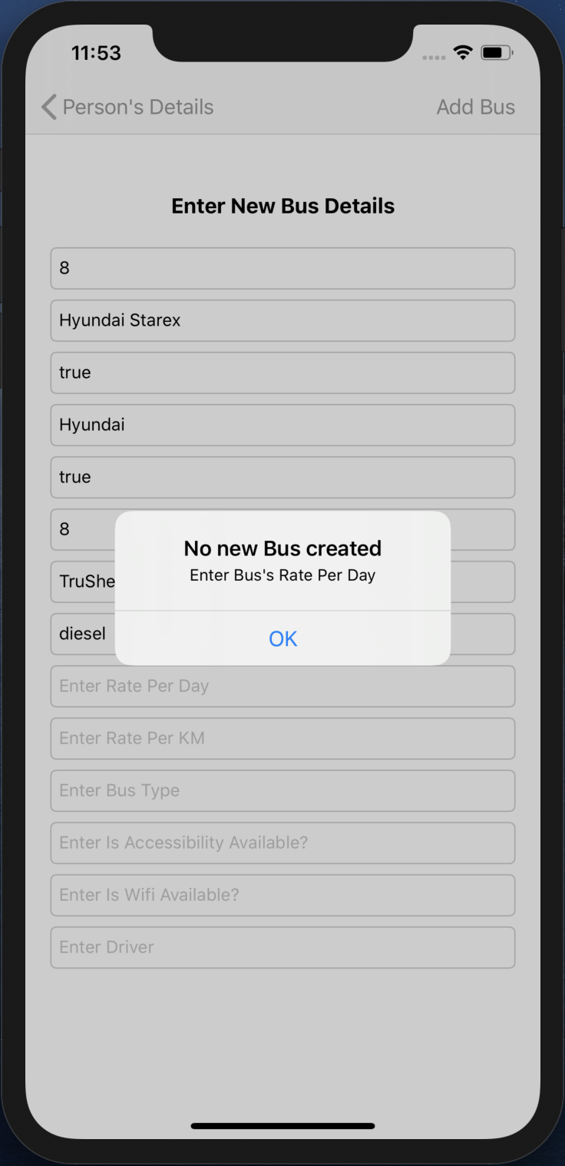

Fig 106. Alert

* An alert will pop up, when the Bus’s Rate Per Day is not filled.

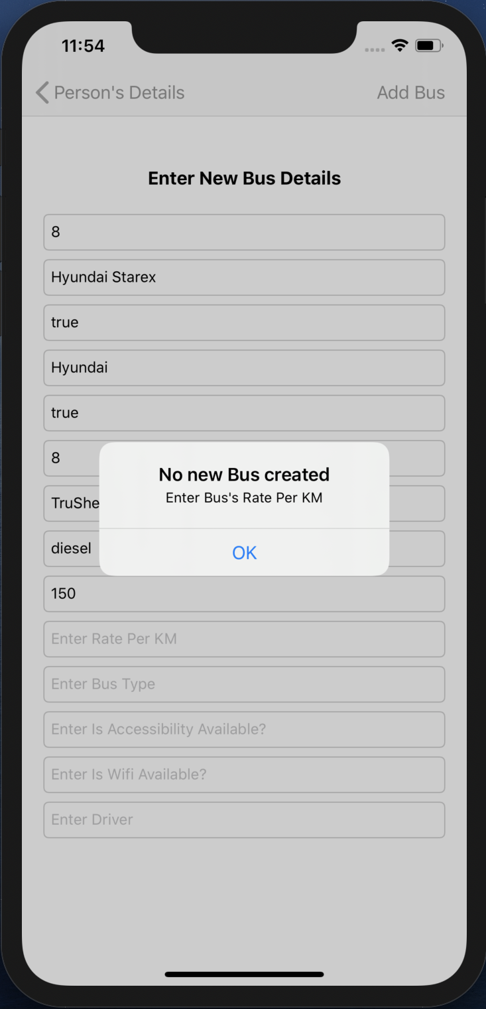

Fig 107. Alert

* An alert will pop up, when the Bus’s Rate Per KM is not filled.

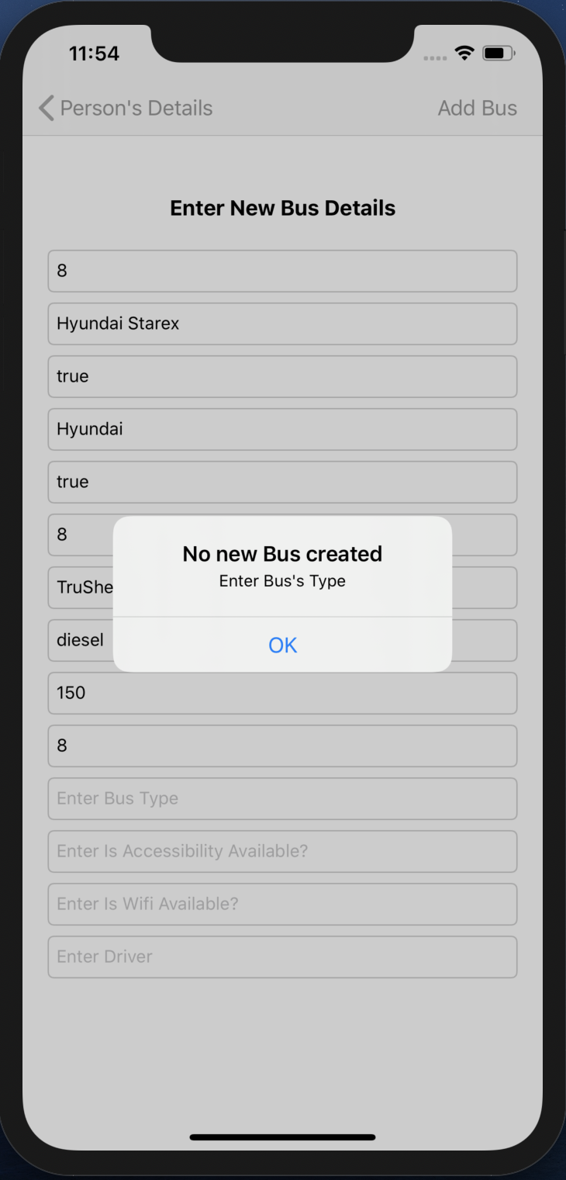

Fig 108. Alert

* An alert will pop up, when the Bus’s Type is not filled.

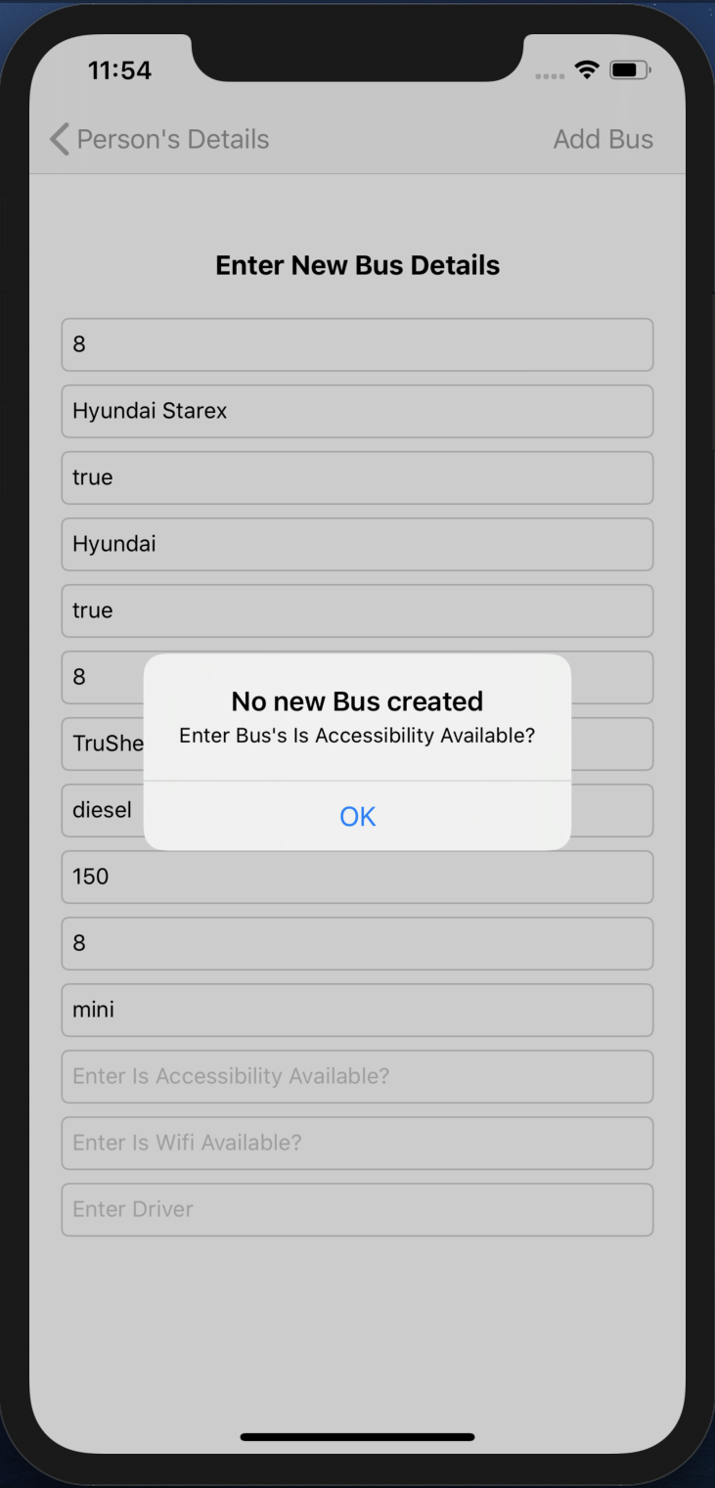

Fig 109. Alert

* An alert will pop up, when the Bus’s Is Accessibility Available? is not filled.

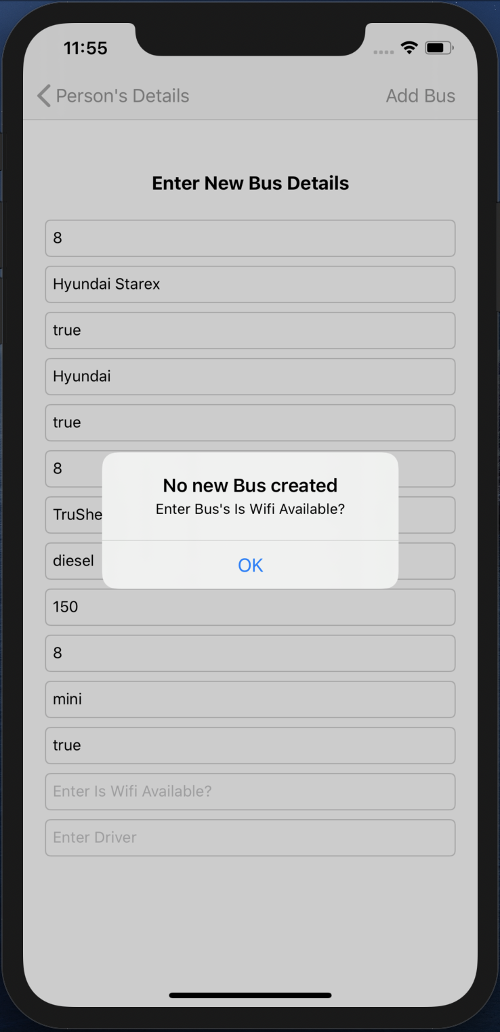

Fig 110. Alert

* An alert will pop up, when the Bus’s Is Wi-Fi Available? is not filled.

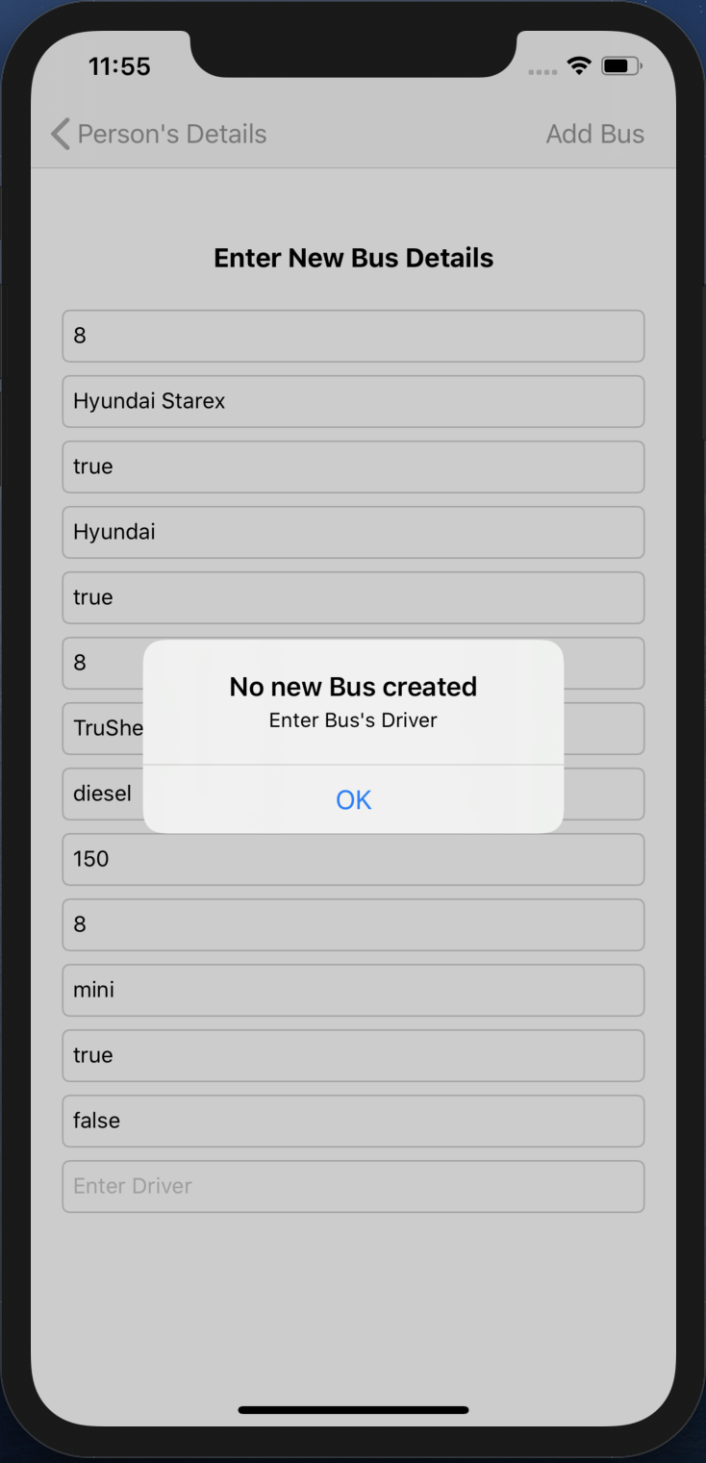

Fig 111. Alert

* An alert will pop up, when the Bus’s Driver is not filled.

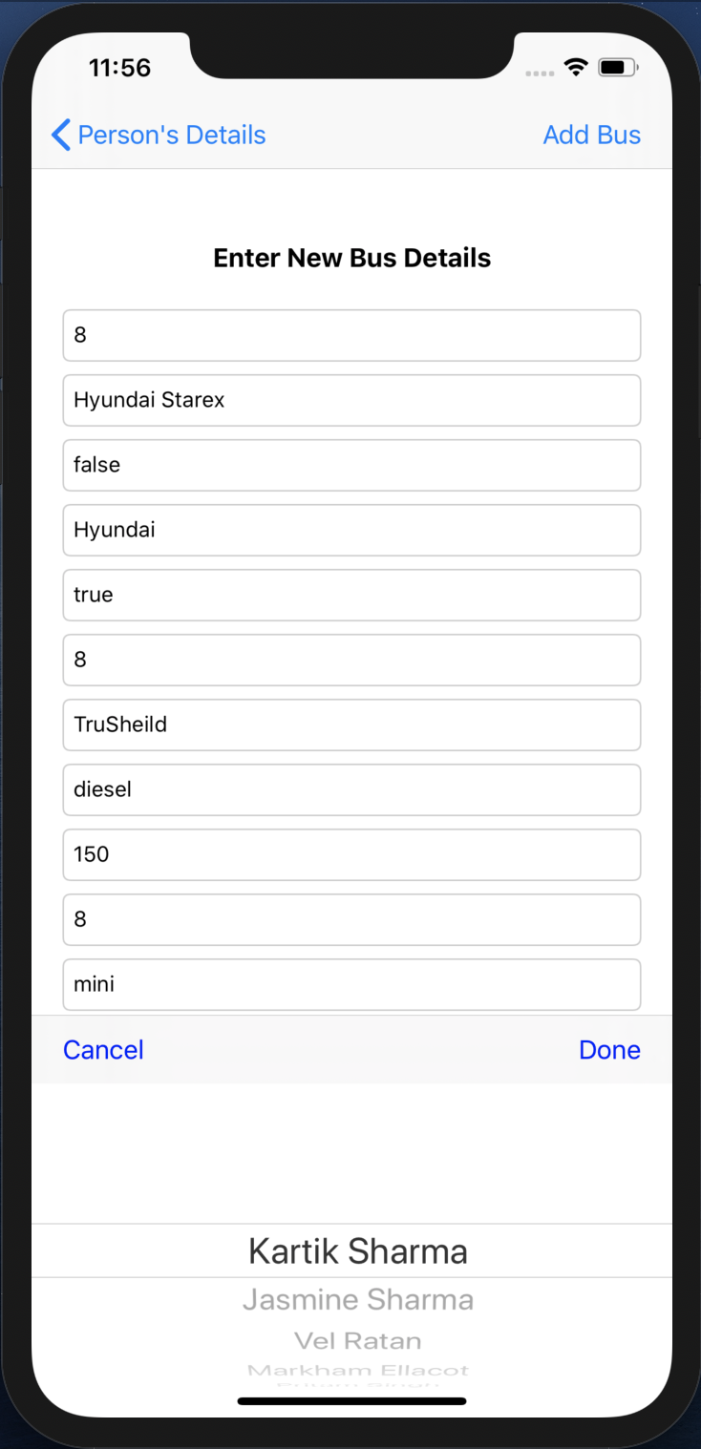

Fig 112. Picker View

* When we click on the Driver TEXTFIELD, the PICKER VIEW pops up to fill it. It contains Driver objects.
* Driver object is selected and Done TOOLBAR BUTTON is pressed of the PICKER VIEW, that driver is filled in the Driver TEXTFIELD.

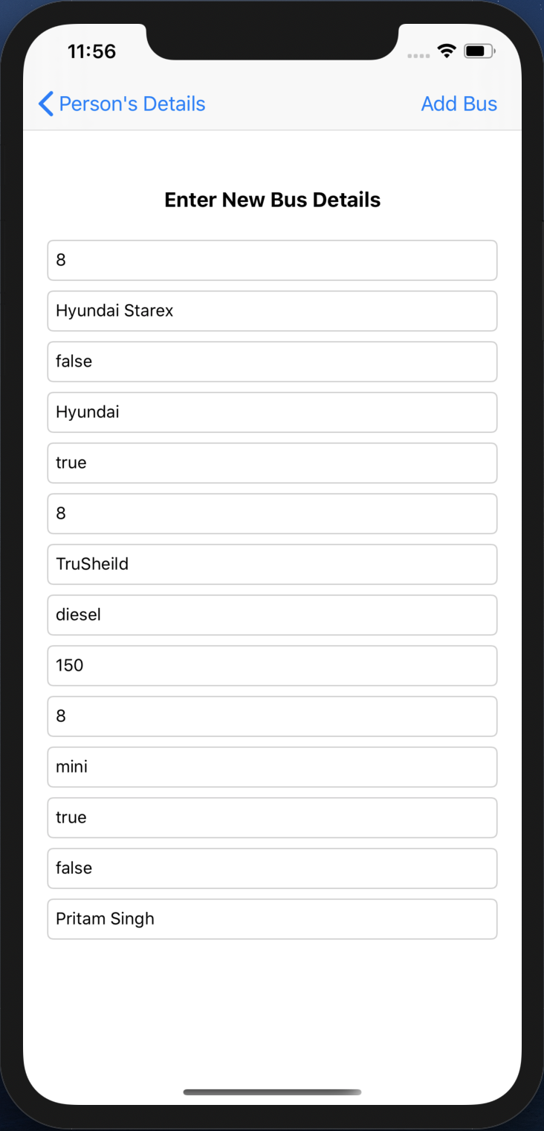

Fig 113. New Bus details

* All the details are entered and Add Bus BAR BUTTON is pressed and the VIEW CONTROLLER pops.

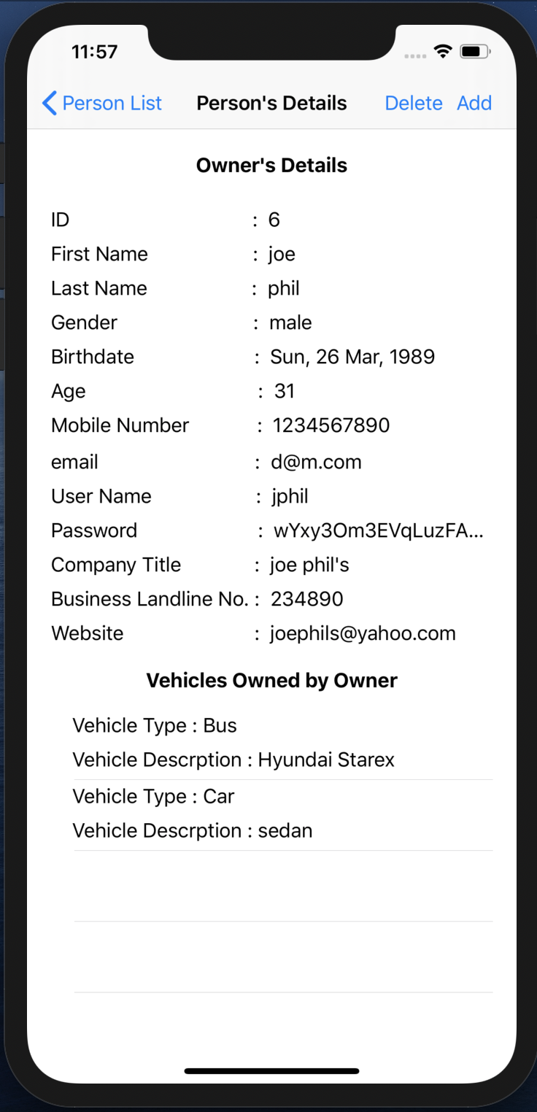

Fig 114. Updated Owner’s Vehicles owned list

* The Owner’s Vehicles owned by owner TABLE VIEW gets updated.

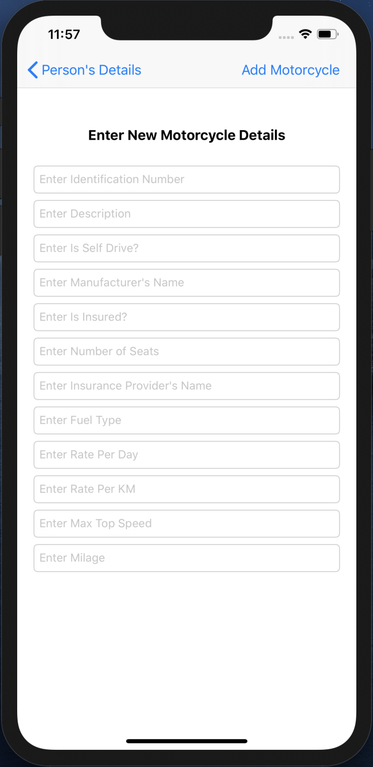

Fig 115. New Motorcycle creation

* This VIEW CONTROLLER contains TEXTFIELDs that shows the requirements that needs to be entered in order to create a new motorcycle.
* When no new motorcycle is needed to be created then the user can simple press the Person’s Details back BAR BUTTON on the top left and go back to the previous screen.

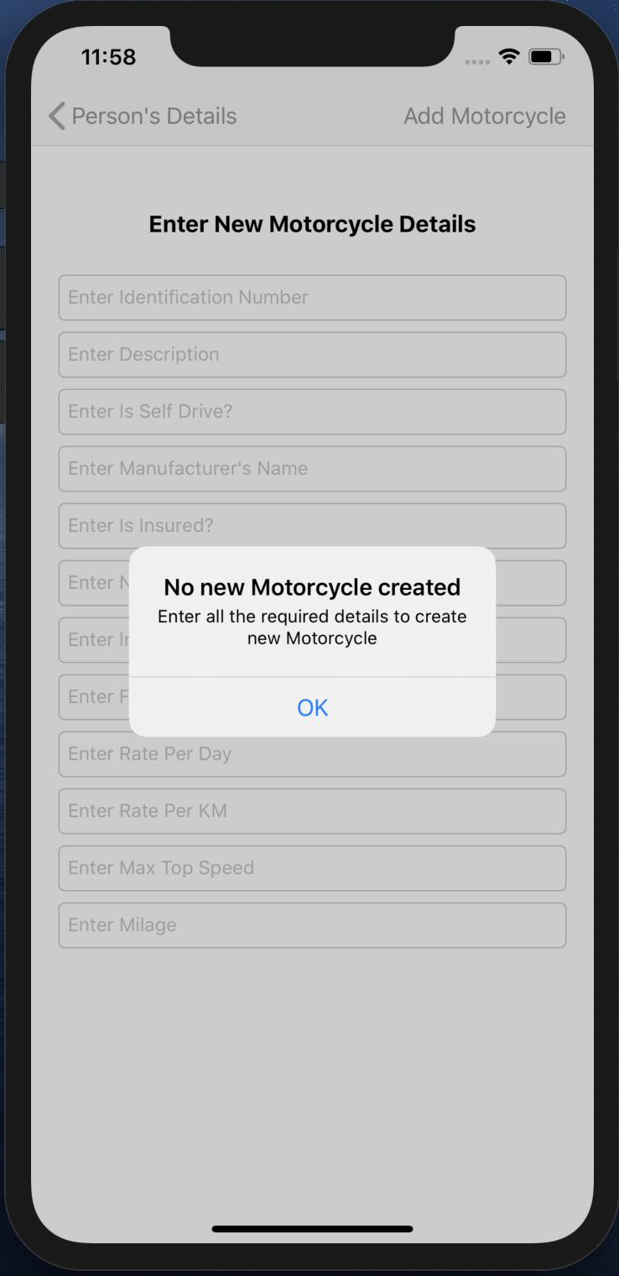

Fig 116. Alert

* When the Add Motorcycle BAR BUTTON is pressed without entering any of the details, an ALERT pops up.
* This alert shows a message asking to fill the details that are required to create a new motorcycle.

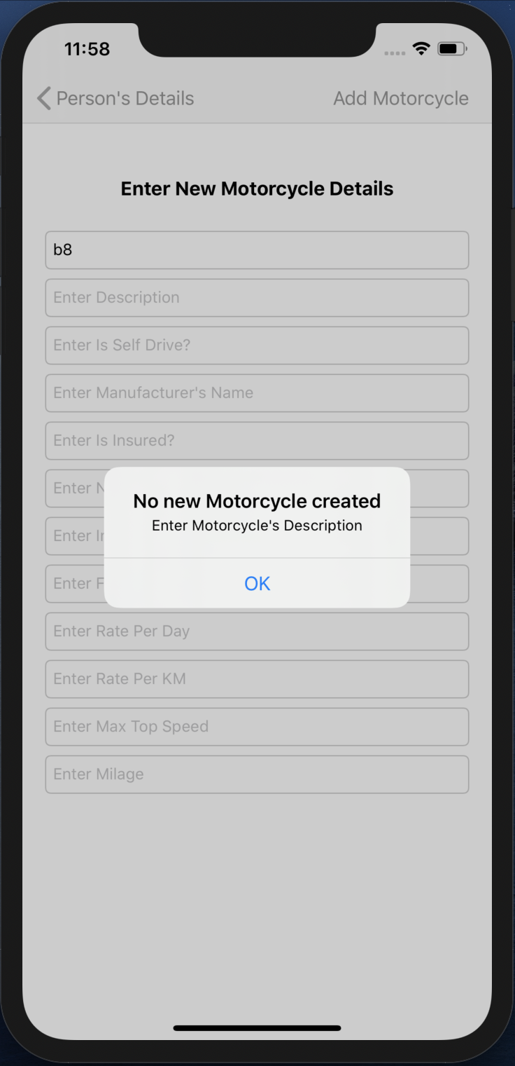

Fig 117. Alert

* An alert will pop up, when the Motorcycle’s Description is not filled.

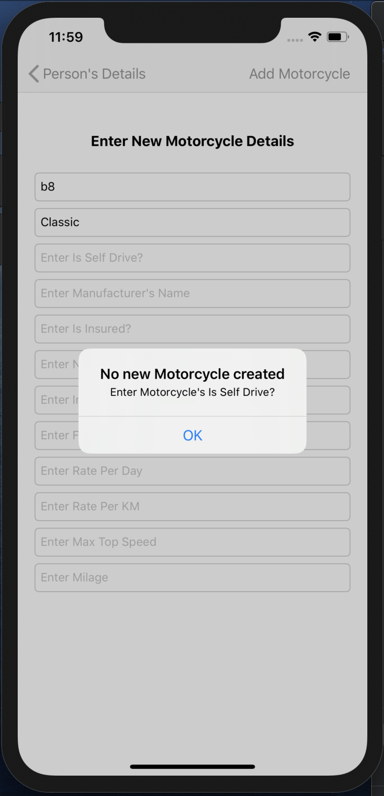

Fig 118. Alert

* An alert will pop up, when the Motorcycle’s Is Self Drive? is not filled.

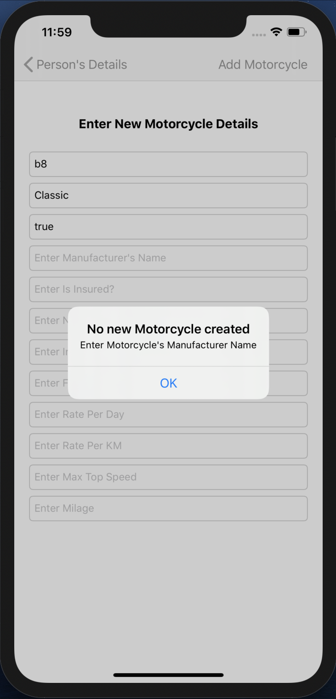

Fig 119. Alert

* An alert will pop up, when the Motorcycle’s Manufacturer Name is not filled.

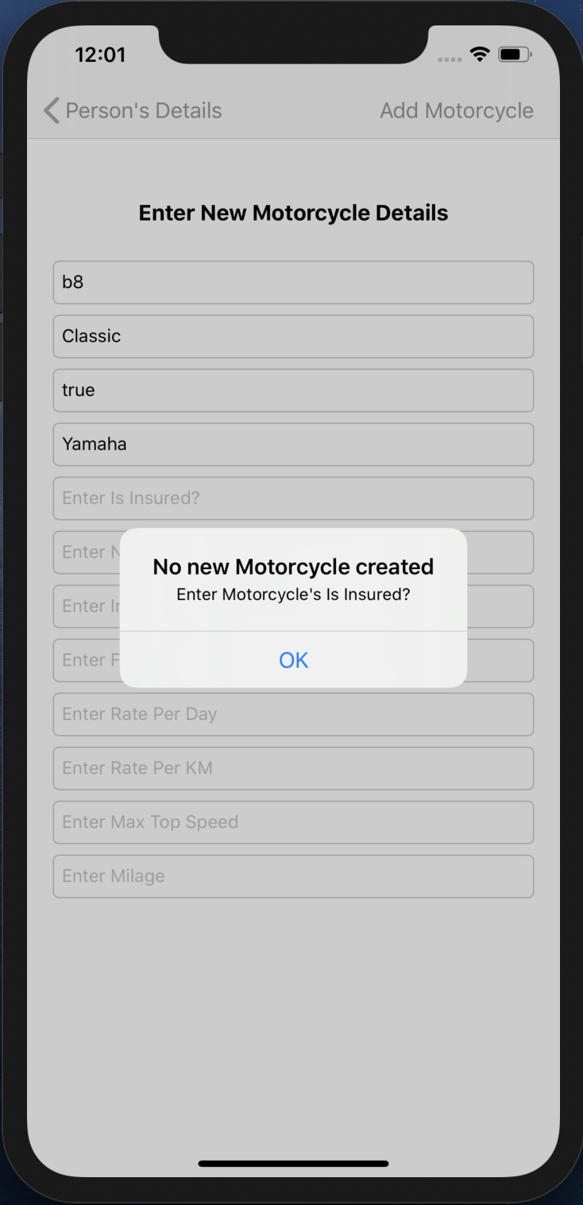

Fig 120. Alert

* An alert will pop up, when the Motorcycle’s Is Insured? is not filled.

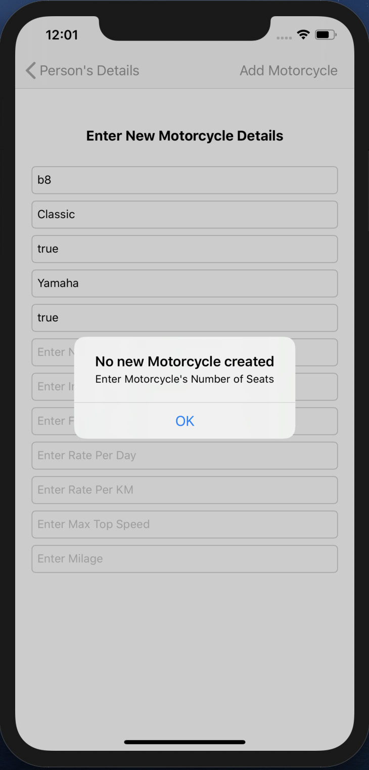

Fig 121. Alert

* An alert will pop up, when the Motorcycle’s Number of seats is not filled.

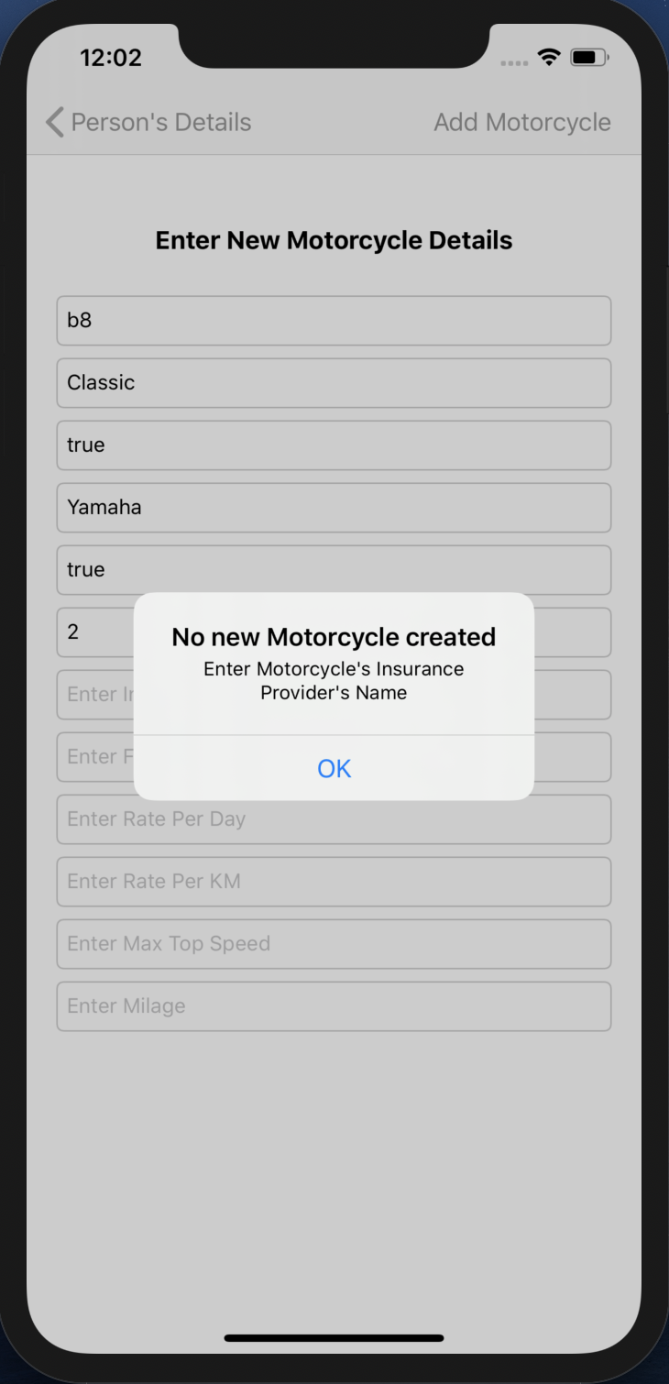

Fig 122. Alert

* An alert will pop up, when the Motorcycle’s Insurance Provider’s Name is not filled.

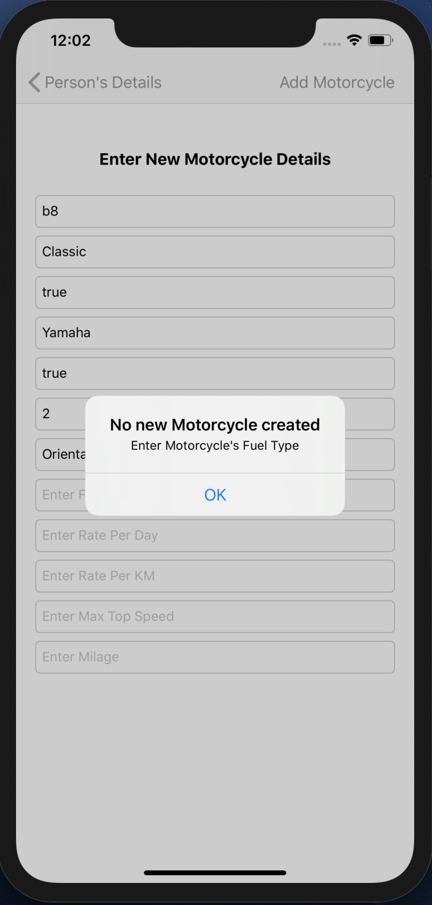

Fig 123. Alert

* An alert will pop up, when the Motorcycle’s Fuel Type is not filled.

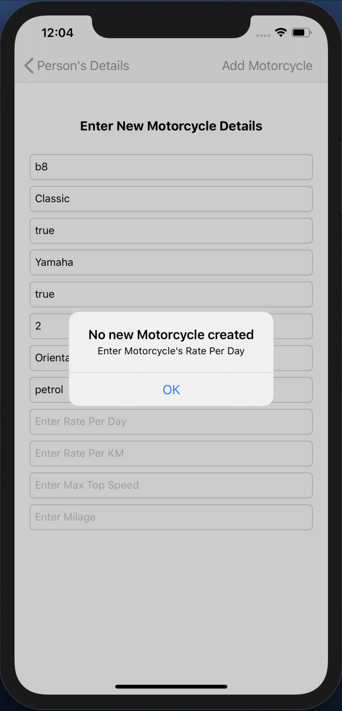

Fig 124. Alert

* An alert will pop up, when the Motorcycle’s Rate Per Day is not filled.

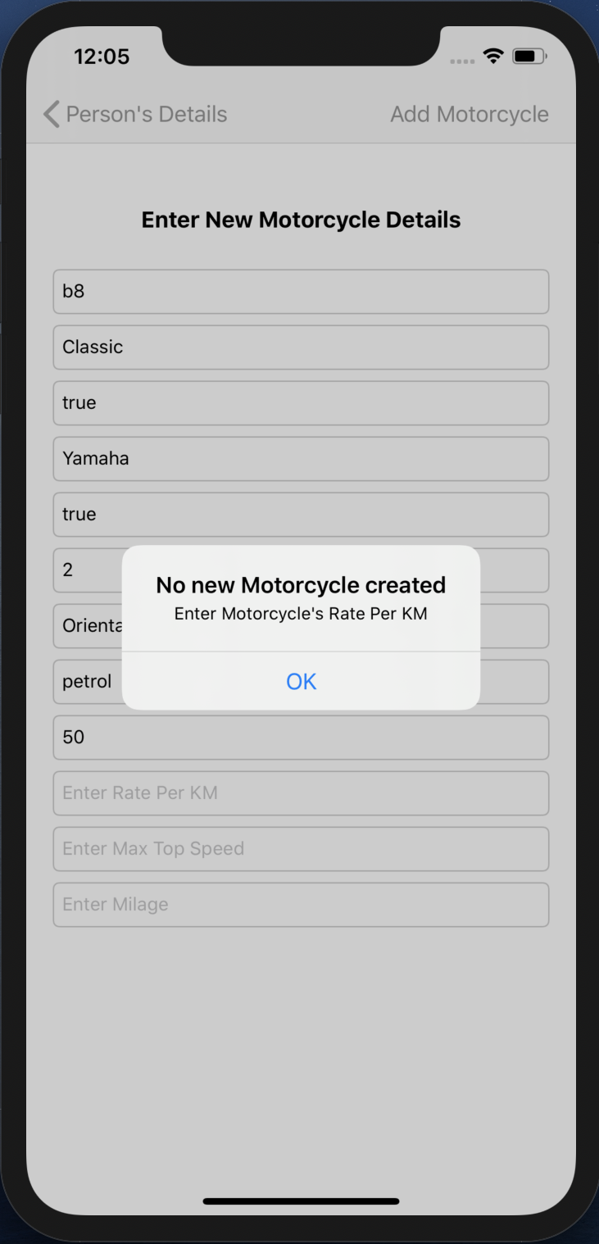

Fig 125. Alert

* An alert will pop up, when the Motorcycle’s Rate Per KM is not filled.

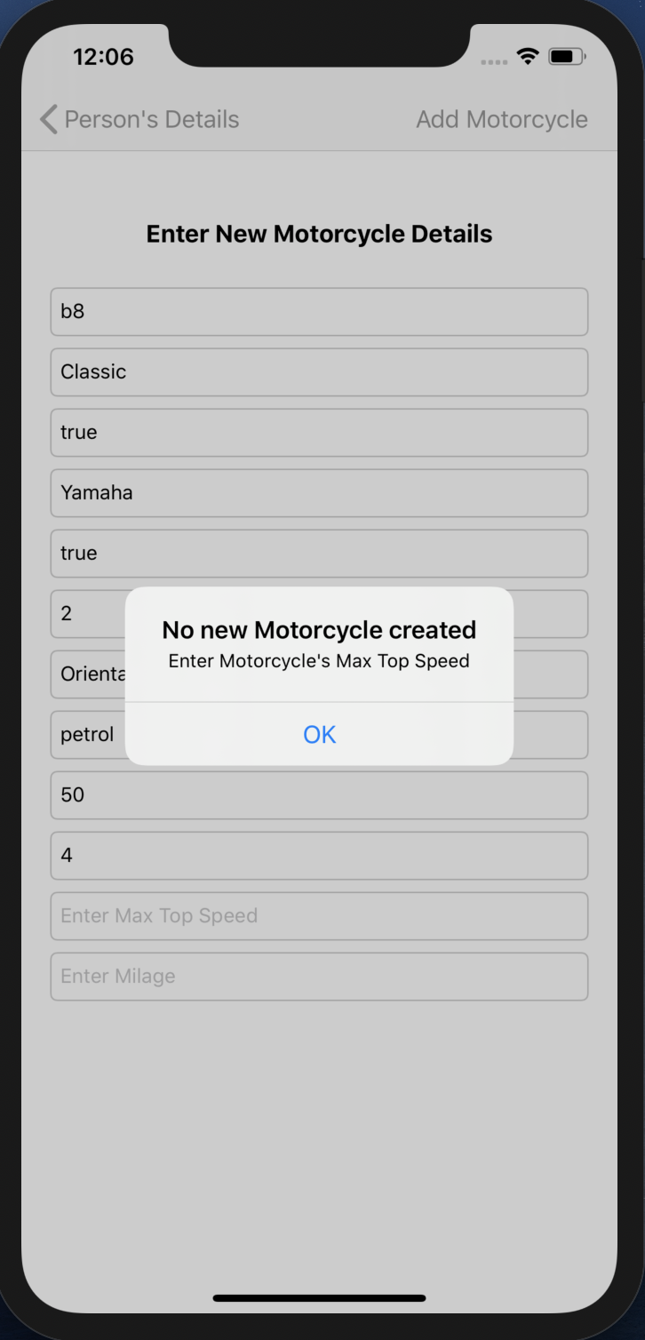

Fig 126. Alert

* An alert will pop up, when the Motorcycle’s Max Top Speed is not filled.

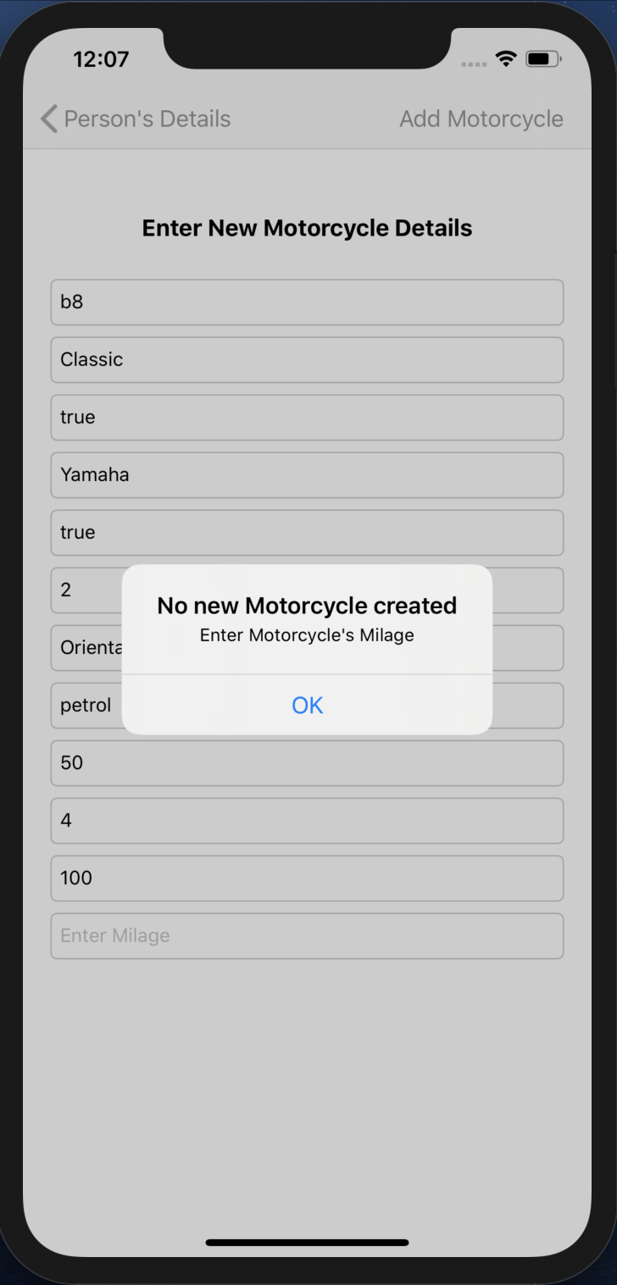

Fig 127. Alert

* An alert will pop up, when the Motorcycle’s Milage is not filled.

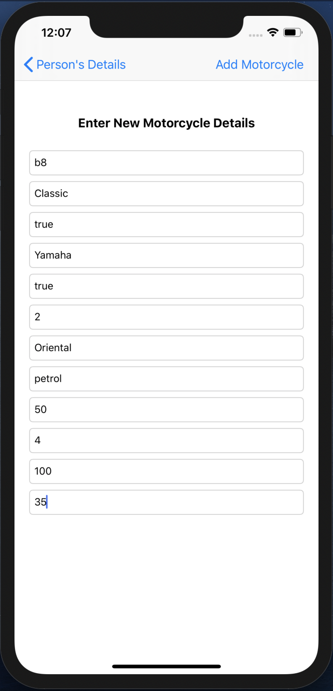

Fig 128. New Motorcycle details

* All the details are entered and Add Motorcycle BAR BUTTON is pressed and the VIEW CONTROLLER pops.



Fig 129. Updated Owner’s Vehicles owned list

* The Owner’s Vehicles owned by owner TABLE VIEW gets updated.

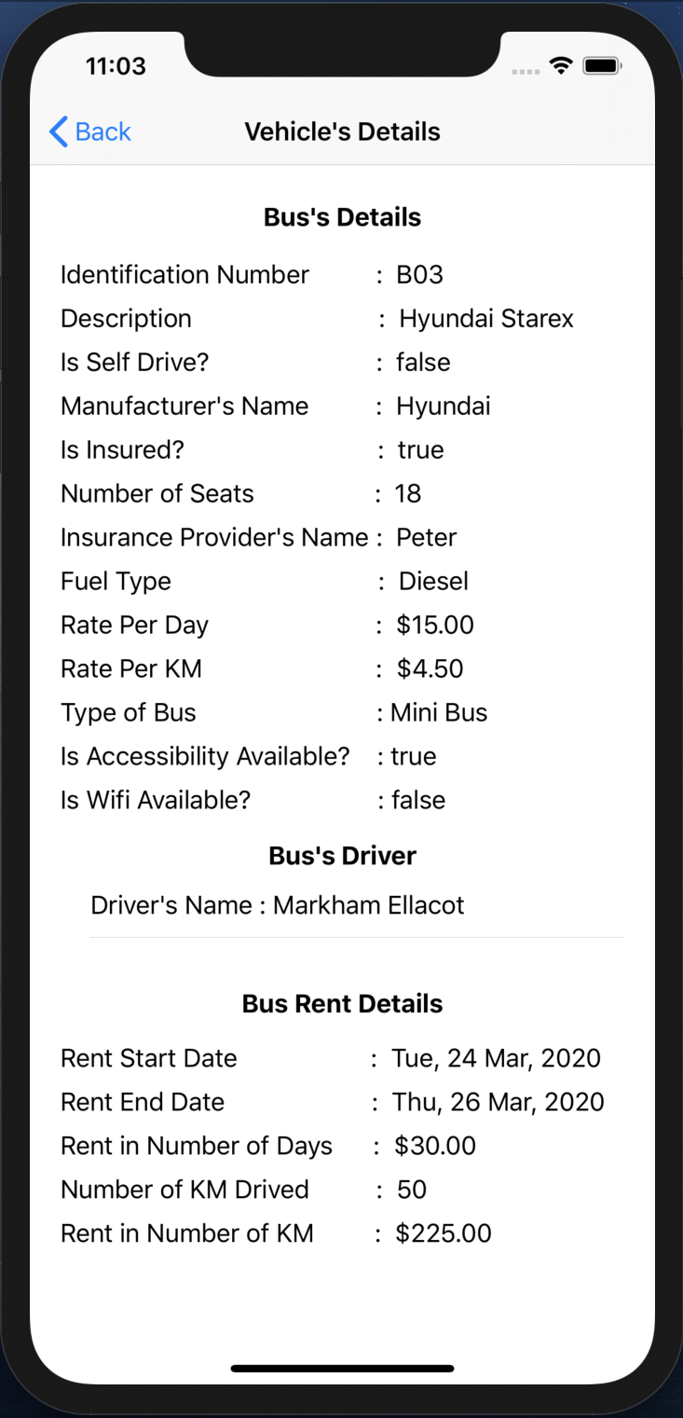

Fig 130. Customer’s Vehicle Rent Details

* When you click on a Customer’s Vehicle rent its details will be available.
* When you click on the Vehicle’s Driver, driver’s details will be available.

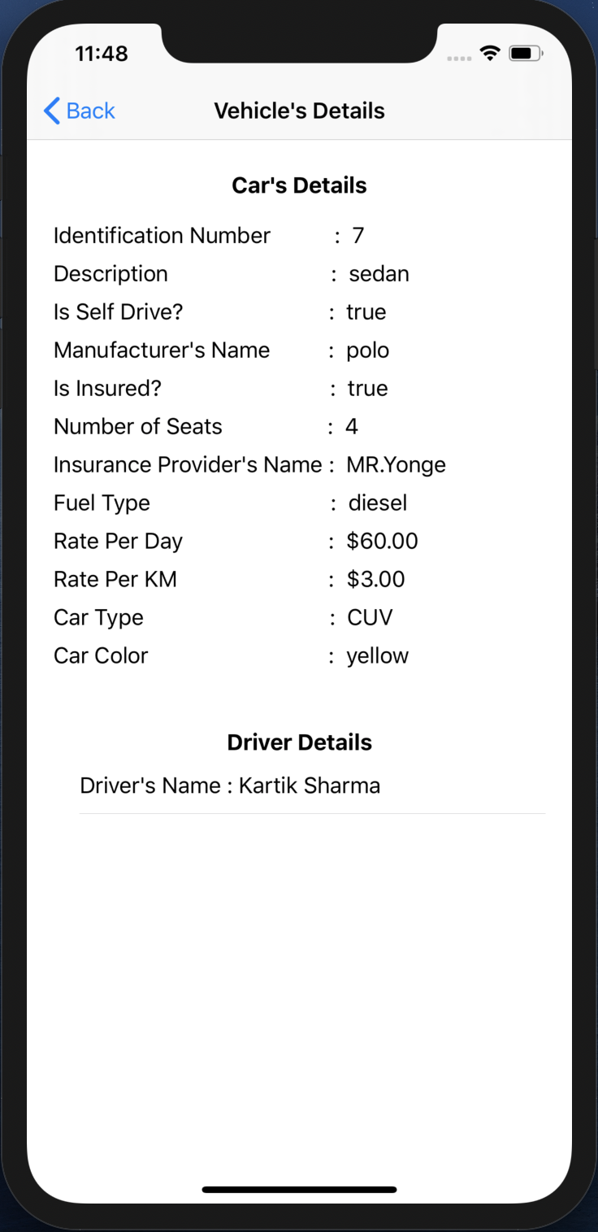

Fig 131. Owner’s Vehicle owned details

* When you click on an Owner’s Vehicle owned its details will be available.
* When you click on the Vehicle’s Driver, driver’s details will be available.

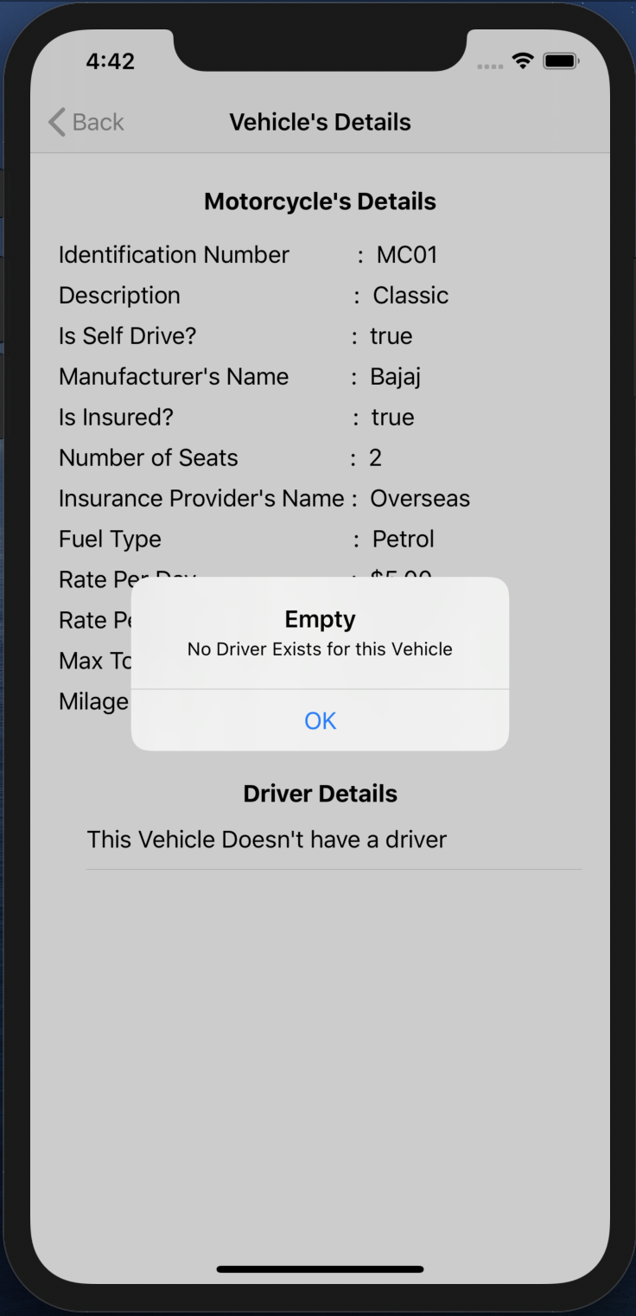

Fig 132. No Driver assigned

* When you click on a Vehicle’s Driver details, if it exists then particular driver’s details will be available.
* If not then an ALERT will pop up, with the message that no driver exists for the particular vehicle.